

**The Ministry of Agriculture, Forestry and Water Management of the**

**Republic of Serbia**

**THE STRATEGY OF AGRICULTURE AND RURAL DEVELOPMENT OF THE REPUBLIC**

**OF SERBIA (2014–2024)**

**November 2013**

**Preface of the Minister**

We are witnessing the complex changes and significant challenges the agriculture and rural areas of Serbia are facing. Ministry of Agriculture, Forestry, and Water Management of the Republic of Serbia is aware that these changes will have consequences on environment, natural resources, food safety, production and economic effects of the agricultural and food production sectors, and especially on the position of farmers, entrepreneurs and rural population, and that is why we have decided to present our view of the development perspective contained in this Strategy of Agriculture and Rural Development of the Republic of Serbia (2014-2024) to our partners, stakeholders and wider public.

The development goals and priorities of this Strategy have been defined with the full recognition of the sustainable development principles and the new role agriculture has in the economy and society in terms of its multi-functional development concept. Besides, recognizing the differences of the Serbia rural areas and significant regional differences in the production systems, the Strategy offers the solutions for more just and equal allocation of the budget funds to all potential beneficiaries.

This Strategy defines the framework for institutional and political reform, as well as the basic guidelines for budget subsidies for agriculture and rural areas for the next decade. The proposed agriculture policy reforms should contribute to establishment of a reliable and attractive business environment in agricultural and food production sectors, to increased stability of income of farmers and welfare of the rural population.

The EU and WTO integration processes that have started represent the important guidelines for definition of the future reforms platform. Aiming at ensuring the stable and maximum benefits for the domestic producers in the long-term, the Strategy foresees gradul taking over the solutions from the European support model, with full recognition of national priorities and situation.

Hoping that by preparing this strategic document we have shown we are ready enough to take over the responsibility for implementation of the set goals, I am inviting you to support us in our efforts and to gather on our joint mission – to make Serbian agriculture a modern and dynamic sector based on knowledge and healthy environment, and to make the rural areas preserved and a reason to be proud of by the generations to come.

Sincerely,

In Belgrade, December 2013

Dragan Glamocic, PhD

Minister of agriculture,

Forestry and water management

Of the Republic of Serbia

**Acronyms**

*APM*-*Agricultural Policy Measures database*

WFP – Work-force poll

GDP – Gross Domestic Product

GAV – Gross Added Value

*BRC* -*British Retail Consortium*-

*CEFTA* -*Central European Free Trade Agreement*

*EBRD* - *European Bank for Reconstruction and Development*

*ЕC- European Commission*

EU – European Union

*FADN -Farm Account Data Network*

GIS – Geographical Information System

*GLOBAL G.A.P.* – Good Agricultural Practices Standard

ALU – Annual Labor Units

*HNVF* – High Natural Value Fields

*IACS* -*Integrated Administration and Control System*

*IFS* -*International Food Standard*

*IPARD* - *Instrument for Preaccession Assistance for Rural Development*

IAS – Institute for Applied Science in Agriculture

*IPO* - *Initial Public Offers*

*ISDACON* -*Inter-Sectoral Working Group for Coordination of Humanitarian and Development Assistance*

*ISO* -*International Standard Organization*

*LEADER* -*Liaison Entre Actions de Développement de l'Économie Rurale* – Liaisons among the rural development actions

*LFA* - *Less-Favoured Areas*

*LPIS* -*Land Parcel Identification System*

LSMS -*Living Standard Measurement Survey*

LSRD – The Local Strategy of Rural Development

*MFN* -*Most favourable nation*

MAFWM – The Ministry of Agriculture, Forestry and Water Management

CSO – Civil Society Organization

*OECD* -*Organisation for Economic Co-operation and Development*

*ОIЕ* – Светска здравствена организација за здравље животиња

*PESTLE* analysis (*Political, Economic, Sociological, Technological, Legal, Environmenta*l)

PDI – Pension and Disability Insurance

ALCA – Areas with Limited Conditions for Agriculture

PSAWMF – Provincial Secreatariat for Agriculture, Water Management and Forestry

ACES – Agricultural Counseling and Expert Services

RS – Republic of Serbia

RSA – Republic Statistics Administration

USA – United States of America

*SAPS* -*Simplified area payment scheme*

WB – World Bank

SMNE – Serbia and Montenegro

*CMO* - *Single Common Market Organizations*

SIEPA-*Serbia Investment and Export Promotion Agency*

SWG – Sector Working Groups

FRY – Federal Republic of Yugoslavia

*STAR* -*Serbian Transition Agriculture Reform*

WTO – World Tratde Organization

SWОТ - *Strengths, Weaknesses, Opportunities, Threats*

*TBT - Technical barriers to trade*

UN – United Nations

UNDP *United Nations Development Program*

*USAID* - *United States Agency for International Development*

CAP – Common Agricultural Policy of the EU

ISU – Independent States Union

**Contents**

INTRODUCTION 1

1.1 Motives for designing the new agriculture and rural development strategy 1

1.2. Legal basis for designing the Strategy and its connection with other strategic documents 2

1.3 Strategy Design Methodology 4

1.3.1 Public policy cycle 4

1.3.2 Phases of work and participants in the Strategy design process 5

2. SITUATION IN THE AGRI-FOOD SECTOR AND RURAL AREAS 9

2.1. Macroeconomic Framework and the Importance of Agriculture to the Serbian national economy 9

2.1.1. Macroeconomic Framework 9

2.1.2. Importance of Agriculture in the National Economy 10

2.2.1. Land 12

**Ownership Structure** 14

**Land Market** 15

**Policy for Managing Agricultural Land Publicly Owned by the Republic of Serbia** 16

2.2.3. Livestock 18

**Cattle Breeding** 19

**Sheep and Goat Production** 19

**Swine Production** 19

**Poultry Production** 20

**Beekeeping** 20

**Aquaculture** 20

2.2.4. Mechanization, Equipment and Facilities 20

2.2.5. Labor force 21

2.2.6. Natural Conditions and Environment 22

**Climate** 22

**Waters** 22

**Forestry** 24

**Agricultural Areas of High Natural Value (HNVF)** 24

**Areas With Difficult Working Conditions in Agriculture (POURP)** 25

**Animal Welfare** 25

2.3. Production Trends 26

2.3.1 Size and Structure of Agricultural Production 26

2.3.2 Plant Production 27

2.3.3 Livestock Production 30

2.3.4 Integrated and Organic production 31

2.4 Production Chain 32

2.4.1 Inputs Industry 32

2.4.2 Food Industry 34

In the total GDP of Serbia food industry in the last decade contributed with an average of about 3.5. The share of the food industry in total employment in the manufacturing sector is 17.76%, and the total investment of manufacturing sector is 16.20%. 34

**Grain Processing** 35

**Oilseed Processing** 35

**Sugar Industry** 35

**Confectionery Industry** 36

**Dairy Industry** 36

**Fruits and Vegetables Processing Industry** 36

**Beer Industry** 37

**Wine Industry** 37

2.4.3. Quality Policy 37

2.4.4. Supply chain 38

2.4.5. Market and Financial Institutions 39

2.4.6. Transfer of knowledge and information 40

2.5. Competitiveness of Serbian agriculture 42

2.5.1. The price competitiveness 42

2.5.2. Foreign Trade 44

2.6. The condition and trends in rural areas 48

2.6.1. Demographic characteristics and trends 48

2.6.2 Rural Economy 50

2.6.3 Small households and poverty 52

2.6.4 Social networks in rural areas 54

2.7 Incentive policies in agriculture in the past period 54

2.7.1 The concept and objectives of agricultural policy in the past 54

2.7.2 The effects of agricultural policies in the past 56

2.7.3 Agricultural budget 57

2.7.4 The structure of the agricultural budget by pillars of support 59

2.7.5. The structure of agricultural budget by groups of measures of agricultural policy 60

**2.7.5.1.Market-price support** 61

**2.7.5.2 Policies for rural development** 64

**2.7.5.3 Support to general measures and services in agriculture** 65

2.7.6. Access to agricultural budget funds 65

2.7.7 International donations 67

*3. SWOT* ANALYSIS AND DEVELOPMENT CHALLENGES 69

3.1 SWOT Analysis Results 69

3.2 Internal challenges for agricultural and rural areas development in Serbia 72

**Resources** 72

**Competitiveness** 72

**Market chain and logistic support to the sector** 73

**Rural areas** 73

3.3 External challenges 74

3.3.1 Climate change 74

3.3.2 Economic globalization 75

3.3.3 Membership in the World Trade Organization 76

3.3.4. Common agricultural policy – Integration process requirements and review of the CAP measures after 2013 77

**CAP integration process requirements** 78

**Review of CAP measures after 2013** 79

4. VISION OF DEVELOPMENT AND STRATEGIC GOALS 83

4.1 Vision of agriculture and rural areas of Serbia 83

4.2 Strategic goals 84

4.3. Priority areas of the strategic changes 86

4.4. Operational goals according to priority areas 87

Priority area 1 Stabilization of the income in agriculture 87

Priority area 2. Establishing the efficient agriculture and rural development financing system and risk management 88

Priority area 3 Efficient land management and improved accessibility of land resources 89

Priority area 4 Improved physical resources 90

Priority area 5. Improvement of the knowledge transfer system and human resources development 91

Priority area 6 Adjustment to and alleviation of the climate change effects 93

Priority area 7 Technological development and modernization of agricultural production and processing 93

Priority area 8 Market chains and logistic sector support development 94

Priority area 9 Protection and improvement of environment and preserving of the natural resources 96

Priority area 10 Preserving agriculture, natural and human resources in the areas with limited conditions for agricultural production 97

Priority area 11 Diversification of rural economy and preserving the cultural and natural heritage 98

Priority area 12 Improvement of the social structure and strengthening of the social capital 99

Priority area 13 Modernization and adjustment of institutions and laws 100

Priority area 14 Improvement of the products safety and quality 101

5. MEASURES AND ACTIVITIES FOR REALIZATION OF THE STRATEGIC GOALS 102

5.1 Budget plan 2014-2023 102

5.2 Elements and principles of the budget projection 104

5.3 Budget structure according to pillars 105

5.3.1 Guidelines for the first pillar of support 106

5.3.2 Guidelines for the second pillar of support 108

5.3.3 Guidelines for the third pillar of support 110

5.4 Activities related to realization of the strategic goals 111

5.4.1 Legislative activities 111

5.4.2 The institutional reform 112

5.4.3. Indicators for monitoring of the strategic goals realization (evaluation) 113

ANNEXES 121

BIBLIOGRAPHY 126

# INTRODUCTION

## 1.1 Motives for designing the new agriculture and rural development strategy

Aiming at tracing the clear path of the future reforms in the agricultural sector in the context of the external and internal challenges it is facing, and aiming at defining the measures and activities for development of rural areas potentials, the Ministry of Agriculture, Forestry and Water Management (MAFWM) of the Republic of Serbia started working on this strategic document. The Result is the Strategy of Agricultural and Rural Development of the Republic of Serbia 201402024 (hereinafter referred to as: the Strategy), which defines the goals, priorities, and frameworks of the political and institutional reforms in the area of agriculture and rural development. Besides, this document the framework of the budget support (in total and according to measure pillars), which clearly reflects the development orientation of the new Strategy. This document will set the foundations of the new agricultural policy, defined in accordance with principles of modern public policy management and with the clear orientation of the Ministry towards gradual taking over the European model of supporting the agriculture.

Each country is responsible to define the framework of political and institutional changes that could contribute to more efficient development of agricultural sector and to wellbeing of the rural population. In order to meet this obligation in an adequate way, a country is responsible for reacting to modern challenges with stable, long-term and efficient policy. In that regard, development of this Strategy is motivated with the need to react to internal and external challenges with new concept of the agricultural policy, and those challenges are:

the need to decrease the lagging behind the competitive countries in the area of technological development and to enable the agricultural sector face with the climate changes effects more efficiently;

the need to increase the food chain efficiency and agricultural and food processing sector competitiveness;

to ensure the stable income and business environment for agricultural producers and other entrepreneurs;

meeting the economic, social and environmental sustainable development goals, in which the multi-functional agriculture and rural development play a major role;

readiness to respond to requirements of the EU and WTO accession processes.

In order to successfully respond to these challenges, the Strategy aims at defining the following:

the future agricultural and processing industry development directions, based on the sustainable development concept, that strongly affirms environment protection and sustainable natural resources management;

the support model that would lead to accelerating of the agricultural and food processing sector, which has significant potentials for increased production and for long-term sustainable competitiveness growth in the area wider than local/regional;

the directions of future reforms of agricultural policy and institutional framework in the three most important segments:

*Agricultural policy reform* in the sense of goals identification and introduction of agricultural policy instruments, which enable a dynamic restructuring of the sector, the efficient accession to the EU through gradual adjustment of the policy with the principles of Joint Agricultural Policy (JAP) and a modern role of the state in agricultural development management in rural areas;

*Adoption and full implementation of the legal framework* which provides the legal basis for both implementation of the Strategy itself and for adjustment of the national laws with EU legislation– *Аcquis communutaire*;

*Institutional reforms* that would enable meeting the strategic goals, efficient implementation of the selected policy and adjusting the administrative structures with EU requirements through reform of the existing and building of the lacking parts of the institutional structures.

In the period when the Republic of Serbia starts a new phase of the Eu integration process, the Ministry, with this Strategy, shows readiness and ability to take over the elements of European agricultural model and introduce them in its political practice in a permanent, gradual and consistent manner, thus ensuring the ultimate benefits for Serbian farmers, entrepreneurs and rural population in the long term.

## 1.2. Legal basis for designing the Strategy and its connection with other strategic documents

Over the last few years, Serbia has adopted numerous documents, strategies and laws that regulate issues relevant for agriculture and rural areas. The Law on Agriculture and Rural Development[1] in its Article 4 provides that the Government of Serbia shall adopt the Agricultural and Rural Development Strategy at the proposal of the Ministry for Agriculture, and that the strategy shall define the long-term directions of agricultural development for the period of not less than 10 years. The same law, in its Articles 5 and 6, provides for the adoption of two national programs, which should define the ways of realization of the strategic goals, namely the National Program of Agricultural Development and the National program of Rural Development. By preparing the Strategy, the Ministry fulfilled the set of political and legal preconditions for designing the national programs for agricultural and rural development and for IPARD programs. In that way, the Government will provide a clear platform for future activities to all decision makers, businessmen and other actors.

The basic directions of development of the Republic of Serbia, and thus the agricultural and rural development framework, are defined through the “umbrella” national strategic documents such as: National Program for EU Integration of Serbia, Strategy of Poverty Reduction in Serbia, National Sustainable Development Strategy, National Economic Development Strategy, etc. Majority of the umbrella strategic documents recognizes the role and importance of agriculture and rural areas in economic development and in preservation of resources and environment. Also, especially newly adopted strategies, recognize the specific needs and constraints the rural population faces.

The Law on Agriculture and Rural Development

The Strategy of Agricultural and Rural Development of the Republic of Serbia - 2014-2024(for the period of 10 years)

Strategic and budget planning

Agreements with EU on usage of IPA funds

National Program for Agricultural Development and

the National Program for Rural Development(period up to 7 years)

Annual Decrees on allocation of subsidies in agriculture and rural development

Scheme 1. The system of agricultural and rural development support planning in the Republic of Serbia

Source: Systematization on the basis of the Law on subsidies in agriculture and rural development, Law on Budget and Law on Government

Other relevant strategic documents this Strategy relies on are:

*The Agricultural Strategy of the Republic of Serbia* from 2005[2], whose solutions have been partly become obsolete, due to dynamic changes in the whole sector and appearance of the new challenges the agriculture and rural areas are facing. On the other hand, the Strategy from 2005 in some parts is missing clear guidelines or does not provide a wide enough range of solutions that a key sector document should offer in the new circumstances.

*The National Agricultural Program of the Republic of Serbia* 2010–2013 (adopted in 2010.)[3] and *National Rural Development Program* 2011–2013 (adopted in 2011.)[4] are the documents the national Strategy from 2005 is implemented with. They contain a set of strategic and specific development goals for the period until 2013, with the clear focus on improvement of agricultural, forestry and food processing sectors competitiveness through restructuring, development of the market and market mechanisms, as well as on rural development improvement and environment protection.

*The National Action Plan for Organic Production Development* (adopted in 2010) aims at increasing the area of land intended for organic production or for conversion to organic production, so as to cover the area of 50.000 ha in 2014.

*The Strategy of Forestry Development of the Republic of Serbia* (adopted in 2006)[5] defines the general development goals of the forestry setor in Serbia and selected measures for reaching those goals. The basic goal in strategic forestry development is preserving and improvement of forests and their development.

*The Strategy of Biodiversity of the Republic of Serbia* 2011–2018[6] addresses the ties between the agriculture and biodiversity. It identifies the concrete threats and pressures on biodiversity coming from agriculture and forestry and proposes the concrete measures for their alleviation.

*The National Strategy for Sustainable Usage of Natural Resources in the Republic of Serbia* (2012–2021)[7] defined the following goals: ensuring the conditions for sustainable usage of resources through adequate planning of the resources consumption, decreasing the impact of resource consumption on economy and environment, and establishing the indicators for monitoring.

## 1.3 Strategy Design Methodology

### 1.3.1 Public policy cycle

The Strategy has been designed in accordance with the modern principles of public policy management, based on the public policy cycle. The stratetig planning theory and political practice have confirmed that it is the best way to create and operationalize the public policies. The public policy cycle concept is related to several phases of the strategic planning, but mostly to three key segments:

*Public policy creation.* Public policy creation, including the agricultural policy, includes identification of the development goals and expected results. In that sense, the jey steps in policy creation process are defining the issues of agriculture and rural areas and proposal of the goals whose realization leads to their solution.

Implementation includes successful realization of all the activities defined during the public policy creation process. The policy implementation falls under the jurisdiction of the Government and requires the definition of the ways of implementation, i.e. defining the responsibilities of separate institutions, their horizontal and vertical connections, defining the stable and transparent financial sources for the defined solutions realization.

Each strategy and its action plan are subject to control and evaluation. The evaluation and monitoring phase of the policy implementation is the final phase which establishes the results and evaluates the effects of the implemented policy. The evaluation ensures the constant quality improvement since it includes the definition of corrective measures, if needed. Namely, the answer to the question whether the defined policy has led to the expected outcomes will decide whether in the future the same solutions will be applied or they need to be amended.

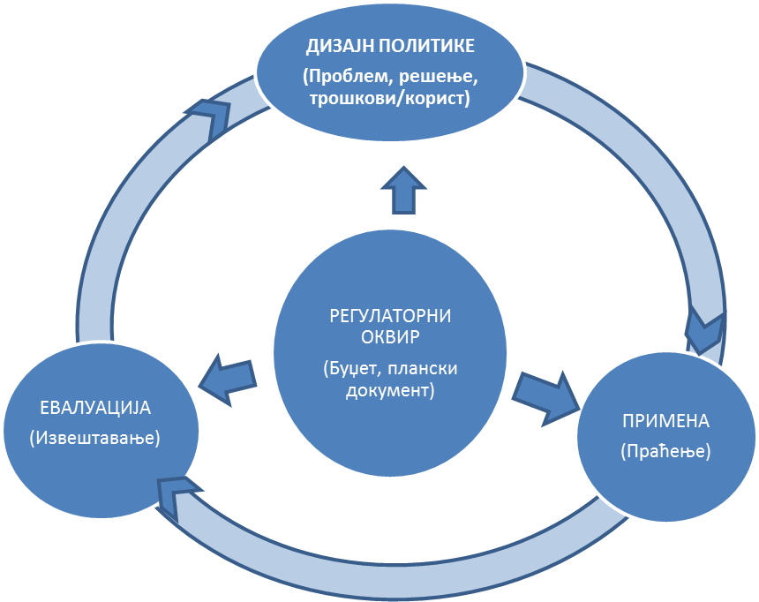

Scheme 2. Creation, implementation and evaluation cycle of public policies

There are rules and procedures set for each of the described phases, and they are usually defined in laws or other regulating mechanisms. In the cases when legal solutions and procedures are not clear, when there is a lack of coordination and communication among institutions, the adverse effects to the policy effectiveness and efficiency are inevitable.

The design process of this Strategy, its concept and contents, are in accordance with the requirements of modern public policy management.

### 1.3.2 Phases of work and participants in the Strategy design process

The process of designing the Strategy of agricultural and rural development in the Republic of Serbia 2014–2024 has been led by the structure of the issues this Strategy addresses, by the profile of the actors whose business activities and future it relates to and by heterogeneous nature of participants in the process of making political decisions relevant for agricultural sector and rural areas.

Activities of the Strategy preparation had a few phases:

*Phase one* During this period, a detailed working concept was prepared and all the organizational and other structures for the Strategy design were defined and established. It involved designing the detailed activities plan with precise definitions of job descriptions, time frames, goals, results; defining the needs for engagement of domestic and foreign experts, defining the organizations, institutions and other key actors in the field of agriculture and rural development that would be involved in the design process of the final document; preparation of the necessary analytical base and documents.

On the basis of the analysis of the national programs and other relevant strategic, scientific and analytical documents and laws, basic statistical data and new guidelines of JAP, the initial contents of the Strategy was prepared, the basic thematic areas and the key goals of the Strategy were defined. In order to ensure the uniformity of the reports and to formulate the clear goals and tasks for Sector working groups (SWGs), the instructions on contents and structure of the sector reports were prepared, that included topics specific for separate sectors. The reports prepared in this manner served as a platform for further work of SWGs (Annex 1).

*Phase two* involved further development of the defined main goals, through their confirmation, addition and further development into specific goals and adequate measures. During this process, SWOT and PESTLE analyses were prepared. All the SWGs workshops were held according to the same model and document basis, in order to reach the uniformity of the whole process.

*Phase three* was the period devoted to adjusting all the opinions and to making the first draft of the Strategy, with the special attention devoted to verification of the general and specific goals and proposed measures and activities. Special attention was paid to making the budget framework in terms of its scope, structure and budget guidelines according to support pillars and budget planning principles for the following period.

*Phase four* involved many consultations and workshops of the expert team and representatives of the Main and expert team of the Ministry, when more detailed budget frameworks were defined and other outstanding issues were addressed. On the basis of their conclusions, the draft of the Strategy was prepared.

*In the phase five* of the process, the prepared Strategy draft was presented to the representatives of the Ministry and chairpersons of the SWGs. All the suggestions and comments were reviewed and incorporated in the final document “Draft Strategy of the Agriculture and Rural Development of the Republic of Serbia 2014–2024".

*In the phase six,* at the end of the process, several public discussions were held where the proposed draft Strategy was presented.

The Main team of the Ministry was established for coordination, monitoring, implementation and evaluation of the activities related to the Strategy design, as well as the relevant groups and individuals (Annex 2), with defined tasks and responsibilities:

1. *Main team of the Ministry of Agriculture –* adopts the tasks and approves engagement of associates, monitors the design of the documents in the key phases, assesses preliminary and final results, participates in public discussions and in promotion of the final document, participates in the administrative procedures related to preparation of the document and implements the Strategy adoption procedure.

2. *Team of experts* – develops the methodology of the sector working groups and sequence of procedures in preparation of the final document; formulates technical instructions for work of the sector working groups; prepares the first draft of the document and processes the comments of the Main team and representatives of the SWGs; prepares the final document.

3. *External experts* – propose the document structure; suggest the ways of incorporating the best international practices and experiences in the area of the proposed solutions; perform the final review of the document.

4. *Chairpersons/Coordinators of the working groups –* purpose the members of the working groups and cooperate with them in preparation of the sector reports; provide information at the request of the team of experts in any phase; cooperate with other coordinators and teams of experts on adjusting the separate reports of the sector groups; are responsible for the final version of the sector working group reports.

5. *The expert team of the Ministry of Agriculture –* actively participates in the activities of the working groups and contributes to the better quality of the final documents; assists to coordinators of the sector working groups; participates in the development of the final versions of the sector working group reports; maintains communication with working group coordinator; prepares the technical report on SWGs workshops; assists public relations service of the Ministry of Agriculture.

6. *Members of the sector working groups*: participate in the consultations in different thematic fields. Members of the working groups are the representatives of the relevant sub-sectors, knowledgeable of the specific issues and areas.

7. *Public relations service –* Ensures the media coverage of the process; prepares reports for internet and other media; prepares the press conferences for the minister.

8. *Process coordinator –* administrative, logistic, organizational and expert support; organization of meetings, workshops, communication process; development and processing of data bases and information.

Methodological approach is based on observing the basic principles of participation and process transparency. The carrier of the Strategy development process is the Ministry of Agriculture, Forestry and Water Management, with its Main team and team of experts, consisted of the representatives of all the relevant organizational units, which ensures the “ownership” of the umbrella institution over this document. The participation of the experts and academia and other stakeholders has been ensured through establishment of the thematic, sector working groups.

The sector working groups belong to three priority areas:

*А – Food production area,*with sector working groups: 1. Crops and vegetable production, 2. Cattle breeding, 3. Fruit and wine production, и 4. Agroindustry;

Б –*Rural development area*, with sector working groups: 1. Environment and natural resources, 2. Diversification of the economic activities and the development of villages, and 3. Small households and fight against poverty;

*В – Creation and transfer of knowledge and technology.*

The SWGs structure reflects all the sub-sectors of agriculture and other parts of the food chain, as well as those parts of development segments identified as bearing the most significant challenges in the following period (Environment and natural resources, Creation and transfer of knowledge and technology, Small households and fight against poverty).

Members of the working groups were also the representatives of the research and scientific institutions, business sector, primary producers, leading associations, project teams, scientific community, local self-governments, Ministry of Agriculture and other Government bodies (Annex 2).

Scheme 3. Phases and activities in the Strategy development process

**Contents of the SWGs report**:  
* Resource analysis  
* Current situation in the relevant segments  
* Institutional and legal framework  
* Support policy  
* SWОТ analysis of the sub-sectors  
* Sepcific challenges in the sub-sectors

Adoption of the Draft Strategy by the Government

Draft Strategy of Agriculture and rural development of the Republic of Serbia 2014-2024

Definition of strategic and operational goals

Design of the national program for the following sub-period

Formulation of the measures and activities to realize goals

**Representatives of the institutions involved in SWGs:**

* Scientific and research community,  
* Associations of producers and processors  
* Civil sector,   
* Institutions from the field of agriculture and rural development

Formulation of budget framework

Piublic discussion  
Participants:  
All the actors involved in the SWGs   
Wider public

Political parties

Decision on launching the process (Decision on establishing a team for Strategy development)

General SWОТ

**Establishing the sector working groups:**

Formulation of the vision

**Sector working groups**:  
1. Crops and vegetable production  
2. Fruit and wine production  
3. Cattle breeding  
4. Agroindustry  
5. Technological development and knowledge transfer  
6. Environment  
7. Rural development

8. Small households and poverty

Reviews, changes

Monitoring of the goals realization

Strategic goals realization

**2. SITUATION IN THE AGRI-FOOD SECTOR AND RURAL AREAS**

**2.1. Macroeconomic Framework and the Importance of Agriculture to the Serbian national economy**

2.1.1. Macroeconomic Framework

In a view of transition reforms, the first decade of XXI century in Serbia can be divided into two phases. During the first phase, most of the privatization and restructuring of the vital parts of the economy was carried out, macroeconomic stability was achieved, market liberalization started, banking sector was consolidated and privatized, the process of joining the EU started, and ​​significant progress was made in all aspects of legislative adjustments. In economic terms, government policy was focused on establishing and maintaining macroeconomic stability and high economic growth.

Second phase of the reform was focused on creating an enabling business environment for investors, reform of the tax system and public sector, creating conditions for establishing public-private partnerships, on reducing gray-economy, as well as on other activities that should help strengthen the credibility of the state. Overall, the reforms undertaken at this stage did not have the same intensity and progress - in some segments reforming had only begun, in other parts the reform process was not continuous, while the progress of some system reforms had gone very far.

Since the second half of the 2008, Serbia begins to face negative effects of the global crisis on the domestic economic and financial markets. The effects of the crisis were primarily manifested in slowing and then declining of economic activity, as a result of the drop in demand on domestic and international markets, as well as reduced inflow of foreign capital. Results of these developments are reflected in reduction of the real GDP, employment and wages, and on the other hand, increased consumer prices and indebtedness. Macroeconomic imbalances affected the fluctuation of the exchange rate, and the weakening of the national currency.

Table 1. The basic macroeconomic indicators of the Republic of Serbia

|  |  |  |  |  |  |  |  |  |  |  |  |
| --- | --- | --- | --- | --- | --- | --- | --- | --- | --- | --- | --- |
|  | **2002.** | **2003.** | **2004.** | **2005.** | **2006.** | **2007.** | **2008.** | **2009.** | **2010.** | **2011.** | **2012.** |
| **Real GDP Growth (%)1** | 4.3 | 2.5 | 9.3 | 5.4 | 3.6 | 5.4 | 3.8 | -3.5 | 1.0 | 1.6 | -1.7 |
| **Consumer Prices (%)2** | 14.8 | 7.8 | 13.7 | 17.7 | 6.6 | 11.0 | 8.6 | 6.6 | 10.3 | 7.0 | 12.2 |
| **Export (MEUR)3** | 3,125 | 3,847 | 4,475 | 5,330 | 6,949 | 8,686 | 10,157 | 8,478 | 10,070 | 11,472 | 11,913 |
| **Import (MEUR) 3** | 6,387 | 7,206 | 9,543 | 9,613 | 11,971 | 16,016 | 18,843 | 13,404 | 14,643 | 16,627 | 17,211 |
| **Unemployment Rate АРС (%)** | 13.3 | 14.6 | 18.5 | 20.8 | 20.9 | 18.1 | 13.6 | 16.1 | 19.2 | 23.0 | 23.9 |
| **Avarage Salary (in EUR)** | 152.1 | 176.9 | 194.6 | 210.4 | 259.5 | 347.6 | 402.4 | 337.9 | 330.1 | 372.5 | 364.5 |
| **Public Debt (in % GDP)4** | 72.9 | 66.9 | 55.3 | 52.2 | 37.7 | 31.5 | 29.2 | 34.7 | 44.5 | 48.2 | 59.3 |
| **Exchange Rate RSD/USD5** | 64.29 | 57.56 | 58.45 | 66.87 | 67.03 | 58.39 | 55.76 | 67.47 | 77.91 | 73.34 | 88.12 |
| **Exchange Rate RSD/EUR 5 ()** | 60.69 | 65.12 | 72.69 | 82.99 | 84.11 | 79.96 | 81.44 | 93.95 | 103.04 | 101.95 | 113.13 |
| **GDP (in MEUR)** | 16,028 | 17,306 | 19,026 | 20,306 | 23,305 | 28,468 | 32,668 | 28,954 | 28,006 | 31,472 | 29,932 |

1) Constant prices of the previous year;

2) Retail prices until 2006;

4) External and Internal;

5) The average of the period;

Source: The National Bank of Serbia

2.1.2. Importance of Agriculture in the National Economy

During the transition period, there were no significant changes in the economic structure in Serbia. Since early 2000, the contribution of agriculture in GDP was declining, primarily as a result of faster growth in activity in the non-manufacturing sectors (primarily in trade). However, the share of agriculture in GDP of the Serbian economy is still very high and in 2012 it was 10.1%. Comparing to the average of EU-27 countries, Serbia has a significantly higher share of GDP coming from the agricultural sector in total GDP, and significantly lower share of the service sector. The high share of agriculture in the basic macroeconomic aggregates in Serbia, in comparison to other countries, can be attributed to the rich land resources and favorable natural conditions for agricultural production, and on the other hand to slower process of structural reform in the rest of the economy and delays in that process.

Table 2. Macroeconomic indicators of agricultural contribution to the national economy

|  |  |  |  |  |  |  |  |  |  |  |  |  |
| --- | --- | --- | --- | --- | --- | --- | --- | --- | --- | --- | --- | --- |
|  | **Unit** | **2002** | **2003** | **2004** | **2005** | **2006** | **2007** | **2008** | **2009** | **2010** | **2011** | **2012** |
| **- GDP of agriculture (in current prices)** | mil. EUR | 2.072 | 1.918 | 2.186 | 2.024 | 2.189 | 2.443 | 2.916 | 2.320 | 2.379 | 2.873 | 2.624 |
| **- GDP of agriculture in total GDP** | % | 14,8 | 13,1 | 13,5 | 11,8 | 11,0 | 10,1 | 10,4 | 9,3 | 9,9 | 10,5 | 10,1 |
| **Employment in agriculture, forestry and fishing (A)** | | | | | | | | | | | |  |
| **- number** | 000 | : | : | : | 839 | 707 | 725 | 674 | 622 | 523 | 466 | 467,1 |
| **- share in total employment** | % | : | : | 23,2 | 22,7 | 20,2 | 20,3 | 23,9 | 23,8 | 22,2 | 21,2 | 21,0 |
| **Trade in agricultural products** | | | | | | | | | | | |  |
| **- export of food and ag products** | mil. EUR | 555 | 509 | 629 | 732,0 | 992 | 1.218 | 1.328 | 1.381 | 1.672 | 1.920 | 2.094 |
| **- share in total export** | % | 25,3 | 20,9 | 22,2 | 20,3 | 19,4 | 18,9 | 17,9 | 23,2 | 22,6 | 22,8 | 23,7 |
| **- import of food and ag products** | mil. EUR | 578 | 577 | 688 | 622 | 721 | 600 | 754 | 711 | 896 | 1.001 | 1.138 |
| **- share in total import** | % | 9,8 | 8,8 | 8,0 | 7,4 | 6,9 | 4,4 | 4,6 | 6,3 | 7,2 | 7,0 | 7,7 |
| **- trade balance of agriculture and food industry** | mil. EUR | -23 | -67 | -59 | 110 | 271 | 618 | 574 | 670 | 776 | 919 | 956 |
| **Coverage of import by export** | % | 96,0 | 88,2 | 91,4 | 114,8 | 137,6 | 201,7 | 175,2 | 194,2 | 186,6 | 191,8 | 184,0 |

Source: RSO

However, absolute employment in agriculture is recording high rate of reduction (the 2012 compared to 2004 was lower by 56%), the share of employment in agriculture in total employment in Serbia is still very high, among the highest in Europe, approximately 21%. Contrary to expectations, since the beginning of the economic crisis, employment was being reduced in agriculture, which, as a rule, in the conditions of crisis absorbs surplus labor force from other sectors. This can be explained by the high proportion of employees in seasonal and temporary jobs in agriculture, which are very sensitive to fluctuations in the labor market during the crisis.

Since 2005, foreign trade exchange of agricultural products and foodstuffs in Serbia has positive and growing balance. The share of agri-food products in total exports reached about 23%, and from 2005 to 2011 it had increased by additional 7 percentage points. Imports of agricultural and food products account for about 7% of total imports, and since 2005 is increased by less than one percentage point.

**2.2. Condition of Resources and Environment**

2.2.1. Land

***Size, Structure and Quality of Land Resources***

Republic of Serbia has 5.05 million hectares of agricultural land, out of which 73% of the area are used in the intensive way (in terms of arable land, orchards, and vineyards), while 29% of agricultural land consists of natural grasslands (meadows and pastures). The main part of the agricultural land, or 3.279 million hectares, respectively 65%, is used in the form of arable land, out of which about 7% is not used in one year (it remains in the form of fallow or uncultivated land). In addition to the areas that are left as fallow, significant part of the area under meadows and pastures is not used due to the inaccessibility, weediness or due to economic unprofitability. It is estimated that each year between 200 and 350 thousand hectares of arable land and meadows are not used, while the area of ​​unused farmland with pastures is significantly higher.

Table 3. Size and structure of agricultural land in Serbia (000ha)

|  |  |  |  |  |  |  |  |  |
| --- | --- | --- | --- | --- | --- | --- | --- | --- |
|  | **2005** | **2006** | **2007** | **2008** | **2009** | **2010** | **2011** | **2012** |
| **Agricultural land, total** | 5074 | 5066 | 5053 | 5056 | 5058 | 5052 | 5056 | 5053 |
| **- arable land** | 3.326 | 3.315 | 3.295 | 3.298 | 3.298 | 3.292 | 3.291 | 3.279 |
| ***Of which uncultivated*** | 194 | 248 | 200 | 199 | 209 | 226 | 224 | 219 |
| **- Land under permanent crops** | 305 | 302 | 301 | 301 | 300 | 299 | 298 | 294 |
| ***Оf which: orchards*** | *239* | *238* | *240* | *242* | *240* | *240* | *240* | 239 |
| ***vineyards*** | *64* | *62* | *59* | *58* | 58 | 58 | 57 | 54 |
| **the rest *(nurseries)*** | 2 | 2 | 2 | 1 | 2 | 1 | 1 | 1 |
| **- Permanent grasslands** | 1.441 | 1.448 | 1.455 | 1.454 | 1.459 | 1.459 | 1.,460 | 1.478 |
| ***Оf which: meadows*** | 609 | 610 | 620 | 621 | 625 | 625 | 624 | 641 |
| ***pastures*** | 832 | 838 | 835 | 833 | 834 | 834 | 836 | 837 |
| **- Оther agricultural land** | 2 | 1 | 2 | 2 | 1 | 8 | 2 | 2 |

Source: RSO

By the size and structure of available farmland, Serbia is among European countries with favorable land resources, for it has 0.7ha of agricultural, that is 0.45ha of arable land per capita. At the same time, the ratio of area of ​​arable land and permanent crops to pastures and meadows (71:29%) is among more favorable ones compared to the other European countries.

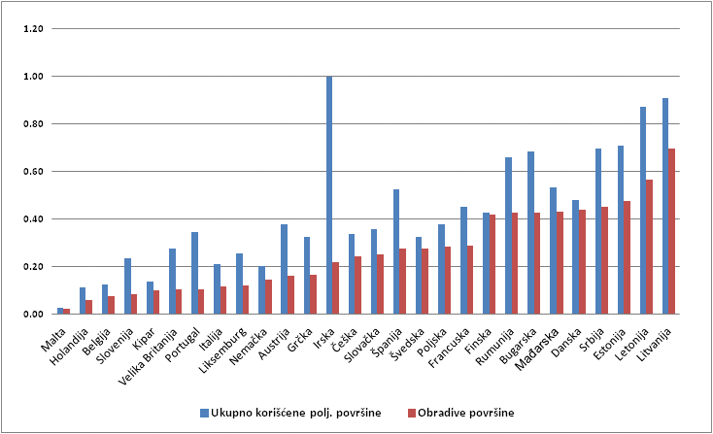

Arable land

Used agricultural land, total

Chart 1. The total area of ​​arable land and permanent crops per capita in Serbia and EU countries (ha)

Source: RSO and EUROSTAT

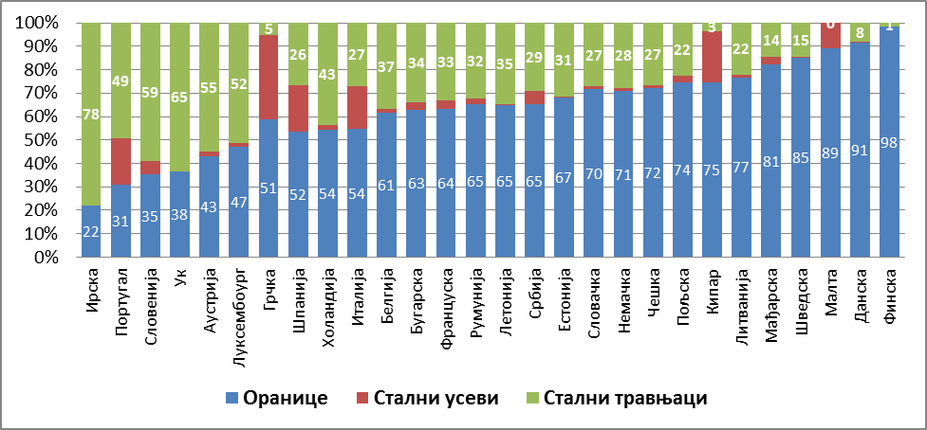

Permanent grassland

Permanent crops

Arable land

Chart 2. Structure of agricultural land, Serbia and EU countries (%)

Source: RSO and EUROSTAT

Land in Serbia is very diverse, as a result of high heterogeneity of the geological structure, climate, vegetation and micro-fauna. Two-thirds of the agricultural land is in the areas where, thanks to favorable distribution of rainfall, crops growing season can last more than 200 days a year. About 45% of agricultural land is agricultural land suitable for cultivation without significant restrictions, while the rest makes agricultural land generally not suitable for cultivation or it can be cultivated with considerable limitations.

The main threats to soil quality, represented by intensity, are: the closure of the soil structure, reduction of organic matter, soil acidification, contamination and erosion. Approximately 88% of the total land area in Serbia is exposed to water erosion, while wind erosion affects about 25% of Serbian territory. Large part of the arable land is acidic (more than one quarter), as a result of uncontrolled use of chemicals, while in Vojvodina part of the area is even saline (14%).

Built irrigation systems cover area of ​​250.000ha, but only 30,000-70.000ha is currently irrigated per year (irrigation systems that have all the permits and pay for water for irrigation), of which 90% is located in Vojvodina; another 47.000ha functions only partially. Area of arable land that is irrigated without permission is two to three times bigger.

Systems for protection against harmful effects of external high water protect 1.25 million hectares of agricultural land. About 2 million hectares of the total land fund are drained (protection from the harmful effects of inland water) through 390 drainage systems, with over 24,000 km of canal network, 210 major and several dozen smaller pumping stations, and 252 gravity drains. In the most vulnerable soils of low areas, in the alluvial plains of large watercourses of Tisa, Begej and Tamiš rivers, density of the canals network is approximately 10-14m/ha. In the Danube area density of canal network is about 10.6m/ha. Horizontal drainage pipes system was built on about 54.000ha. It is mostly in Banat, a little bit less in Bačka, and the least in the Morava River sub-basin.

***Ownership Structure***

According to the Census in Agriculture from 2012, there are 631.522 households in Serbia, which use 3.437 million hectares of agricultural land and have an average holding size of 5.44ha. Among the enumerated holdings, 99.6% of households are individual holdings, and they use 84% of the area. The average size of the individual holding is 4.5ha, and varies greatly by the region - from 2.1 ha in Jablanica district to 10.0ha in Central Banat District. The remaining 0.4% of households is owned by legal entities; they are using 16% of the area and have an average farm size of 210 ha per farm.

Due to the incomparability of data obtained from the last two Censuses (2002 and 2012), at the moment we cannot keep track of changes in the structure of the holdings in the last decade. In general, it can be concluded that there has been an ongoing process of concentration of farms by the size of holdings, which is more pronounced in Vojvodina comparing to the rest of the country. Farms of size over 20ha have 3.1% of the total listed households in Serbia, which use 44% of registered agricultural land. On the other hand, households that use up to 5ha of agricultural land make 77.7% of the total number of registered farms, and they use 25.3% of the total used agricultural area. This ownership structure (including a large number of small-sized farms) is a typical model for agriculture in the Southern European countries. However, in Serbia there are some differences comparing to neighboring countries, with respect to increased share of farm size of 2-10ha in the total number of farms and the used area (35.3%).

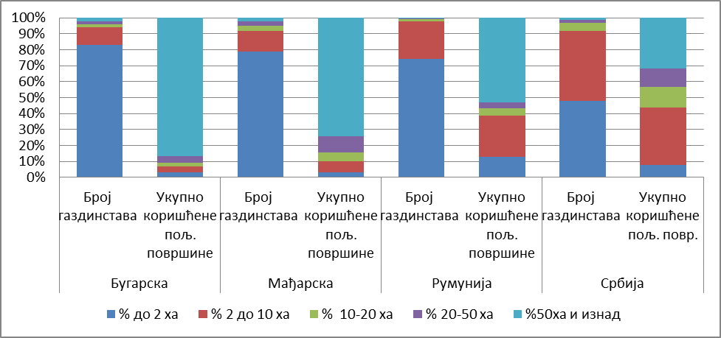

**Number of**

**households**

**Number of**

**households**

**Number of**

**households**

**Serbia**

**Romania**

**Hungary**



**Used agricultural land, total**

**Used agricultural land, total**

**Used agricultural land, total**

**Used agricultural land, total**

**Number of**

**households**

Chart 3. Household structure in Serbia and EU countries

Source: RSO and EUROSTAT

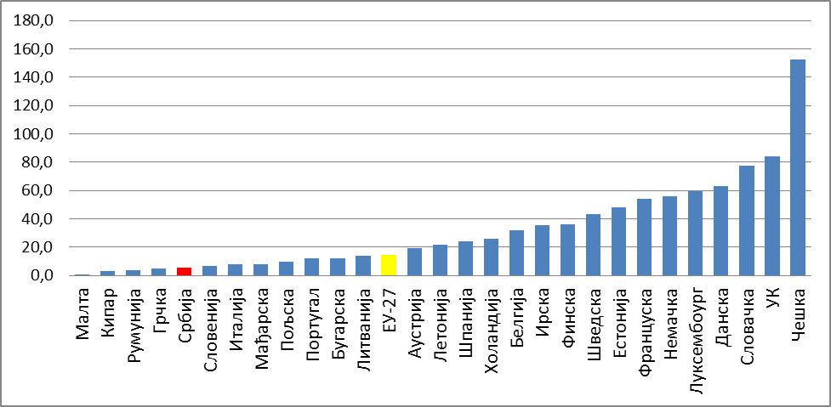

Chart 4. Average household size in Serbia and EU countries (ha)

Source: RSO and EUROSTAT

In addition to the relatively small average size of holdings, an important limitation for more effective land use is fragmentation, fragmentation of holdings, which is reflected in the fact that the average number of lots per household is about 4 (according to the results of 2002 Census). By 2006, land consolidation in Serbia was conducted at 1.445 million of hectares of agricultural land, out of which 77% is agricultural land in Vojvodina. In the same period of time, regrouping covered about 300.000ha. From 2006 to 2013 consolidation of agricultural land covered about 166.256ha, on 93.796ha process is completed or is in the final stages, while the 64.890ha are in the preparatory phase.

***Land Market***

An important prerequisite for the development of agriculture is developed market of agricultural land. Securities of ownership and rental, and use of agricultural land, are the most important prerequisites for a well-functioning land market. Creating single register of real estates for the territory of the Republic of Serbia is an important contribution to safe trade of agricultural land, although tardiness of this data presents certain difficulty in this trade.

According to the data of the Treasury, in the 2012 the register of agricultural holdings had enrolled total of 2,480 million hectares, out of which total of 773.603 hectares was under lease. Of these, about 40 % is publicly owned agricultural land. These data show that the market of agricultural land, primarily of agricultural land under lease, is active. The turnover of agricultural land among all individuals is free, while there are limits concerning to prohibited acquisition of property for foreigners, prohibited alienation of public property and certain limitations in alienation of socially owned agricultural land. The Law on Restitution and Compensation completed the legal framework in terms of return of agricultural land.

Obstacles to effective use of land resources are primarily division and fragmentation of holdings, lack of infrastructure, lack of favorable credit lines, inadequate tax policy, social insecurity of land owners and the possibility that owners of agricultural land are not farmers (land owners do not have a steady job, pay small tax on agricultural land, so they do not want to sell it), unfinished process of restitution and relatively lengthy procedures of inheritance disputes.

***Policy for Managing Agricultural Land Publicly Owned by the Republic of Serbia***

Agricultural land publicly owned by the Republic of Serbia is administered by the ministry in charge of agriculture (MoA). The main objectives of managing the agricultural land in public ownership of the Republic of Serbia are efficient use of the land in accordance with the principles of sustainability, increased possession of agricultural households and land consolidation. Agricultural land in public ownership of the Republic cannot be alienated, but it is used in procedures such as: lease for a period of 1 to 40 years; available for use free of charge in accordance with the law; restitution; use in the procedures for consolidation; transfer of rights of public ownership of the Republic to the public property of the local government, in order to build economic zones, i.e. public ownership of other government bodies, organizations and companies; granting rights to public service.

Significant limitation of the effective management of publicly owned agricultural land is the lack of information systems on agricultural land. According to information available to the MoAg, the total area of publicly owned ​​agricultural land of the Republic of Serbia is 923.004 hectares (including meadows and pastures that have been returned to the rural communities for use), out of which arable land makes 529.295 hectares. In 2013 a little more than 320.000 hectares of publicly owned agricultural land is under lease. One part of these areas is not the subject of lease, since there has was a change compared to data from a single register (due to changes of land owners, changes in land use, the land was subject to restitution, due the court decisions, etc.).

2.2.2. Perennial Plantings

The Republic of Serbia has favorable soil and climate conditions for the production of different fruit and grape varieties. Importance of this production is in the fact that it allows better use of the land at various locations and areas with less favorable soil and climate conditions, including soils of poorer physical, chemical and other properties, as well as areas with steeper slopes.

Orchard areas are approximately 240.000ha, while there are about 58.000ha of vineyards. Observed by regions, most of the orchards are in the areas of Southern and Eastern Serbia (30.51%) and Šumadija (55.11%), which is the largest area under vineyards as well (53.32% and 24.69%, respectively)

According to Census data, the area under orchards covers around 163.310ha, out of which 98.575ha are plantations and 64.735ha are the extensive plantations, and vineyards are on around 22.150ha. According to the same source (Agricultural Census 2012), in the structure of plantations the most represented ones are prunus species (including plum with 45.4% and cherry with 9.5%), followed by apple-like fruits (apple with 15%) and berry fruits (raspberries with 6 8%). Plantations of nuts are very small.

The general assessment is that the existing plantations are mostly extensive, since a large portion of orchards and vineyards are over 20 years old, and in heyday of the exploitation period. Thanks to the initiative of the private sector, the expansion of the newly planted plantations, with modern production technology, is noted. This is primarily related to the apple, cherry and strawberry. New varieties are introduced for all fruit species, although the remaining obstacle is lack of certified and quality planting materials, and inadequate agro-technical measures. Fruit production in protected areas is negligible. Exceptions are areas (mainly apples) under hail nets, as well as different types of indoor strawberry production. In addition to these examples, other aspects of production in protected areas are almost nonexistent.

Serbia has favorable climate, soil and other conditions for grape vine growing, which are reflected in the existence of three vine growing regions, 22 vine growing counties and 77 vine growing districts. Although there is a great potential for cultivation of grape vine, the economic crisis and loss of markets in the 1990s had led to large reduction of the area under grape vines. Vineyard areas are characterized by highly fragmentized plots, since the average size of vineyard in Serbia is only 0,275 hectares. According to the Census of Agriculture from 2012, 80.445 households cultivate 22.150 hectares of vineyards, out of which 27.224 households have vineyards of total area of ​​less than 10ars. Such fragmented structure of plantations significantly increases the total cost of grape production.

Thanks to harmonization of legislation with EU requirements, introducing vineyard geographical production areas, transformation of the geographic origin system and favorable measures to support winegrowing, over the past few years modern vineyards are being raised mostly with wine varieties for production of high quality wines (Chardonnay, Sauvignon Blanc, Riesling, Cabernet Sauvignon, Merlot, Pinot Noir and other). Investors are mainly small family wineries. At the same time, number of processor is constantly growing (currently 75), as well as wines with geographical indications (214 wines are in the system of geographical origin). There is an increased interest in in raising plantations with high quality and authentic regional varieties (Prokupac, Muscadine, Skadarka and others) and locally created varieties (Probus, Sila, Morava and others), which all contribute to the improvement of viticulture Serbia .

2.2.3. Livestock

Serbia has favorable natural conditions for the development of livestock farming, given that it has over 1.4 million hectares of permanent grassland of high quality and significant unused buildings for the accommodation of cattle and sheep. Nevertheless, this part of agriculture records negative trend for the third decade in a row. Just over the last ten years, the number of livestock units per hectare of agricultural land decreased from 0.34 to 0.27.

Table 4. Number of livestock units in the Republic of Serbia (in 000)

|  |  |  |  |  |  |  |  |  |  |  |  |
| --- | --- | --- | --- | --- | --- | --- | --- | --- | --- | --- | --- |
|  | **2002** | **2003** | **2004** | **2005** | **2006** | **2007** | **2008** | **2009** | **2010** | **2011** | **2012** |
| **Total** | 1516 | 1553 | 1529 | 1571 | 1631 | 1602 | 1578 | 1540 | 1475 | 1442 | 1437 |
| **Cattle** | 921 | 913 | 904 | 917 | 891 | 882 | 863 | 817 | 765 | 766 | 755 |
| **Horse** | - | - | - | - | 17 | 17 | 15 | 13 | 13 | 10 | - |
| **Pigs** | 384 | 411 | 395 | 415 | 477 | 447 | 443 | 454 | 436 | 413 | 395 |
| **Sheep** | 138 | 152 | 154 | 158 | 160 | 167 | 168 | 156 | 153 | 150 | 168 |
| **Goats** | - | - | - | - | 12 | 11 | 12 | 11 | 11 | 10 | - |
| **Poultry** | 73 | 77 | 76 | 81 | 74 | 78 | 77 | 89 | 97 | 93 | 118 |

Source: RSO

Regional differences in trends and systems of livestock production are big. The usual order of the relative importance of certain types of livestock is cattle-sheep-poultry-pig. In Vojvodina and valley areas the order is reversed. Ownership structure, the structure of used agricultural land, the predominant household model and other, have led to the order of importance of certain types of livestock in this area to be: swine-poultry-cattle-sheep.

The largest part of livestock production is carried out on a large number of small farms, but in the last ten years, concentrations of certain productions are noted (poultry and pig) in holdings of legal entities and large individual holdings. According to the Census of Agriculture from 2012, 20% of pigs and 37% of poultry are bred on farms of legal entities. Numerous of small producers, who are primarily engaged in a production for their own needs, are an obstacle to intensive production development. Small producers traditionally apply low intensive production systems based on locally adapted breeds.

The livestock breed composition is not satisfactory, and development of the sector is largely conditioned by import of breeds and hybrids from countries with developed livestock production. In cattle production, domestic spotted cattle of Simmental type is dominating, while Holstein breeds and pure Simmentals are much less represented. Representation of beef breeds is negligible. Domestic breeds dominate in domestic production, which include different lines of “pramenka” and Tsigaja, while foreign breeds are Wuerttemberg and Ile de France. There are frequent cases of unplanned crossing, without getting new traits, but significantly losing existing recognizable breed traits. In poultry production, the development of the industry completely relies on imports of broiler breed hybrids and light lines of laying hens intended for egg production. Also, in pig production the best results give crossbreds and hybrids imported from countries with developed agriculture.

Special significance in livestock structure, as well as in total agricultural production, have cattle and sheep productions. Sheep and cattle are also important from the point of herd renewal, offspring production as basis for breeding and reproduction, revitalization of traditional production systems in hilly and mountainous areas and the preservation of their biodiversity. In addition, there are capacities for more than 120,000 heads of young cattle for fattening and abandoned facilities of large farms for sheep production.

***Cattle Breeding***

Cattle production is the most important part of livestock production in Serbia, primarily for small and medium-sized family farms. Most of the animals that enter supply chain come from a herd size of 5-8 animals. Households with less than 3ha with one cow on average, in the total number of cattle, account for about 25%. It is estimated that about 250,000 farms with a herd of 1-5 cows make 95% of the total number of cattle, 89% in the number of cows, 68% of milk production and provide 59% of milk delivered to dairies[8]. Households with more than 50 cows account for less than 1% of the total number of herds, 5% of the total number of cows, produce 11% of the total milk produced and contribute with 14% of the total delivered amount of milk to dairies. Much of the production in this group of large manufacturers comes from large corporate farms with more than 200 cows. Group of farms with 20-50 cows and with growth potential and marketability is still very small, and has fewer than 500 households[9].

***Sheep and Goat Production***

Sheep production in Serbia has a long tradition and strong regional component. There is a high concentration of sheep in the highland areas (above 300m above sea level), particularly in Eastern and Southern Serbia, where different lines of “pramenka” is sheep dominant breed. In addition, there are about 20 local recognized breeds, as well. In Vojvodina, in recent years, the traditional breeding of tsigaja breed is replaced with Württemberg breed or crossbreed of Württemberg with other breeds. Also, some modern fattening sheep breeds are being increasingly used, such as Ile de France. Production is based on extensive pastures that are not suitable for other types of agricultural production.

Goats are extensively bred in the mountainous areas, although there are tendencies towards production intensification. In breeds’ composition, the prevailing is Balkan type goat (50%), then various crossbreeds (about 30%), domestic white goat (15%), while the rest belong to Sana and Alpino breeds.

***Swine Production***

In commercial industrial production, pigs are bred in large herds, where in 80% of cases the number of animals is over 1.000 per herd. Larger commercial production makes up 45% of the total pig production, while the rest is grown in small herds on small family farms. In large commercial enterprises production is carried out through the system of breeding pyramid, so that in every company there is a nucleus, the reproductive part and commercial part of the herd. Most prevalent breeds in Serbia are Landrace and Yorkshire, as well as a number of terminal meat breeds (Duroc, Hampshire and Pietrain).

***Poultry Production***

In the last decade the total number of poultry has reversed trend compared to other livestock sectors, recording continuous growth. The commercial production of poultry (broilers) is concentrated in a few large companies, with modern slaughterhouses, as well as on numerous small farms. Production on small family farms makes up a large percentage of the total production. Many of these small farms produce poultry products for their needs, and occasionally sell them through out-of-market channels.

***Beekeeping***

According to the 2012 Agricultural Census there were 673.000 beehives in Serbia. Existing bee grazing is only 5%, but the sector generally shows signs of growth in the number of households engaged in the production, as well as the number of hives that they possess.

***Aquaculture***

Aquaculture is done in carp and trout ponds. Trout fish farms are located in hilly and mountainous regions, while carp farms are located in the plains. The growth of aquaculture production is influenced by the fact that the ponds were privatized, which had resulted in the rationalization of operations and better control of fish production, followed by the improvement of breeding technology, which was reflected primarily in improved nutrition. Potential to increase trout production is limited with the resource of clean water flows, while the potential for the development of carp production is almost unlimited.

2.2.4. Mechanization, Equipment and Facilities

Expressed in the number and power of the tractors, Serbian agriculture well mechanized from the standpoint of mechanical traction. However, this is not the case with the machinery for seedbed preparation and planting, as well as specialized agricultural machinery intended for fruit and viticulture and vegetable production. Households have on average 0.64[10] double-axle tractor, and the average agricultural used land cultivated with their own two-axle tractor is 8.5ha. Medium and small farms are equipped with second-hand machinery, which is technologically obsolete comparing to holdings in the countries with developed agriculture. Farmers in Serbia mostly use equipment of lower grip, with relatively higher fuel consumption and losses in handling (more harvest losses), which further affects the increase of production costs.

Amenities of facilities for cattle are very uneven and primarily determined by the degree of specialization and herd size. Over the last decade, large farms had significant investments in standards’ improvement, construction and expansion of existing capacities. These facilities are technically well equipped to fulfill the requirements of the standards for animal welfare. Nevertheless, manure management and storage remains one of the key problems for most of the large, and for some small producers. Compliance with veterinary and sanitary requirements and general and special hygiene conditions of food of animal origin is the basis for the placement of meat and meat products in the international markets.

2.2.5. Labor force

According to preliminary results of the 2012 Census, the number of members and full-time employees on farms in the Republic of Serbia is 1.44 million people. Of this number, about 98% are farm owners and members of their households, and only 1.9% of persons are regularly employed in agriculture.

Таble 5. Household members and fully employed persons at households (000)*

|  |  |  |  |
| --- | --- | --- | --- |
|  | **TOTAL** | **Women** | **Men** |
| **Republic of Serbia – total** | 1.442 | 615 | 827 |
| ***On family households*** | 1.416 | 609 | 808 |
| ***On households owned by legal entities*** | 26 | 7 | 19 |

*Ag Census Preliminary Data

Source: RSO

Expressed by the number of annual work units (AWU), the number of employees in the agricultural sector is 646.283 people. Of these, approximately 40% of AWU realize people who are 100% engaged in agriculture, while about 28% of AWU is formed by persons who are engaged in agriculture occasionally (less than 50% of working time). Of the total amount of AWU, 91% is work done by household holder, i.e. members of their households (44:47%), 4% work full-time employees and 5% seasonal workforce.

Regional distribution of the total work is very uneven, and shows that the largest number of farms and full-time employees on farms are in the Central and Western Serbia, which are normally characterized by lower average holding size and larger agricultural population. It is also an area in which the structure of agriculture is oriented towards labor-intensive sectors, such as fruit, vegetable and livestock productions.

Preliminary results of the Census indicate that the level of qualifications of the farms/household managers for agricultural activities is not particularly high. The data indicate that 60% of household administrators gained experience only in agricultural production, 2.5% have completed high schools of agriculture and 1.4% graduated from the Faculty of Agriculture. Only 3% of household managers received some kind of education and training during the census year.

Unresolved social status of workers in agriculture makes farmer job less interesting, insufficiently attractive and not competitive compared to other jobs in the rural labor market. Pension insurance of active farmers is not systematically resolved; therefore, social security of workers in agriculture is relatively unfavorable compared to other labor categories. Records of the number of agricultural workers socially insured is unreliable, but it is estimated that only one of five active farmers is insured, mostly property owners. Seasonal workers and those employed as supernumeraries on the farm, usually do not have social security, what additionally highlights the informal status of their work engagement.

Publication of the final Census results will reveal the data on the age structure of employees in agriculture, which is one of the most delicate questions in the sector. This problem is important both in terms of the social structure in rural areas, and in terms of human resources capacity for the adoption of new technologies, changing the production structure, etc.

2.2.6. Natural Conditions and Environment

***Climate***

Serbian climate is moderately continental, with more or less localized variations. Spatial distribution of climatic parameters determined by the geographical location, relief, large-scale air pressure distribution, terrain exposure, presence of river systems, vegetation, urbanization, etc. Of geographic characteristics of Serbian climate, we should mention the Alps, the Mediterranean Sea, the Pannonia Plain and the valley of the Morava River, as well as the Carpathians and Rhodope Mountains and hilly and mountainous region, with its valleys and highland plateaus.

Average annual air temperatures range from 3°C in areas over 1,500 meters above sea level and 12°C in plain areas. Annual precipitation on average increases with the altitude. General trend of decreased amount of rainfall from west to east is noted. Lowest annual amount of rainfall is recorded in sub-basins of the rivers of South and Great Morava Rivers, as well as on the territory of Vojvodina. Most of Serbia has continental regime of rainfalls, with higher amounts in the warmer half of the year, apart from southwestern areas which have the most rainfall in autumn.

***Waters***

Due to high amount of annual rainfall, Serbia is an area rich in springs and water streams. Although water supplies for people and animals are not compromised, water quality in all areas is not satisfactory. In addition, the water is not used for irrigation of agricultural crops, which is reflected in their yields, especially in dry seasons and arid areas.

Natural quality of ground waters in ​​Serbian territory is quite uneven, ranging from excellent quality, to the water of such quality that requires very complex treatment prior to use through public water supply. Key sources of pollution are untreated industrial and municipal wastewater, drainage water from agriculture, water from landfills and pollution caused by river transportation and operation of power plants. The Danube-Tisa-Danube Canal and secondary irrigation and transportation canals in Vojvodina are highly polluted due to discharge of untreated industrial and municipal wastewater and drainage water from agriculture. Pressure on groundwater resources is also uncontrolled use for irrigation purposes, for both small and large agricultural areas.

Less than 10 % of the population is covered by some form of wastewater treatment, while less than 5 % of the population has access to adequate wastewater treatment. There is an apparent difference in the amount of population connected to the sewerage system in relation to being connected to water supply, which is a particular threat to groundwater pollution with specific parameters of water quality, such as nitrates. This primarily applies to farms and businesses in the northern part of Serbia (Vojvodina and Mačva). In addition, intensive livestock production and manure participate in emissions of carbon dioxide, methane and other greenhouse gases. For now, there are no regulations that would define nitrate-vulnerable zones, or the decision to initiate determination of zones affected by nitrates.

***Biodiversity***

The area where Serbia is positioned is characterized with large genetic, species and ecosystem diversity. High mountains and mountainous region of Serbia, as part of the Balkan Peninsula, is one of six European biodiversity centers. In addition, Serbia, due to rich flora, is potentially one of the global centers of plant diversity. Heterogeneity of flora and fauna is highly expressed, for widely prevalent species can be encountered, as well as endemic species (Balkan, local and steno-endemic).

In Serbia, there is no centralized database or coordinated system of biodiversity monitoring at the national level. Level monitoring of biodiversity is incomplete and fragmented. The quality and quantity of data are very diverse, they are not standardized and they are often not comparable with data from other European countries.

Genetic resources in Serbia are very rich and include large number of indigenous varieties and breeds of cultivated plants and animals:

*Plant genetic resources* It is estimated that all local agricultural institutions are keeping around 15,000 samples of cultivated plants in the form of seeds and 3,500 samples of fruit trees and vines, originating mainly from Serbia and other Western Balkan countries. National ex situ collection of plant genetic resources, which is managed by the Bank of Plant Genes, contains total of 4,238 samples, and in nature, in situ, there are about 1,000 wild relatives of cultivated plants. In addition, Serbia officially registered more than 400 known species of medicinal plants, some 150 plant species are protected by the law from use and trade, and there is a great potential of plant species (about 1,800 honeybee species) and ecosystems, as well as habitats for pollinators (bees, bumblebees ) which are used in agriculture.

*Animal genetic resources* In Serbia, large number of exotic and 30 indigenous breeds is registered, under 15 species of domestic animals, and on their conservation is actively working. Population of indigenous breeds in Serbia is stable, with a slight upward trend. Preserving semen and embryos of animal genetic resources is not yet organized, but there is preservation of live animals.

*Forest genetic resources* Forest ecosystems consist of 282 tree species, of which about 250 are indigenous. Of particular importance is the presence of 88 wild fruit tree species in 18 genera. The most common are two types of beech and oak. As a form of in situ protection of genetic diversity of forest tree species, as well as for the purpose of their direct use, 212 seed stands were set aside (58 coniferous and 154 deciduous species) in the total area of ​​1.865ha. Animal biodiversity of forest ecosystems is characterized by the presence of 46 species of amphibians and reptiles, 350 species of birds and 94 species of terrestrial mammals.

Despite the efforts and commitment of the responsible institutions in the conservation of biodiversity and natural areas through the ratification of international treaties, the adoption of a national legal framework and the establishment of large number of protected areas, Serbia still faces difficulties in the implementation of policies and strategies in this area. The reason can be found in the lack of financial resources and lack of appropriate institutional structures in the field of biodiversity conservation, as well as the lack of monitoring and information systems.

***Forestry***

*Resources of forest species* Serbia has 2.25 million hectares of forests, which make 29.1% of the total area. Most of the forest (53% of the area) is state property. Forest condition is unsatisfactory, as the extent of forest coverage, which lags behind the optimum of 41.4%[11] of the total area of ​​Republic of Serbia, and the total insufficient values of timber volume and volume increment. This condition is characterized by the following:

unfavorable structure based on origin and growing form, dominated by forests of coppice origin (2/3 area of ​​forest with barely half of potential inventory and growth that have natural high forests;

on 29% of the covered area thin and devastated forests are spread, that is incomplete and interrupted forests with annual production of wood of only 3.1 and 1.4 m3/ha;

extremely unfavorable age structure of natural high forests;

absence of natural regeneration on significant part of high forests surface;

poor health conditions, which is intensively expressed particularly in chronic forest drying process;

unfavorable ratio of round technical wood and spatial (fuel) wood is 33.5 : 66.5 %;

insufficient density and unbalanced schedule of forest roads ;

other forest resources and forest habitats (non-timber forest products and biomass) are not utilized to the possible extent.

***Agricultural Areas of High Natural Value (HNVF)***

The Republic of Serbia has taken first steps in identifying agricultural areas of high natural value. According to the Agency for the Environment, HNVF surface of Serbia stretches to 1,187 million ha, which corresponds to a rate of about 19​​% of all agricultural land and 13% of the territory of Serbia. The dominant types of agricultural land of high nature value are grasslands (about 1 million hectares). Most of the areas are semi-natural grasslands, formed in the forest area (as a result of deforestation), while the natural or primary ones appear in places such as high mountains (above timberline), flooded land in the valleys and plain steppes and/or saline habitats in the Vojvodina[12].

Preliminary estimate is that in Serbia exist 10 types of valuable areas associated with agricultural systems. These areas are HNVF:

Deciduous forests with high proportion of grassland;

Winter nomadic pastures in sinantropic habitats and stubble;

Semi-natural and artificial meadows which are used for hay production;

Semi-intensive grazing on mountainous semi-natural grasslands in the area of ​​forests and on natural grasslands above the forest line;

Extensive nomadic grazing of mountainous pasture;

Extensive grazing at rural outlets;

Combined use of mountain grasslands;

Deciduous trees pruned to produce dry leaves;

Extensive grazing on light, salty or heavy soils;

Grazing on wet meadows in lowland areas.

***Areas With Difficult Working Conditions in Agriculture (POURP)***

MoAg has recognized the need to acknowledge, through support system, difficult working conditions that exist in certain areas of Serbia. Detailed assessment of resources and working conditions in these areas is not done, but it is defined by the Rule Book on areas with difficult working conditions in agriculture[13]. This Rule Book identifies settlements that meet one of the three criteria provided for classification of settlements in POURP:1) the settlement is situated at an altitude of over 500 meters , 2) it is located within the boundaries of the National Park , and 3) have less than 100 employees per 1000 inhabitants. According to these criteria, POURPs are identified on the territory of 91 municipalities.

***Animal Welfare***

Over the past several years, in Serbia, significant efforts were undertaken to improve institutional and legal progress in the field of animal protection; however, the situation is still unsatisfactory. Low level of awareness about the importance of animal welfare, the absence of adequate mechanisms and specific incentives, are reasons for slow adjustment of Serbian standards in the field of animal welfare, which are valid in the European Union, the recommendations of the World Health Organization for Animal Health (OIE) and others. This situation is an obstacle to increased competitiveness and raised confidence of European consumers in Serbian products and Serbian livestock production.

The best situation in terms of animal welfare in Serbia is on the stud farms, which can be explained by large investments that horse owners are willing to invest in their animals. Following are poultry farms (both large and mini farms), which generally meet all the required standards, and in some areas, such as population density, have better indicators than those prescribed by the Law. Beef cattle farms mostly adapted to the required standards, while dairy farms need to improve condition of the facilities and training of workers. Relatively poor condition is on pig farms, where there are numerous problems, which can be reduced to deterioration of the facilities.

When welfare of animals during transport is of concern, the situation in Serbia is not satisfactory. Carriers do not have the appropriate level of consciousness and they have not adapted transport conditions determined by the Regulations.

Animal welfare in slaughterhouses also does not meet EU standards. Regulations are harmonized with the EU, certain slaughterhouses have invested significant means to meet these requirements, but, still, necessary efforts must be done for facility improvement, on raising awareness, on education of employees and on the standard application control.

**2.3. Production Trends**

2.3.1 Size and Structure of Agricultural Production

Agricultural production in Serbia is largely extensive, and as such is exposed to the strong influence of weather, especially drought. Low level and incomplete application of agro-technical measures in crop production, small percentage of irrigated land, poor genetic potential and unbalanced diet for cattle, have strong effects on the fluctuations in crop and livestock production. Period 2002-2012 was marked by significant annual fluctuations in the volume of agricultural production and yields of most crops were lower than in the pre-transition period (the 1980s).

Analysis of the index of agricultural production indicates that the cyclic occurrence of extreme weather events in the past decade strongly influenced crop production, in which, only several times production of volume greater than in the basic 2005 was realized. Decline in livestock production is continuous, and is especially evident in the years of the economic crisis, when there was a large rise of animal feed prices.

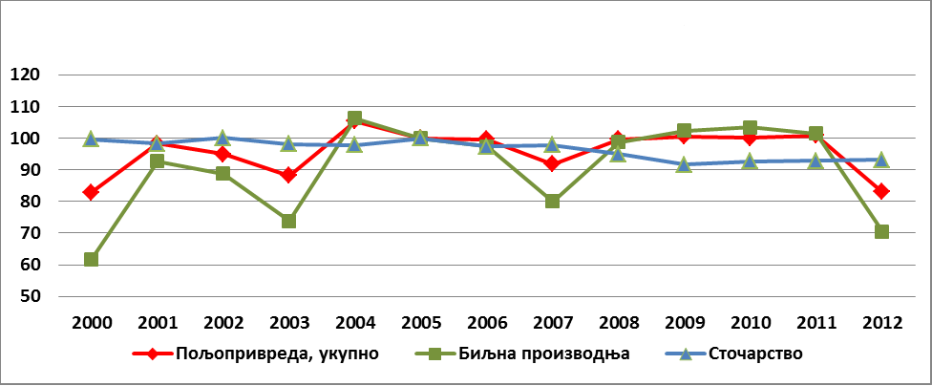

Livestock production

Crop production

Agriculture, total

Chart 5. Indexes of agricultural production (2005=100%)

Source: RSO

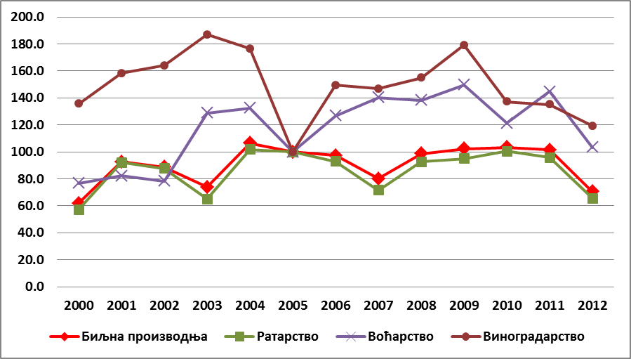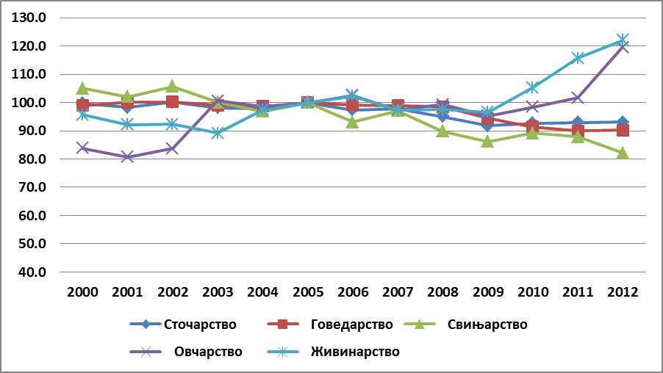

Pig

Poultry

Cattle

Sheep

Livestock

Wine grape production

Plant production

fruit production

Crop production

|  |  |
| --- | --- |
| Chart 6. Plant production indexes (2005=100%) | Chart 7. Livestock production indexes (2005=100%) |

Source: RSO

In value structure of agricultural production, plant production is dominant with corn, wheat and vegetables as main products. The share of livestock production in total value of agricultural production is decreasing, mainly due to developments in the meat production sector.

Таble 6. Agricultural production value structure of the Republic of Serbia*

|  |  |  |  |  |  |  |  |  |  |  |  |
| --- | --- | --- | --- | --- | --- | --- | --- | --- | --- | --- | --- |
|  | **2002** | **2003** | **2004** | **2005** | **2006** | **2007** | **2008** | **2009** | **2010** | **2011** | **2012** |
| Field Crops | 55.9 | 46.8 | 58.1 | 59.2 | 53.4 | 49.6 | 56.6 | 55.8 | 58.4 | 58.2 | 50.7 |
| Fruits | 5.2 | 9.7 | 8.5 | 6.7 | 8.3 | 11.4 | 9.8 | 10.3 | 8.3 | 10.1 | 9.2 |
| Vine | 2.6 | 3.3 | 2.5 | 1.5 | 2.0 | 2.4 | 2.2 | 2.3 | 1.7 | 1.8 | 2.0 |
| **Plant Production** | 63.7 | 59.8 | 69.1 | 67.3 | 63.7 | 63.4 | 68.7 | 68.4 | 68.4 | 70.1 | 61.9 |
| Cattle production  (milk and meat) | 14.9 | 16.5 | 12.9 | 13.6 | 15.5 | 16.7 | 14.6 | 14.0 | 13.4 | 13.0 | 16.6 |
| Pig production | 15.0 | 16.0 | 11.7 | 12.5 | 13.7 | 13.3 | 10.8 | 11.6 | 11.9 | 10.5 | 12.5 |
| Sheep  (meat and wool) | 1.9 | 2.6 | 2.0 | 2.1 | 2.3 | 2.0 | 1.8 | 1.7 | 1.8 | 1.8 | 2.7 |
| Poultry  (meat and eggs) | 4.5 | 4.9 | 4.1 | 4.4 | 4.6 | 4.5 | 4.0 | 4.0 | 4.3 | 4.4 | 5.9 |
| **Livestock Production** | 36.3 | 40.2 | 30.9 | 32.7 | 36.3 | 36.6 | 31.3 | 31.6 | 31.6 | 29.9 | 38.1 |
| **Total, agriculture** | 100.0 | 100.0 | 100.0 | 100.0 | 100.0 | 100.0 | 100.0 | 100.0 | 100.0 | 100.0 | 100.0 |

* The structure of the value of individual product groups in the gross value of agricultural production was calculated based on three-year average manufacturer price (purchase and sale) and does not represent the value of agricultural production for the given year, but only serves as support for calculating the index of the physical volume of agricultural production.

Source: RSO

2.3.2 Plant Production

Within plant production, special place based on the total value belongs to crop and vegetable production, which is carried out on the area of ​​3.3 million hectares.

Developments on the international market of agricultural products have influenced significant change in the sowing structure in Serbia in the recent years. Area under grains remained relatively constant (1.9 million hectares), but within them there was redistribution as increasing areas under corn at the expense of reducing the area under wheat, in the total planted area. Rise in prices of grain on the world market, opted producers to switch to the corn, which sown areas in recent years had increased by about 10%, while the areas under wheat in mid of the last decade for the first time dropped to less than 500 hectares. Corn is the single most important Serbian market product with an average production of 5.6 million tons over the last decade, and the planted area of 1.2 million hectares. Wheat production is about 2 million tons, on planted area of about 500 hectares. High proportion of grains in sowing structure, and relatively lower yields compared to developed countries, are reflection of the relatively extensive production, where there is the lack of compliance with the requirements for crop rotation and agro technical measures.

Table 7. Areas and production of the most important field crops in the Republic of Serbia

|  |  |  |  |  |  |  |  |  |  |  |  |  |
| --- | --- | --- | --- | --- | --- | --- | --- | --- | --- | --- | --- | --- |
|  | **2002** | | **2003** | **2004** | **2005** | **2006** | **2007** | **2008** | **2009** | **2010** | **2011** | **2012** |
| **Surface (000ha)** | | | | | | | | | | | |  |
| **Grains, total** | | 2.085 | 1.979 | 2.003 | 1.941 | 1.853 | 1.900 | 1.899 | 1.912 | 1.837 | 1.865 | 1.896 |
| ***of which:*** | |  |  |  |  |  |  |  |  |  |  |  |
| ***- Wheat*** | | 694 | 612 | 636 | 563 | 540 | 559 | 487 | 568 | 484 | 493 | 481 |
| ***- Corn*** | | 1.196 | 1.200 | 1.200 | 1.220 | 1.170 | 1.202 | 1.274 | 1.209 | 1.230 | 1.258 | 1.269 |
| **Oilseeds** | | 253 | 334 | 308 | 331 | 347 | 315 | 350 | 320 | 352 | 355 | 338 |
| **Sugar beat** | | 52 | 65 | 60 | 64 | 72 | 79 | 48 | 61 | 66 | 56 | 65 |
| **Potato** | | 91 | 88 | 89 | 85 | 84 | 81 | 81 | 78 | 77 | 78 | 75 |
| **Grapes** | | 69 | 67 | 66 | 64 | 62 | 59 | 58 | 58 | 57 | 56 | 54 |
| **Fruits** | | 269 | 272 | 269 | 263 | 261 | 262 | 264 | 263 | 263 | 263 | 262 |
| **Vegetables** | | 156 | 156 | 158 | 158 | 158 | 161 | 160 | 158 | 158 | 155 | 151 |
| **Forage crops** | | 336 | 335 | 336 | 336 | 332 | 332 | 336 | 332 | 334 | 333 | 346 |
| **Production (000t):** | | | | | | | | | | | |  |
| **Grains, total** | | 8.329 | 5.477 | 9.926 | 9.586 | 8.349 | 6.213 | 8.833 | 8.982 | 9.273 | 9.066 | 5913 |
| ***of which:*** | |  |  |  |  |  |  |  |  |  |  |  |
| ***- Wheat*** | | 2.240 | 1.365 | 2.758 | 2.007 | 1.875 | 1.864 | 2.095 | 2.068 | 1.631 | 2.076 | 1.911 |
| ***- Corn*** | | 5.586 | 3.817 | 6.569 | 7.038 | 6.017 | 3.905 | 6.158 | 6.396 | 7.207 | 6.480 | 3.532 |
| **Oilseeds** | | 530 | 584 | 760 | 722 | 822 | 628 | 857 | 771 | 944 | 917 | 667 |
| **Sugar beat** | | 2.098 | 1.738 | 2.814 | 3.086 | 3.189 | 3.206 | 2.300 | 2.798 | 3.325 | 2.822 | 2.328 |
| **Potato** | | 918 | 679 | 975 | 963 | 930 | 743 | 844 | 898 | 887 | 892 | 578 |
| **Grapes** | | 395 | 450 | 425 | 241 | 359 | 353 | 373 | 431 | 330 | 325 | 263 |
| **Fruits** | | 593 | 1.239 | 1.116 | 1.439 | 1.557 | 1.523 | 1.648 | 1.241 | 1.528 | 1.115 | 1.116 |
| **Vegetables** | | 909 | 1.029 | 871 | 964 | 1.015 | 1.055 | 993 | 805 | 909 | 1.029 | 871 |
| **Forage crops** | | 1.933 | 1.585 | 2.159 | 2.189 | 2.155 | 1.801 | 2.024 | 2.277 | 2.319 | 2.134 | 1.814 |

Source: RSO

In the period 2002 – 2012 industrial crops were grown on the area of ​​400 to 440 thousands hectares, with significant variations of planted areas, applied to all the crops in this group. Industrial crop production accounts for about 9% of the total value of agricultural production in Serbia. Generally, during that period the areas under oilseed crops were increasing (with variable share of individual crops in this group), while the areas under sugar beet were highly unstable. The Republic of Serbia is among the largest producers of oilseeds in Europe. The main oilseed crop is sunflower, but the most significant increase was noted in the production of soybeans and canola. The largest area under oil crops are in Vojvodina (94%). This is due to favorable climate and soil conditions, processing facilities and extensive network of suppliers and buyers.

The Republic of Serbia is the largest regional producer of vegetables. Vegetables during the last decade were grown on the area of ​​about 175 hectares, with about 80 thousand hectares under potatoes. Medium early and medium late vegetables are mostly grown, although there are good conditions for growing certain early and late vegetables. Competitiveness of vegetable production is largely dependent on the inputs, i.e. the price and quality of seeds and fertilizers. Seeds produced in the Republic of Serbia do not cover needs of the domestic market and significant amounts of vegetable seeds are imported. Volume of vegetable production increased in the recent years, as a result of significant investments in equipment, machinery and inputs, and increased production of vegetables in protected areas. Thanks to that, apart from increased yields, a wider offer and introduction of new types of vegetables in the product range is noted. Export of vegetables is increasing, both in terms of quantity and observed by many countries in the Serbian exports.

Fruit production was carried out over the past decade in the area of ​​about 260 hectares (including strawberries and raspberries) and accounts for about 11% of the value of agricultural production in Serbia. Production takes place mainly on private households. In this sector, significant progress has been made in improving standards in primary production and processing, but also in the field of business networking. Variation in the volume of production is high, because the sector is still at a relatively low technological level and its production is subject to influence of weather.

Viticulture is widespread throughout the country, with an average production of 350.000 tons of table and wine grapes. Most of the grape production is used for wine production. Over the last five years volume of planted areas slightly increased, as well as the volume of physical production.

Yields of most of the crops are relatively lower compared to developed countries and are showing significant fluctuations. Analysis of the yield change dynamics ,expressed through ten-year average of the last three decades, shows that permanent increase in yield have only industrial crops and some fruits (plums and raspberries). Wheat yields still do not reach the ten-year average level of pre-transition period (1980-1989). Wheat and corn are two leading crops by share in acreage, with long tradition, good local and international available assortment; therefore, the level of yields and production can be attributed to insufficient training of producers, outdated technology and lack of adaptation to the climate change. The reason for underutilization of plant genetic resources are inadequate agricultural practices, disrespect of crop rotation requirements and lesser use of inputs in relation to the optimal values ​​and recommendations. High input prices and problems with loan repayments for equipment and machinery resulted in a decline in size of investments, resulting in a too high dependence of production on weather conditions. Positive trends and satisfactory conditions are recorded for yield of oilseeds crops, which are at the level of the largest producers in Europe.

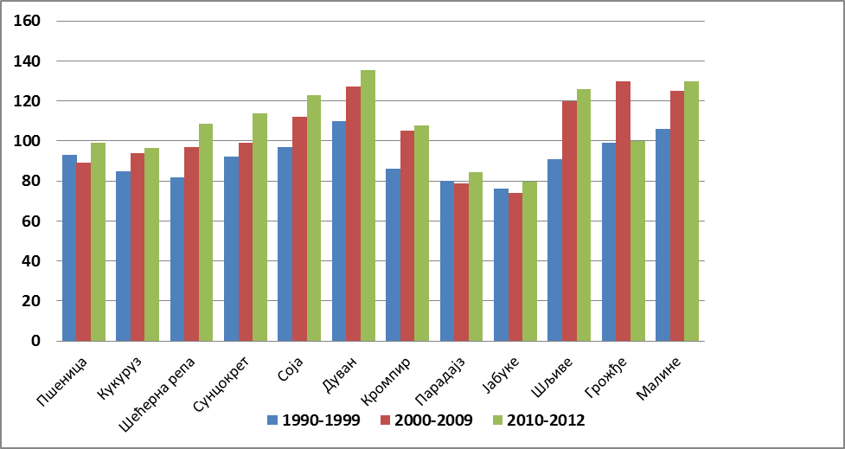

Wheat

Tomato

Raspberries

Sugar beet

Sunflower

Grapes

Plum

Apple

Potato

Tobacco

Soya

Corn

Chart 8. Changes of average yields (1980-89=100%)

Source: RSO

Low level of realized yields is conditioned, apart from above mentioned factors, with great rate of production for private consumption, that is to say by low marketing level. Large holdings chose new technologies and technical solutions more often, and by the level of realized yields they exceed national average by far. In general, those sectors where production concentration is evident (industrial crops, some fruit productions, etc.) record more dynamic yield increase.

2.3.3 Livestock Production

The share of livestock in structural value of production is about 30%, which is, due to the available land areas and its structure, actually a low share. Similar trends of decreased share of livestock in the value of agricultural production other countries in transition also recorded, as well as other countries in the region. By value, cattle production is the most important production, followed by pig, poultry and sheep productions.

Total meat production in Serbia in the last decade has recorded signs of slow growth, reaching production volume of 480 thousand tons. Situations for each type of meat are very different - while beef production continues downward trend (for ten years it decreased by 13%), production of lamb, and especially poultry, have dynamic growth trend of about 60% each. These trends are determined by a set of factors such as: the impact of weather on production and on prices of animal feed, the decline in domestic demand for quality meats, inability to export pork, etc. In addition, the production of meat for a long time was not in the system of incentives for agriculture, which had further negative impact on the production and loss of already gained markets. To increase production of beef and lamb meat all necessary preconditions exist such as the available number of animals in the breeding stock, production of forage and concentrate feed and facilities for housing and breeding of animals.

Table 9. Production of livestock products in the Republic of Serbia (in 000t)

|  |  |  |  |  |  |  |  |  |  |  |  |
| --- | --- | --- | --- | --- | --- | --- | --- | --- | --- | --- | --- |
|  | **2002** | **2003** | **2004** | **2005** | **2006** | **2007** | **2008** | **2009** | **2010** | **2011** | **2012** |
| **Cattle** |  |  |  |  |  |  |  |  |  |  |  |
| **- total gain\*** | 190 | 185 | 184 | 186 | 185 | 186 | 187 | 177 | 167 | 165 | 161 |
| **- meat production\*\*** | 97 | 95 | 93 | 90 | 83 | 95 | 99 | 100 | 96 | 81 | 82 |
| **Pigs** |  |  |  |  |  |  |  |  |  |  |  |
| **- total gain\*** | 473 | 448 | 433 | 447 | 417 | 435 | 402 | 386 | 399 | 393 | 368 |
| **- meat production\*\*** | 277 | 258 | 242 | 253 | 255 | 289 | 266 | 252 | 269 | 271 | 252 |
| **Sheep** |  |  |  |  |  |  |  |  |  |  |  |
| **- total gain\*** | 36 | 44 | 43 | 44 | 45 | 43 | 44 | 43 | 44 | 46 | 54 |
| **- meat production\*\*** | 15 | 18 | 20 | 21 | 20 | 20 | 23 | 24 | 23 | 24 | 22 |
| **Poultry** |  |  |  |  |  |  |  |  |  |  |  |
| **- total gain\*** | : | : | : | 95 | 100 | 96 | 106 | 116 | 120 | 140 | 140 |
| **- meat production\*\*** | 65 | 59 | 65 | 67 | 75 | 70 | 76 | 80 | 84 | 103 | 94 |
| **Eggs (in millions)** | 1.335 | 1.421 | 1.536 | 1.476 | 1.456 | 1.346 | 1.204 | 1.026 | 1.219 | 1.219 | 1.388 |
| **Honey** | 2,6 | 3,2 | 3,6 | 3,7 | 4,0 | 3,5 | 2,6 | 4,6 | 4,5 | 4,3 | 6,9 |
| **Cow’s milk** | 1644 | 1638 | 1641 | 1650 | 1635 | 1595 | 1580 | 1522 | 1506 | 1477 | 1442 |
| **Sheep’s and goat’s milk** | 16 | 13 | 14 | 14 | 38 | 34 | 33 | 26 | 26 | 27 | : |
| **Wool** | 2,1 | 2,3 | 2,4 | 2,5 | 2,5 | 2,5 | 2,6 | 2,4 | 2,5 | 2,4 | 2,6 |

* production of live-weight

** net weight of slaughtered livestock

Source: RSO

The quota for the export of beef at preferential terms in the EU Member States is 8,700 tons per year, and was used by only 5%. Significant opportunities for marketing beef and lamb meat are on the Russian market, and in Asian countries.

Total milk production in Serbia is around 1.5 million tons, and since 2002 records permanent decline. Average milk production per cow is 3.1 thousand liters, with significant regional differences - milk yield is much higher in Vojvodina (3.890 liters/cow), where larger farms are located, compared to Central Serbia (2,730 liters/cow). In the controlled part of the herd, this presents 28% of the total number of cows and heifers, milk yield ranging from 4.726-7.758 liters, depending on the region, and breed. Differences in milk production are the result of differences in breed composition: 52% of cows in Vojvodina are Friesian - Holstein breed, while in Central Serbia prevail Simmental cattle and cattle of Simmental type. Quality of feed on small farms, especially in mountainous areas do not meet the needs of dairy cattle, and thus the production results are lower than in the lowlands. It should be noted that in the period 2002-2012 the number of dairy cows declined by one-third (34%), so that the increase in milk yield per cow by 20% only partially compensated the decrease in production.

2.3.4 Integrated and Organic production

Taking into account the natural resources, favorable soil and climatic conditions, biodiversity and relatively healthy agro-ecosystems, it can be said that in Serbia there are favorable conditions for the development of integrated and organic production. Serbia does not have developed legal framework that defines integrated agricultural production, but it is recognized for its great importance and potential.

Since 2006, after the Law on organic production and organic products was passed and after incentives for organic production were introduced, there is a constant increase in the number of producers, in the areas where organic production methods are applied, as well as in the number of certain species of animals in livestock production. According to the MoAg in 2012 under organic production was 6.335ha were under organic production, or 0.11% of agricultural land. Of this, 5.360ha are arable land and 975ha are meadows and pastures. Number of producers involved in organic production in 2012 increased to 1061.

Table 10. Agricultural land and number of animals in organic production in the Republic of Serbia in 2012

|  |  |  |  |
| --- | --- | --- | --- |
| **Surfaces under organic production** | | **Organic livestock production** | |
| **Type of products** | **Acreage (ha)** | **Type of animals** | **Num. of animals/units** |
| Grains | 2,522 | Sheep | 2837 |
| Fruits | 1,415 | Pigs* | 196 |
| Forage Crops | 663 | Cattle | 1395 |
| Industrial Crops | 540 | Goats | 211 |
| Vegetables | 113 | Poultry | 2074 |
| Medicinal and aromatics plants | 28 | Donkeys | 7 |
| Other | 79 | Horses | 66 |
| Pastures and meadows | 975 | Bees (Beehives) | 961 |

* Of the total number of pigs, 159 heads are mangulica breed

Source: Ministry of Agriculture, Forestry and Water Management

Organic plant production is mainly located in Vojvodina (72%), followed by the Southern and Eastern Serbia (16 %), and Šumadija and West Serbia (11 %). The most common plant species that are grown using methods of organic production are corn, wheat, soy, plum, apple and raspberry. Also, large amount of certified wild plant species (raspberries, strawberries, blackberries, apples, blueberries, mushrooms, etc.) are collected from the nature in accordance with applicable regulations. Number of orchards and vineyards dedicated to organic production is small, like the areas they occupy. In organic livestock production in the 2012 mostly sheep, poultry and cattle were bred.

Domestic market for organic products is not sufficiently developed, for not enough effort was made in educating producers, consumers and for the promotion of organic products. From Serbia only organic products of plant origin were exported so far, mainly partially processed. Export of frozen fruits is the most common (72% of the total amount of organic products), and mostly exported to Austria (35.85%) and Germany (27.96%), followed by the Netherlands and Italy.

From January 2011 the organic production in Serbia is regulated by the Law on Organic Production[14] and the Regulation on the control and certification of organic production and organic production methods[15]. Regulations in this area were harmonized with current regulations of the European Union (other than regulations relating to organic wine). The Works of control and certification of organic production MoAg assigns to control organizations, and supervises their work.

**2.4 Production Chain**

2.4.1 Inputs Industry

Serbian agricultural sector is essentially a production system with small investments, which use relatively small amounts of chemicals and other inputs. This is due to the relatively high cost of inputs, which are not easily available to most of the (small) farmers.

Domestic industry of agricultural machinery and fertilizers were unsuccessfully privatized, which had caused decline in production and a high to complete dependence on import. Privatized and closed is the only industry for the production of combines and corn pickers; tractor industry is in the process of restructuring and the production volume is ten times smaller comparing to the period of ten years ago. Average annual production is slightly more than 3.500 tractors, of which about 2.200 are exported, mainly to neighboring countries, as well as on the markets of developing countries.

Most of the factories for production of mineral fertilizers are not working, while in the ones that are still working production is reduced to a minimum. Major part of the required amount of fertilizer (about 60%) is provided from import. In the production and import of fertilizers prevail standard combinations of components, ones that are best suited to needs of the agricultural land. Production of plant protection products, the volume and structure are inadequate, so most of the needs, like for the fertilizers, are provided through import. All necessary products are offered on the market, from all world known producers.

Ways of advertisement material supply vary and depend on the size of households and their economic power. Large and medium-sized households are purchasing inputs primarily for cash. Small farms are obtaining inputs mainly through the exchange, using two standard models: barter (a product for inputs) where the parity is adverse to detriment of small producers; exchange with "euro-clause" is the second model, which carries a high risk for producers since it is linked to the price of products and exchange rate.

Beside domestic seeding materials, imported varieties are even more used. Domestic varieties still dominate in wheat production, while in maize there is an equal use of both local and foreign hybrids. For the production of industrial crops foreign varieties and hybrids are significantly used, for the sunflower and sugar beet prevail foreign hybrids, while domestic cultivars prevail for soybean. Significant quantities of seeds are imported for the vegetable production. Domestic production of vine planting material is declining, and the main problems are the lack of production of certified planting materials, quality of the planting material and inadequate control of production.

Insemination of cattle is done through artificial insemination. Pig insemination is performed on large farms, while small producers usually select natural mating. In other branches of animal husbandry artificial insemination is almost entirely applied. Semen for artificial insemination of cattle arrives from the Centers for reproduction and artificial insemination of farm animals, as well as from distribution centers, which were established in recent years. Semen used in the cattle comes from animals that fulfill all zoo-technical and veterinary requirements and are tested in accordance with these rules, while in the pig production it is necessary to improve the level of assessment of semen quality.

2.4.2 Food Industry

In the total GDP of Serbia food industry in the last decade contributed with an average of about 3.5. The share of the food industry in total employment in the manufacturing sector is 17.76%, and the total investment of manufacturing sector is 16.20%.

The structure of companies in the food industry is dominated by micro and small enterprises[16]: 75% of all businesses employ fewer than 10 people, while 90% of companies are with less than 50 employees and/or less than 10 million euro turnover[17]. Exceptions are the milling industry, sugar, beer and tobacco industry, where medium and large companies represent more than 10% of the companies within respective industries.

The rate of utilization of the installed capacity of the food industry is below 65%[18]. Industries with higher degree of capacity utilization are industries of meat, sugar and milk, and tea and coffee, beer and mineral water and soft drinks; they use of 75-85% of installed capacities. All other food sub-sector industries that are not mentioned have low capacity utilization, which indicate the low efficiency. Main sub-sectors in terms of turnover are meat, milk, mill and beverage industry (beer, water and soft drinks).

The most important branches of Serbian food industry are comparable, by the size and performance, with those in the reference countries. Looking at the added value by industry, all parts of the Serbian food industry are well positioned comparing to their competitors in the reference countries and generate similar percentages of added value. However, as there are no further detailed information on profitability, investments, product characteristics and other relevant indicators, this comparison in share of turnover and added value too small basis for making clearer conclusions about the competitiveness of Serbian food industry[19]**.**

An important characteristic of the food sector is expressed by dual structure, with a lot of (very) small and medium enterprises and with only a limited number of large, modern enterprises. Regardless of the typically fragmented structure of the food industry, its over sizing in almost all sectors and relatively modest financial resources to invest in modern technology (to improve production efficiency and product quality) adversely affect future prospects of most existing food companies. In many cases, foreign direct investments acted as initiators of the positive change, bringing capital and technical innovation.

In the food industry in Serbia, significant foreign investments were made in the last decade. Most of them are associated with acquisitions and greenfield investment (new factory and/or retail chains) in the beverage industry and the retail sector. In addition, foreign investors have acquired significant stakes in the companies, among other, in the sugar industry, in the dairy and meat industry.

Technical-technological equipment varies by the industry, but in general it can be said that the larger capacities are better equipped. It is primarily referring to the milling-baking industry, sugar refineries, confectionery industry and dairies. In the production of edible oil ​​significant investments were made in modernization and equipment, both in large, and small capacities for production of cold- pressed oils, while the technology of production and processing of meat, except for some facilities, is not at the satisfactory level. Significant investment in technical and technological equipment were not made in the industry for fruit and vegetables processing, and in most facilities equipment is below required standards for export, especially for export to the EU market.

Retail chains introduced stricter criteria for buying and trading with food products, what caused massive adoption and implementation of standards by the food industry. The modern sector of retail chains in Serbia requires more stringent guarantees on the quality and safety of food at competitive prices. Main challenge for the agricultural and processing sector is to meet increasing number of requirements and standards of the food supply chain, in order to prevent the increased imports.

***Grain Processing***

Milling-baking industry has processing capacities of 2,143 million tons of wheat, which is used in recent years to about 55%. There is no precise data on the number of bakeries in Serbia, given that the large number of small capacities is in the gray zone. Officially, the number of bakeries in Serbia is 3.408, of which 3.023 are smaller capacity of craft type.

Industry of pasta production has the capacity to produce 35.000 tons of pasta per year, of which 60% is used. Milling-baking and pasta production are characterized by relatively stable level of production in the last ten years. Capacities are evenly territorially distributed, and it is noted that crafting capacities are mainly present in southern Serbia.

***Oilseed Processing***

As one of the largest producers of oilseeds in the region, Serbia is also the area with the largest processing capacities in the area of ​​CEFTA region. Capacity of the oil industry enables yearly processing of 885.600 tons of sunflower, 482.000 tons of soybeans and 247.000 tons of rapeseed. The average level of processing of sunflower in the last ten years in Serbia was at the level of only 40% of the available capacity, and for soybeans it is 70%. Quality of raw materials and promising market (primarily in the soybean processing) create good opportunities for larger utilization of capacities.

***Sugar Industry***

In Serbia, there are six sugar factories currently working, with processing capacity based on an average of 100 processing campaign days of about 4.150 million tons. In 2012 processing capacities of the functioning plants were used of 65%. Factories are owned by three companies - "Hellenic Sugar", "Sunoko" and "Sfir". There is a growing trend in sugar production in the last 10 years. The fact that in this market are three sugar producers certainly raises the question of monopoly in the raw materials markets, and the market of finished goods.

***Confectionery Industry***

The confectionery industry by number of companies (78), capacity, production volume, export potentials and the number of workers, is an important part of the food industry in Serbia. Having in mind that in the confectionery industry in Serbia expansion of products portfolios and new product lines is very active, as well as in building of new factories, the capacities are constantly increasing.

***Slaughter Industry***

Serbia has significant processing capacity in livestock production (1.176 facilities for slaughtering of cattle, pigs, sheep/goat and poultry and for meat cutting and processing of cattle, pigs, poultry and fish). Capacity utilization is far below projected. Small number of facilities is registered for export (only 114). License to export to the EU market have 9 slaughtering facilities, as well as eight facilities for meat processing. For export to The Customs Union (Russia, Belarus and Kazakhstan) approved are 17 facilities, of which nine facilities for slaughter and 7 facilities for cutting and processing fish meat.

***Dairy Industry***

Until October 1st, 2013 total of 260 facilities are approved for milk processing. Utilization of existing dairy capacities is about 60%. It is expected that in the coming period there will be further decline in the number of dairies, since many will not be able to invest in adoption of EU standards and thus survive on the market. In addition, in the register of the Veterinary Department 1,755 facilities for milk processing in households are registered (production of cream and/or white cheese intended for domestic market).

For export, there are currently registered 56 facilities for processing of milk and milk products. Out off that, for export to the EU six milk processing facilities are approved, and to the market of Customs Union seven facilities, of which two establishments are approved for export of ice cream.

***Fruits and Vegetables Processing Industry***

*Cold processing* – There is no precise data of the number of cold storages in Serbia. Based on data from MoA for 2011, there were 363 cold storages with freezers in Serbia, for storing fruits, vegetables and mushrooms, with a total capacity of about 550,000 tons. Capacity utilization is around 75%.

*Hot processing* - In Serbia, 85 business companies deal with heat processing and drying of fruits and vegetables, as well as the production of juices, with total installed capacity of about 565,000 tons. Capacity utilization is about 50%. Significant part of the processing capacity is related to the production of fruit and vegetable juices. Production capacity of fruit juice on a year level is around 240 million liters, which puts Serbia into group of serious producers in the region.

***Beer Industry***

Average beer production in the last three years is uniform and is around 5.395 million hectoliters per year. Capacity of five major breweries in Serbia is 11.500 hectoliters, and they cover 80% of the total capacity of the breweries in Serbia. Operational breweries usually have optimum employment of its technical capacity.

***Wine Industry***

The average ten year wine production in Serbia is around 1.7 million hectoliters. In production and processing of grapes are engaged about 80.000 households, while for industrial production are registered 235 wine producers. With geographical origin, in 2013 were registered 75 wine producers. Export results of the industry are growing, but are still relatively modest.

2.4.3. Quality Policy

Quality policy includes quality schemes and standards of food safety and quality. In terms of product quality, significant progress has been made in the field of protection of geographical indications. In Serbia, there are three systems of protection of geographical origin: for agricultural and food products, wines and spirits. Protection of agricultural and food products is defined by the Law on Geographical Indications[20] and by by-laws, defining production and trade control procedures and system of marking products with geographical indications. So far, 33 agricultural and food products are protected, with some of the geographical indications, although for some of them there are no authorized producers. Quality schemes for the protection of traditional specialties (products) have not been established.

Protection system of geographical origin for wines is regulated by the Law on wine[21] and by-laws that comply with the new EU requirements. Currently in the system of geographical origin there are 74 producers with 214 wines. Geographical origin of brandy is regulated by the Law on brandies and other alcoholic beverages[22]. Given the huge potential of this sector, there is still no sufficient number of spirits with geographical origin.

Quality standards for the majority of products are regulated by special by-laws or regulations that further regulate requirements in terms of food quality. Serbia is in the process of continuous harmonization of these regulations on food quality with applicable EU regulations.

Market of agricultural and food products is one of the most competitive markets, where very often, in front of the producers, especially those that export food to the markets of the EU member states are set additional requirements for introduction of certain standards, initiated primarily by the large retail chains, as well as by the consumers. For the above mentioned reasons, there is a need that processes of production and trade of food, comply with the requirements defined by the food safety and quality standards ( GLOBALG.AP, BRC, IFS, ISO, HALAL, Kosher, etc.). The availability of data on the implementation of standards is no adequate. Some production standards, such as GLOBALG.AP, have not yet become part of the mass implementation/practice because domestic market, especially in the field of fruits and vegetables, has not defined them yet as a condition.

Most EU standards relating to the quality of livestock products are not applied, except in the dairy sector, where there is the national standard for raw milk pretty close to EU standards (milk of E class must meet the requirements that are placed before European producers). Dairies have tried to pay producers based on the quality of purchased milk, but the problem that exists in this area is the establishment of national laboratories for quality control of raw milk, to include all producers in Serbia in a system of control, and to have independent results.

2.4.4. Supply chain

A large part of the primary agricultural sector is excluded from the commercially oriented agri-food chain; because of the small production scale producers cannot provide consistent quality products in sufficient quantities. With the arrival of modern retail chains suppliers of fruit and vegetables are more vulnerable to their complex requirements in terms of delivery conditions, such as price, quantity, quality and timeliness. In such a context, a major challenge for producers is the ability to meet the set of requirements, maintaining the highest possible participation in satisfying the domestic demand. Since their market position is crucially determined by the volume and quality of supply, we can expect better integration within the primary sector as well as its closer ties with retail chains.

Contracting of production in most agricultural sub-sectors is not common practice, mainly due to low performance in the primary agricultural production and also in a large part of the processing industry. Due to the high volatility of the market, farmers often opt for the spot markets even though they have signed contracts. Business connections between producers and processors are based mainly on the level of contracting of "joint production" or contracting mercantile production for parity exchange for production inputs. In these business arrangements farmer often does not have adequate protection against the risk of price change.

In livestock production contracting takes place mainly between the major producers and processors. There are also cooperative relations, especially in fattening of beef cattle and pigs. Livestock is bought and paid per kilogram, without determining leanness and other production standards. Within the meat industry there is a complex network of companies engaged in wholesale trade of meat and meat products. These companies sell to retailers (small retail and butchers) and to further processors (all other types of meat processing facilities). Some wholesalers are also importers and exporters. In varying amounts they all meet the needs of a large number of companies in the processing sector, as well as the needs of independent butchers and other subjects.

The choice of the market chain in sales of raw milk varies depending on herd size and quantity of milk. Large dairies purchase milk on the basis of parameters of milk fat, protein and somatic cell count, while the small dairies pay for milk only in accordance with the quantity of milk fat.

The small volume of supply of agricultural products in most of the territory of the Republic, as well as the established traditional flows of certain goods, result in a small number of modern systems and facilities for storage and distribution. In addition, in the whole system there is lack of information and communication systems and professional support. There are not enough storage facilities for agricultural produce, and they are not adequately equipped. Apart from silos, grain is stored as well in warehouses which are in bad condition and in temporary facilities, causing significant losses to processors especially in quality. The capacity for storage of table fruits is insufficient, while the cold storage capacity and the capacity for different types of fruit and vegetables is sufficient for acceptance of fresh fruits and processing. Most of the warehouses are owned by the old socially owned cold storages, which are poorly equipped and have outdated technology.

The number of existing associations of all kinds is very big, especially in primary agricultural production. In Serbia, there are 2.534 registered cooperatives and cooperative unions, of which 60% are in agriculture. Production associations, cooperative associations, and even chambers of commerce have not been transformed, being burdened with accumulated organizational problems from the period of transition and privatization, they have lost their business function. Producer associations are poorly developed, and their roles and activities are quite limited. Most of the associations of producers are at a low level of organization, which is primarily manifested in a low level of professionalism and lack of management personnel. In recent years, the associations have been more visible, especially in situations when there are problems in the market, but their bargaining power is generally low due to high dependence on processing industry.

2.4.5. Market and Financial Institutions

The development of the logistics support to the sector and infrastructure facilities for setting up efficient markets are low. Wholesale markets are a well known system of concentration and distribution of goods, both from industrial processing facilities, and small plants of craft type. In Serbia, there is only one wholesale market (Belgrade), which is still under construction. The development of wholesale markets as sales channels is particularly important, since these are the places where control of food safety standards and storage conditions is carried out. Distribution centers are located in regional production centers and close to major consumption centers.

The Directorate for Commodity Reserves is established on the basis of the Law on Ministries[23] as a separate organization that is responsible for state administration and technical tasks related to organization of commodity reserves; creating, storage, keeping and renewing of the Republic of stockpiles; determining the volume, structure and quality balance of stockpiles; controlling the amount in order to maintain reserves at the necessary minimum; construction of storage facilities for republic stockpiles; material and financial and evidentiary operation with stockpiles, as well as other activities in this area. Operations of the Directorate for Commodity Reserves are regulated by the Law on Commodity Reserves[24]. According to this Law, the Commodity reserves are established and used: 1) for the stabilization of production and market prices, protection of domestic industries and export promotion, 2) to provide for the needs of the Republic in case of a state of emergency, imminent war danger, and war. Therefore, this institution does not have the authority or capacity to appear in the role of market institutions that contribute to the regulation of commodity flows and market stabilization. .

The system of public warehouses and collaterals is extremely undeveloped. The number of Certified Public Storages is extremely small and regionally inadequately distributed, which further complicates the recognition of public warehouses and collaterals. A large number of commercial banks are not interested to use collateral, because there is no certainty at all. The system of public warehouses should increase the level of security of storage goods, especially of primary agricultural products, their classification by quality categories and to allow owners of warehouse receipts to use these receipts as collateral and to have better access to capital markets and loans. Bringing of the new Law on commodity exchanges will create a framework for the functioning of mercantile exchanges, which would create the so-called forward market of "commodity derivatives" that would allow market participants to create their market strategies in a way to protect themselves against the risk of sudden price changes. In this way, farmers would be protected from the effects of falling prices, and processors would be protected against sudden jumps in pricing. The Directorate for Commodity Reserves, according to the model of institutions of this type in countries with developed market economies should retain the function of preserving the strategic inventory levels of strategic goods, and on the other hand to install a system that will allow effective market intervention when it is in the function of the market protection.

Sources of financing of the agricultural sector are the agricultural budget, commercial banks, leasing companies and development funds (state, provincial, and municipal). These sources, however, are not sufficient to meet the needs of the sector for funding. The unused potential for obtaining the financial resources for raising the investment capacity of agricultural holdings is the capital market. Options offered by this type of strengthening of financial capabilities are primarily for fund raising through the institute of recapitalization through the issuance of shares or through an initial public offering (IPO) in the primary market through an organized exchange market. This type of additional fundraising is generally accepted model in countries with developed capital markets. Unfortunately, large illiquidity of our financial markets has largely prevented this otherwise very efficient and cost effective model for obtaining funds. Financial institutions specialized in supporting the measures of agricultural and rural policies included in national programs have not been established.

2.4.6. Transfer of knowledge and information

Transfer of knowledge in the field of agriculture takes place through the formal education at all levels (from secondary education to doctoral studies), through a variety of trainings organized by educational and research institutions, agricultural expert extension services, private companies, project units, media, etc. Extension System includes 34 agricultural extension and professional services (PSSS) 22 in the area of ​​Central Serbia that are working under MoAg and 12 PSSS and the Enological station whose work is monitored by the Provincial Secretariat for Agriculture, Water and Forestry.

The existing structures and systems of knowledge transfer are not efficient enough and fail to adequately fulfill the needs of dynamic technical and technological restructuring of the sector. The necessity of direct connecting of knowledge creators with users is neglected in the different system solutions - from a legal framework that regulates the work of research institutions and extension services, to the absence of any stimulus for this cooperation. Therefore, there are no functional networks with specialized centers of knowledge, knowledge is not systematically stored and it is difficult to access relevant information. The quality of the equipment and the overall technical requirements for research lags behind the European average. However, the existing scientific and educational institutions have a relatively good quality of the staff that has developed a number of results recognized and acknowledged in the world (new varieties, breeds and strains, scientific papers and technical solutions). Knowledge creation is functioning with some difficulties of material nature. This problem has contributed to the disappearance of certain scientific institutions or loss of their status of scientific institutes in the period after 2000, weakening the development of science in the interior of Serbia (Zaječar, Kragujevac, Guča).

On the territory of Serbia proper MoAg, Group for extension brings Annual development program of extension work in agriculture and with the help of the Institute for Science Application coordinates the work of PSSS and contributes to the implementation of measures of agrarian policy and rural development. The Institute for Science Application in Agriculture (IPN), is the authorized organization for monitoring and evaluation of the work of extension agents, conducting training and specialization of agricultural extension agents and other stakeholders. Experts from IPN organize educations for agricultural advisors with a goal to transfer new knowledge and technology from scientific research institutions and universities. On the territory of AP Vojvodina, Provincial Secretariat for Agriculture, Water and Forestry (hereinafter PSPVŠ) finances, brings the annual program for improvement of advisory work, coordinates and supervises the work of extension agents and also contributes to the implementation of the measures of agricultural policy . The system of knowledge transfer is only partially functional, since there is a lack of systematic correlation between extension services and knowledge (cooperation with institutes, centers and universities).

The work of extension service encompasses 41.500 households, the majority of which are selected farms, which are intensively monitored four times a year (4.000 in Central Serbia and 2.500 in Vojvodina), while other households are included in the extension system in other ways, mainly through participation in group classes and the occasional on farm visit/consultations. This type of education covers 25.000 households in Central Serbia and 10.000 in Vojvodina. Organized transfer of knowledge through the extension services reaches a relatively small number of users.

Users often accept information with caution and rarely dare to invest their own funds in the obtaining of new knowledge and skills. Users’ uncertainty is fueled by the fact that even the transfer of knowledge done for the purpose of promotion of new products and technologies, through the media and otherwise, could be biased and primarily focused on profit for information providers. New technologies are more quickly and efficiently accepted on larger farms and in the more developed regions (Vojvodina , Stig, Mačva). Generally, between different parts of the agricultural sector, there are no significant differences in the positions of acquiring knowledge, except that more complex production forms require a larger scope of information on modern technology.

Opportunities provided by public-private partnerships in the area of ​​knowledge and technology transfer have not been exploited.

**2.5. Competitiveness of Serbian agriculture**

The assessment of the level of competitiveness of Serbian agriculture is presented on the basis of the comparison of prices of basic agricultural products in Serbia and other countries (as partial indicators), and through analysis of the trade balance and the level of coverage of imports by exports, and as well through aggregate indicators. Both aspects generally reflect the balance of (operating) costs and/or quality of products.

2.5.1. The price competitiveness

Data on agricultural products prices in Serbia are presented as the average price calculated from data on sales and purchase (quantity and value of sold goods) of agricultural enterprises and private households. The data are to some extent comparable with the methodological approach and standards in the EU. Statistical data on input prices do not exist, which makes economic analysis of the sector and its competitiveness difficult. Although the available data on the prices do not take into account differences in the categories and the quality of some products (table fruit and fruit for processing, table grapes and grapes for processing, the milk of a certain quality, etc.) these prices allow, at least roughly comparison with the prices in the EU countries, but the results must be taken as indicative rather than exact.

Price indexes of agricultural products indicate dynamic growth, especially in prices of plant products. Except for the sharp drop in prices in 2009 compared to 2008 in which prices and world markets recorded a record high value, prices of plant products have been constantly growing. Prices of livestock products have been growing at a slower pace, having stagnated in the middle of the last decade and since the beginning of the economic crisis the disparity in their growth compared to the cost of plant products has been increasingly apparent.

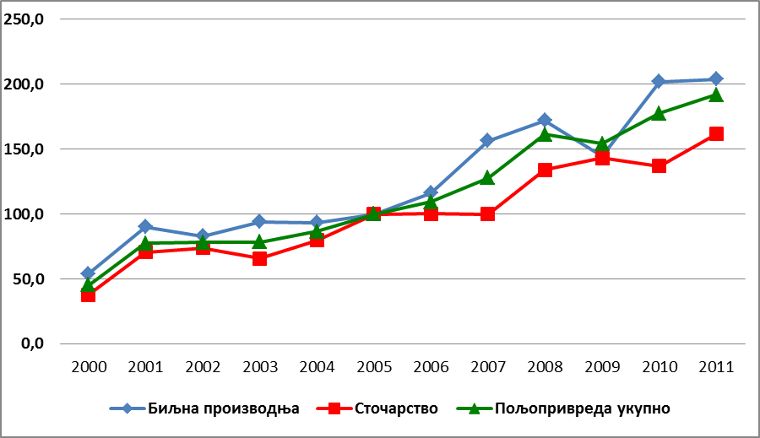

Plant production

Livestock

Agriculture, total

Chart 9. Price Indexes

Source: RSO

Compared to neighboring countries, the prices of plant products in Serbia are lower. The price competitiveness is particularly noticeable in grain and industrial crops, while in vegetable and fruit production it is valid only for certain products and certain year.

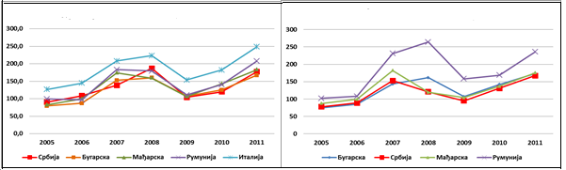

Selling prices of wheat (euro/ton) Selling prices of wheat (euro/ton)

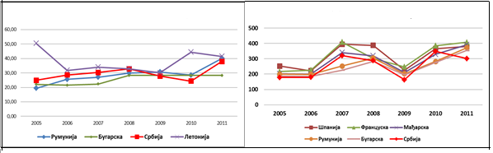

Selling prices of sugar beet (euro/ton) Selling prices of sunflower (euro/ton)

Chart 10. Selling prices of basic field crops in Serbia and selected countries

Source: RSO

High price competitiveness of Serbian agriculture can be explained by the lower costs of labor and number of market factors. This primarily refers to the monopoly position of buyers and the food industry, which is still highly protected from import. In addition, it should be noted that in Serbia there is no practice of payment based on the quality of grain, but the whole production is realized at the same price, thus it is lower than in European countries.

Competitiveness of livestock products is much lower, especially when it comes to beef meet. The reason for the relatively high price of beef is a drop in production, relatively low domestic demand, high cost of feed, and the fact that gray economy is still partly present in the sector.

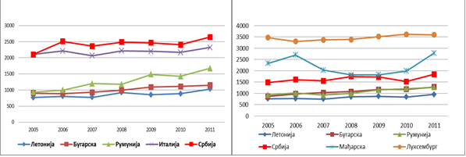

Selling price of beef (euro/ton) Selling price of calf (euro/ton)

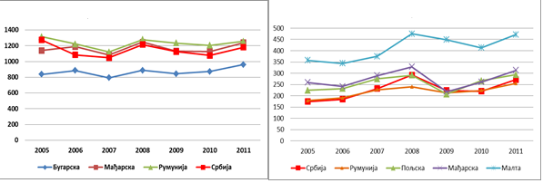

Selling price of beef (euro/ton) Selling price of raw cow’s milk (euro/ton)

Chart 11. Selling prices of basic livestock products in Serbia and selected countries

Source: RSO и EUROSTAT

Prices of pork and milk are highly competitive compared to other countries. High competitiveness of pork is caused by the lower price of corn as the primary feedstock in comparison to other countries, and the competition in terms of price of milk should be taken with high reserves (given the various payment schemes in terms of quality in some countries).

2.5.2. Foreign Trade

Serbia is a net exporter of agricultural and food products, and agriculture sector contributes significantly to the balancing of the foreign-trade balance. The share of agriculture in total value of exports of the Serbian economy is about 22% and it is higher than the share of agricultural imports in some years, in some years even triple. The total volume of trade in agricultural and food products has been constantly increasing. With the increase in exports and imports growing surplus, since the pace of growth in the value of exports exceeded the increase in the value of imported agricultural and food products.

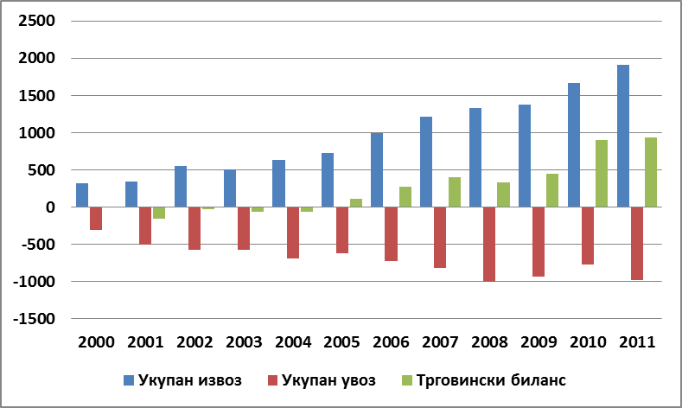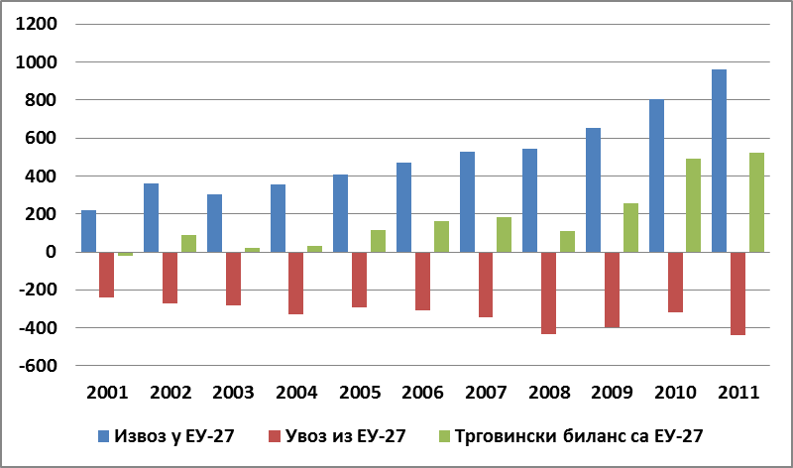

**Trade balance EU27.**

**Imp in EU27.**

**Exp in EU27.**

**Trade balance**

**Total imp.**

**Total export**

|  |  |
| --- | --- |
| Chart 12. Agricultural trade balance of Serbia (millions of euro) | Chart 13. Agricultural trade balance of Serbia with EU-27 |

Source: RSO

In terms of the value of the trade balance in relation to the volume of available agricultural land, Serbia is placed at the bottom of the list among European countries with positive trade balance of agricultural and food sector. This group of countries also includes Poland, Lithuania and Bulgaria. The cause of such low value of balance in relation to the available land area is in the structure of export, where raw materials, grains (21% of exports) and fruit (17 %) are highly represented. The share of commodities that include expensive products and produce of higher processing phase is much smaller, which practically positioned Serbian agriculture as a supplier of raw materials.

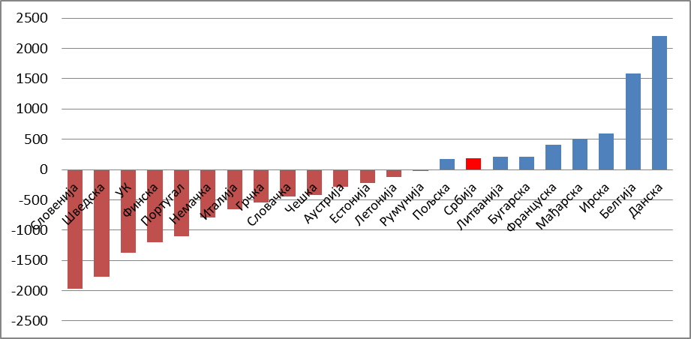

Chart 14. The balance of foreign trade of agri - food products

of the Republic of Serbia and the EU countries (euro/ha)

Source: RSO and EUROSTAT

There were no significant changes in the structure of trade in agricultural and food products in the last decade. Traditionally, the most important export products were grains (HS10), fruits and nuts (HS08), sugar (HS17), fats and oils (HS15) and beverages (HS22), which together account for about 60% of the total value of exports of agricultural and food sector. Import of agricultural products was much more diverse. Four major imported products (fruits and nuts, coffee/tea, various food products and beverages) accounts for 30% of imports of agricultural products in Serbia. There was relatively little trade in meat and dairy products in both directions.

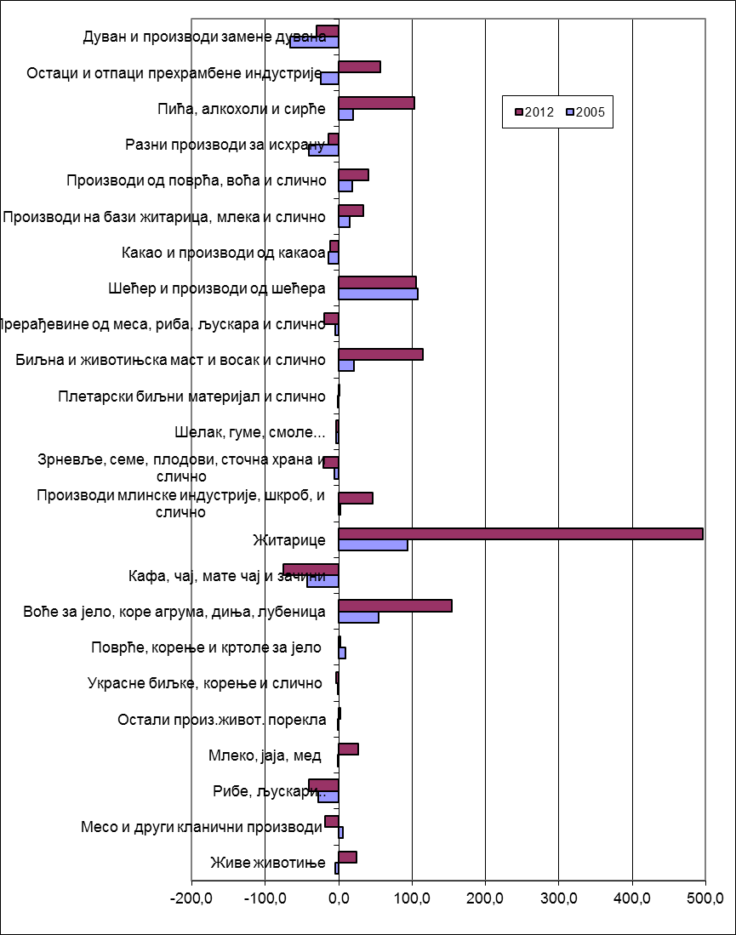

Live animals

Meat and other slaughtering products

Fish and Shellfish

Milk, eggs and honey

Vegetables, roots and tubers for eating

Other products of animal origin

Ornamental plants, roots and similar

Stone fruits, peel of citrus fruit, melons & w.melons

Coffee, tea and spices

Grains

Products of the milling industry and starch

Grains, seeds, fruits, feed and similar

Shellac, rubbers, and resins

Wickerwork plant material and similar

Vegetable and animal fat, wax and similar

Meat, fish and shellfish products

Sugar and sugar products

Cocoa and cocoa products

Prod. Based on grains, milk and similar

Products from fruits and vegetables

Different food products

Beverages, alcohols and vinegars

Remains and waste from the food ind.

Tobacco and tobacco replacements

Chart 15. The balance of trade based on group of products

in 2002 and 2005 (millions of euro)

Source: RSO

The most important trade partners of Serbia are the countries of EU-27. Half of the exports and 45% of imports of agricultural and food products is carried out with the EU countries. Five major agricultural products imported in Serbia from the EU are different food products (HS21), fruits (HS08), beverages (HS22), remains and waste from the food industry (HS23) and tobacco (HS24), which accounts for about 40 % of total imports of agricultural products. Main exports from Serbia to the EU are fruits (HS08 - especially raspberry, sour cherry and blackberry), cereals (HS10), sugar (HS17), animal and vegetable fats and oils (HS15, of which soya and sunflower oils are major export products of Serbia to EU). The five categories of products account for about 70 % of total Serbian exports to the EU.

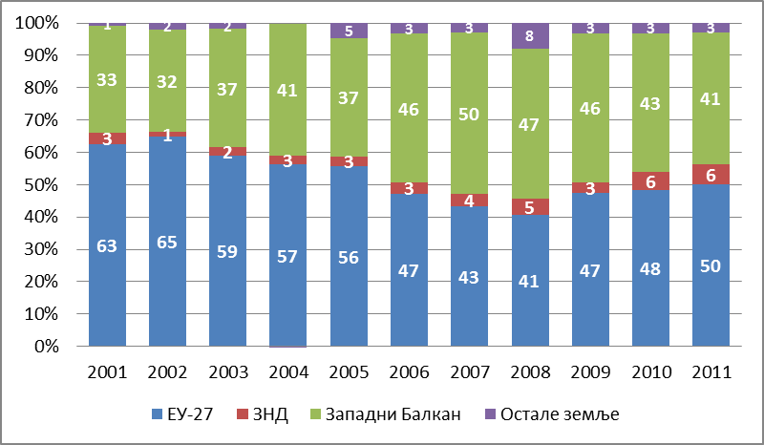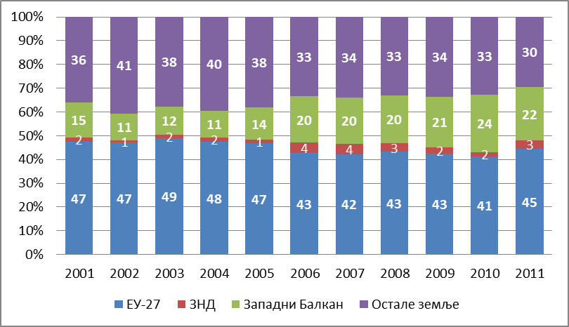

**CIS**

**CIS**

**EU27**

**EU27**

**Other Countries**

**Other Countries**

**West Balkan**

**West Balkan**

|  |  |
| --- | --- |
| Export | Import |

Chart 16. The structure of exports and imports of agricultural and food products of

Serbia by groups of countries (%)

Source: RSO and EUROSTAT

Trade with EU countries has been conducted on the basis of the Interim Trade Agreement (ITA). Serbia decided to start with the implementation of the Agreement on January 30th 2009, while the EU started applying the Agreement on February 1st, 2010. The European Union approved the elimination of all quantitative restrictions, tariffs and duties on their own imports of agricultural and fishery products from Serbia. Exceptions are alive male calves and "baby beef", sugar and wine. For calves tariffs were reduced (compared to the MFN tariff levels) but not completely abolished, while for the "baby beef" and sugar the annual quota (of 8.700 tons and 180.000 tons, respectively) has been applied. Also, when it comes to certain categories of fruits and vegetables, specific tariffs (fixed amount per ton) were eliminated, while the tariffs of the added value although reduced, were retained. and.

Second important foreign trade partner of Serbia are former Yugoslav republics. Almost half of the exports of agricultural products Serbia has the ultimate destination to one of these countries, and nearly a quarter of total imports of agricultural and food products in Serbia originates from these countries. Trade in agricultural products between Serbia and neighboring countries is quite diverse. Grains or products/processed grains are the main products that Serbia export to the region. Beverages are the main product in the export to and import from the former Yugoslav republics. In the trade on the regional market, Serbia has (traditionally) been a net exporter in each of these countries except Croatia.

Growing share in the structure of exports of agricultural and food products was recorded by a group of countries of the Commonwealth of Independent States (CIS). Serbia is the only country in Europe, apart from some members of the Commonwealth of Independent States, which has signed a Free Trade Agreement with Russia. The agreement stipulates that the goods for which it can be proven to originate from Serbia (goods that have more than 50% of the content from Serbia), do not pay customs duties when they are intended for the Russian market, unless exempted from free trade regime. A list of products on which the free trade regime is not applied changes every year, but agricultural products have not been affected until now. A major problem in exporting products to the Russian market is the large number of technical barriers. These barriers were caused by the existence of strict regulations and standards that are defining the characteristics of the products that can be traded on the Russian market. These standards are in some respects more demanding then standards that apply to the EU market.

**2.6. The condition and trends in rural areas**

On the territory of the Republic of Serbia there are 6,158 settlements, of which 193 are in urban areas (3.1%), and 5,965 are other settlements, which are automatically considered rural ones. Since 1981, The Republic Statistical Office of the Republic of Serbia has been applying administrative criteria for identification of the type of settlement, according to which settlements are divided into "urban" and "other". The division was based on the decision of the administrative units of local government to declare certain settlement as urban. All other settlements that are not designated city are classified as "other". For the description of the situation in the rural areas of Serbia in this document the official statistics data on "other areas" as defined by the RSO will be used.

2.6.1. Demographic characteristics and trends

Population Census results from 2011 show that the demographic trends in Serbia, especially in its rural areas, are increasingly unfavorable. In the period of 2002-2011 there was a decline in the total population of 4.15%, which was primarily a result of negative population growth and due to migration abroad. The rural population in this period was reduced for 311.139 people (10.9%), and fell below 3 million, and now is 40.6% of the total population of Serbia. The following information explains the negative demographic trends in rural areas:

In about 1000 villages population is less than 100 inhabitants, which basically shows that every fifth villages on the verge of disappearing, the biggest concentration of such settlements are on the south and on the east of the country, where every third village has fewer than 100 residents.

Ten villages do not have a female resident, while in two villages live only women.

In rural areas of Southern and Eastern Serbia population was reduced by 19% during the period of nine years. The average population density in a square kilometer in Crna Trava was boiled down to just five people, and the average age of its residents is ten years above the national average.

Region Šumadija and Western Serbia is the only one where more people live in rural than in urban areas (52.6%).

***The age structure of the rural population***

One of the key characteristics of demographic development in Serbia is an increasingly unfavorable age structure. Changes in the age structure in the period of 2002-2011, indicate a continuation of the process of declining of share of young people, with simultaneous increase in share of the elderly people. The parameters of the age structure of the rural population are even worse. Every fifth resident of village in Serbia is older than 65 years of age, while in the Southern and Eastern Serbia it is every fourth one. The coefficients of age dependency in rural areas, with the exception of the region of Vojvodina, indicate that per each person older than 65 years, there are three (in some areas even less) in the age group of 15-65 years. On the other hand, the relationship between the young and old populations shows that per every 100 people older than 65 years, there are only 69 of those under the age of 15 years (in the Southern and Eastern Serbia, only 52).

Table 12. Age structure of the rural population in the Republic of Serbia, in 2011

|  |  |  |  |  |  |
| --- | --- | --- | --- | --- | --- |
|  | **Population structure by age groups (%)** | | | **The coefficient of age dependency** | **The relationship between the young and old populations** |
| **0-14** | **14-64** | **65+** |
| **Serbia** | 13,9 | 66,0 | 20,1 | 30,4 | 69,3 |
| **Belgrade region** | 15,0 | 69,1 | 15,8 | 22,9 | 95,2 |
| **Vojvodina** | 14,3 | 68,5 | 17,3 | 25,2 | 82,7 |
| **Region Šumadija and Western Serbia** | 14,1 | 65,3 | 20,6 | 31,5 | 68,7 |
| **Region Southern and Eastern Serbia** | 12,8 | 63,1 | 24,1 | 38,3 | 52,9 |

Source: RSO

***The educational structure of the population***

In the educational structure of persons older than 15 years of age in the Republic of Serbia, the most common are those with a high school education (47%), whose share has increased since the previous Census by 5 percentage points. The same trend is also present in rural areas, where people with a high school education make up 37% of the population over 15 years of age, and for the first time there are more people in this category than in the category of the illiterate or people without primary education (which made 15% according to the last Census). Growth in the share of people with secondary education took place at the expense of reducing the share of persons with lower education. However, noticeable is the reduction in the share of highly educated rural population, in all regions. Favorable educational and age structure of the population have villages in Vojvodina.

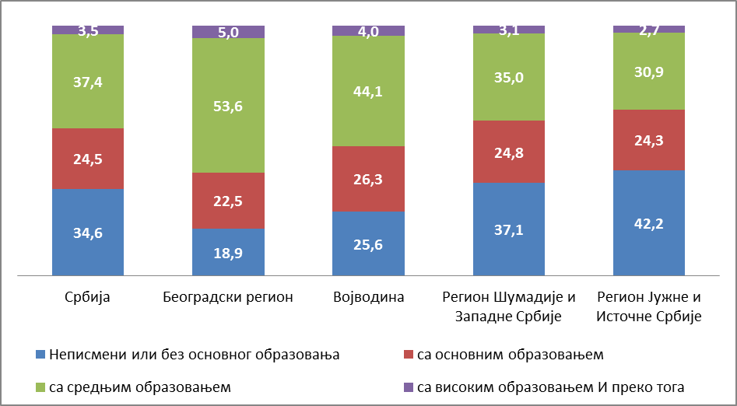

With primary education

With university or higher education

Illiterate or w/o primary education

With high school education

Serbia Belgrade Region Vojvodina Šumadija & W.Serbia South & Est Serbia

Chart 17. Educational structure of rural population in the Republic of Serbia, based on regions

Source: RSO

Modest knowledge and lack of additional skills of the rural population are confirmed by the data according to which 97% of the rural population has not attended additional training programs, and 54% does not have special knowledge and skills[25]. These results adversely affect the overall capacity and competitiveness of the labor force in rural areas. The low quality of the labor force can be considered as one of the factors that hold back economic development in rural areas, since it is the reason of low entrepreneurial potential of the people in rural areas, just as it causes low economic interest of foreign investors. Such an environment encourages the migration of highly educated population, because it is difficult for an educated workforce to remain in areas without enough attractive jobs that match their education and ambition.

2.6.2 Rural Economy

The state of the rural economy of Serbia, due to lack of data cannot be represented by standard indicators related to rural GDP and its structure. For this reason, the overview is focused on different aspects of the labor market and income of rural households.

The movement of the main labor market indicators (unemployment rate, employment and activity) indicates that there was no significant difference between urban/rural in Serbia over the last decade, and that their relation is not different from the general picture in which rural areas are in a better position compared to urban. The urban areas are characterized by a higher share of the unemployed and the active in the population and a lower share of the employed and the active in the population of working age, hence the position of the rural population in the labor market is somewhat better than that of the urban population. The rural population of working age, compared with the urban population has higher rates of activity (60.9:59.5%) and employment (47.9:43.4 %) and lower rates of unemployment (21.3:27%) and inactivity (39.1:40.5%). The reason for this is the fact that rural areas provide higher employability for less educated people, especially with regard to their work in agriculture. On the other hand, this type of engagement points to a significantly higher share of vulnerable employment in rural as compared to urban population.

Table 13. Employment rate

|  |  |  |  |  |  |  |  |  |  |
| --- | --- | --- | --- | --- | --- | --- | --- | --- | --- |
|  | **2004** | **2005** | **2006** | **2007** | **2008** | **2009** | **2010** | **2011** | **2012** |
| **Employment rate (15-64)** | | | | | | | | | |
| **Serbia** | 53,4 | 51 | 49,8 | 51,5 | 53,7 | 50,4 | 47,2 | 45,4 | 45,4 |
| **Urban settlements** | 52 | 49,6 | 49,1 | 50,8 | 50,7 | 47,9 | 45,4 | 43,9 | 43,4 |
| **Оther settlements** | 55,5 | 53 | 51 | 52,4 | 58,1 | 54 | 49,8 | 47,4 | 47,9 |
| **Unemployment rate (15-74)** | | | | | | | | | |
| **Serbia** | 18,5 | 20,8 | 20,9 | 18,1 | 13,6 | 16,1 | 19,2 | 23 | 23,9 |
| **Urban settlements** | 20,4 | 22,6 | 22 | 18,6 | 15,9 | 18,4 | 21,4 | 24,8 | 26,9 |
| **Оther settlements** | 16,2 | 18,7 | 19,4 | 17,3 | 10,8 | 13,3 | 16,4 | 20,6 | 20,1 |

Source: RSO

Structure of employment by sectors of the rural population has changed dynamically in recent years. Employment rate in agriculture is still the highest in comparison with other sectors and from 2004 to 2012 it was in the range from 43 to 50%, which is very high compared with other European countries. Employment rate in agriculture, however, has had the highest reductions in comparison with other sectors, so in 2011 it dropped to a level of less than half a million employees, and the rate in 2012 in relation to the rate in 2004 was lower by 56%. The decline in employment in agriculture can be linked to a high share of employment of rural labor force in the informal sector (31.3%), on seasonal and temporary jobs whose market is flexible and very sensitive to market fluctuations, especially in times of crisis. However, such a sharp reduction in informal jobs since the beginning of the crisis is difficult to explain, since it is contrary to the standard thesis on reverse direction of changes in informal employment in time of crisis[26]. The explanation can be found in the fact that during that period persons who are only occasionally active left the labor market , as is evidenced by the high rate of depopulation and aging in rural areas. The share of the tertiary sector has been recording a constant increase (with the exception of the 2008), while employment in the primary sector and industry decreases[27].

Only every fourth or fifth inhabitant of villages is working in the industry and that number is decreasing. On the other hand, the rural population has been increasingly employed in the tertiary sector, which can be interpreted in two ways: on the one hand, it is the result of better stability of jobs in the industry sector, and on the other, it is due to the growth in the number of employees in the public administration, education, community and social services.

Incomes of rural households mainly (35-42%) come from incomes in employment (regular and supplementary), and are immediately followed by the share of pensions whose share is very high and increasing (from 20% at the beginning of the period, to about 30% in 2012)[28]. Incomes from agriculture vary in the range from 6 to 9 % of the total available funds of households, which highly depends on yields in agriculture in some years. At the same time, the value of natural consumption, which is mainly attributed to the consumption of food produced on the farm, is stable at a level of 12-14%. In any case, the incomes earned from agriculture are relatively low compared to earnings from other sectors and social benefits, which is a clear indicator of the sector’s low productivity.

Table 14. Structure of income of rural households Serbia

|  |  |  |  |  |  |  |  |
| --- | --- | --- | --- | --- | --- | --- | --- |
|  | **2006** | **2007** | **2008** | **2009** | **2010** | **2011** | **2012** |
| **Income from employment** | 38.9 | 37.1 | 42.1 | 39.9 | 36.3 | 36.9 | 35.7 |
| **Pensions** | 19.7 | 23.1 | 24.2 | 26.6 | 29.5 | 26.8 | 30.2 |
| **Incomes from agriculture** | 7.8 | 6.8 | 8.3 | 6.8 | 9.3 | 7.8 | 7.6 |
| **Natural consumption** | 14.8 | 14.7 | 12.7 | 12.6 | 12.4 | 13.9 | 13.2 |
| **Оther** | 18.8 | 18.3 | 12.7 | 14.1 | 12.5 | 14.6 | 13.3 |

Source: RSO

Gender issues in the area of ​​economic participation are very common among the rural population. There is less participation of active people among women, fewer employees and fewer people working outside agriculture than men. From the perspective of regional differences, it is evident that in Vojvodina is a slightly smaller share of the unemployed among women than among men, which does not mean that their economic situation is better since they are less employed in non-agricultural sector than men, less engaged in agriculture and are inactive in a significantly larger number of cases. . Women are in much less favorable position according to all indicators in the Southern and Eastern Serbia where gender differences are particularly strongly manifested in all segments of the labor market.

In addition to women, young people in rural areas are also facing a high risk of exclusion from the labor market. Young people in the age group between15-24 are in only 21% of cases employed in non-agricultural sectors. Although in this age group even half of them are inactive, what indicates the difficulty of access to jobs is significantly larger share of the unemployed, which in these categories and the following age categories (25-34 years) is only 15.5%.

2.6.3 Small households and poverty

Through their number, proportion in land resources, as well as their specific patterns of functioning, small family households are an inevitable part of the rural economy that requires special attention. Their number is reducing under the influence of the aging process of villages, migration, globalization, increase of concentration of capital in agriculture and under many others influences. On the other hand, with their own food production and the contribution to food self-sufficiency and stability, their importance for conservation of resources and rural environment, participation in the local market for goods and services, small family farms are positioned as subjects that require proper treatment of common agricultural policies.

In Serbia, most family farms use up to 2ha of agricultural land (48.8% of the total number), and these farms cultivate approximately 8% of agricultural land. Moving the “focus” of the land used to the higher group (up to 5ha), we can see that this size of farms, although they account for 78% of the total number, have only 25.3% of the area at their disposal.

The category of small households in Serbia is very heterogeneous. Small holding is possessed by:

poor households, which can be of two types: a) elderly, often single-person households, and b) farms owned by persons who were formerly employed outside agriculture, and/or long-term unemployed;

"returnees" from the city – mainly older, retired people, although (sporadically) there are young families that prefer a rural environment and are ready to start an alternative activity on a small farm;

residents of rural areas with regular income from non-agricultural sectors, entrepreneurs and employees in the civil service or company in the place of residence or the immediate vicinity.

Such a diverse socio-economic profile of small family households indicates that their strategies of survival, and therefore their relation toward agriculture and rural environment, have to be significantly different. In any case, the prospects of these households are within the range of phasing out (elderly households) to participation in the market offers of innovative products and services of the rural areas (those who have a vital and well-qualified workforce and strong social capital), through a series of transitional arrangements in the form able to adapt to cyclical market trends.

Poverty in Serbia is predominantly a rural phenomenon, having in mind that rural areas were in some periods affected twice more than the urban areas. Although there was a significantly faster decline of poverty in rural than in urban areas before the crisis (2006-2008), in 2009 overall increase in poverty was launched in rural areas, while the percentage of poor people in urban areas remained almost unchanged (5% and 4.9%, respectively).

Table 15. Percentage of poverty based on type of settlements – absolute poverty line

|  |  |  |  |  |  |
| --- | --- | --- | --- | --- | --- |
|  | **2006** | **2007** | **2008** | **2009** | **2010** |
| Serbia | 8,8 | 8,3 | 6,1 | 6,9 | 9,2 |
| Urban areas | 5,3 | 6,0 | 5,0 | 4,9 | 5,7 |
| Other areas | 13,3 | 11,2 | 7,5 | 9,6 | 13,6 |

Source: RSO

Rural areas were more responsive to the economic crisis and were strongly affected by it, the overall increase in poverty in the Republic of Serbia was generated as a result of increased poverty in rural areas. Compared to 2008, the percentage of poor people in rural areas (measured by the absolute poverty line) in 2010 increased by 6 percentage points, while the percentage of the urban poor people increased by less than one percentage point. The widening gap between poverty of urban and rural areas during the crisis was passed on from year to year, so in 2010 it reached a record rate of 2.4. While the growth of poverty in the countryside in 2009 could be explained with the sudden drop in food prices (after the record yields in 2008), the rapid impoverishment of the rural population in 2010 certainly had roots in the economic crisis and its impact on the rural labor market. Since the economic crisis has been strongly reflected in employment in the informal sector, which is very frequent in the rural economy, it is likely that the trend of increasing poverty in the country will continue.

Large regional differences in poverty are in line with the existing differences in the economic development of the regions. Regional differences in the prevalence of rural poverty are significant and follow the relationship that exists between the regions in terms of overall poverty: the most unfavorable situation is in the Southern and Eastern Serbia, while it is more favorable in Vojvodina.

2.6.4 Social networks in rural areas

In Serbia in the period from 2000 to 2012, with the help of international donor support a large number of civil society organizations were formed, including those dealing with specific aspects of rural development. However, the development of social capital and networks in rural areas of Serbia is relatively modest in terms of the number and types of civil society organizations that are present in these areas. Special activity during this period was demonstrated by organizations dealing with issues of poverty and vulnerable groups in rural areas (situation/status of refugees and displaced persons, women and young people), environmental issues and the preservation of cultural heritage.

In early 2007, the MoAg began the process of intensive co-operation with civil society sector through the systematic support for the establishment of the National Network for Rural Development, encouraging the network members to support rural development in strengthening the bonds between all of identified individuals, implementation of all joint activities and training of the CSO sector in rural development. Through the established network office information dissemination was enabled as regards all aspects of development support to agriculture, the basic principles of LEADER and other current topics. Today, the Association "Network for Rural Development of Serbia" is voluntary, non-profit organization, founded on the freedom of association of persons and legal entities. Area of activity of the Association is the whole territory of the Republic of Serbia and the members of the Network for Rural Development Serbia are 23 regional associations of CSO. The ultimate goal is to develop and improve agriculture, create better living and working conditions in rural areas and poverty reduction in rural areas.

In the period between February 2011 and February 2013, through the support instrument for pre-accession assistance (IPA), the LEADER Initiative project in Serbia (LIS) was implemented. During the two years of implementation of this project, 605 groups signed Memorandums of Understanding defining partnerships for territorial rural development. During the process of creating and strengthening partnerships’ work, the development of 24 Local Rural Development Strategies was supported. Of this number, simulating IPARD evaluation process, it was estimated that 21 LSRR meet the LEADER program criteria, covering 8% of the population and about 15% of the territory of the Republic of Serbia.

**2.7 Incentive policies in agriculture in the past period**

2.7.1 The concept and objectives of agricultural policy in the past

In Serbian agriculture the incentives policies during the last decade were exposed to the complex and heterogeneous factors such as: political and economic (in) stability, dynamic changes in the volume and structure of production due to unstable weather conditions, and from the second half of the 2000s the global market distortions.

The first transition years brought radical shifts in comparison to the previously applied policy that was characterized by strong state interventionism in the regulation of the agricultural sector. The first reform-oriented government devoted most of attention to institutional changes, especially with regard to legislative solutions. A major challenge in the early 2000s was to reduce the space for gray market activities and to establish a stable market supply with basic agricultural products. Significant efforts were made in the recovery of certain branches of agricultural production, whose scope was significantly reduced during the economic sanctions, isolation and loss of market in comparison to the previous period (production of meat, sugar, fruit and vegetables). By the measures of agricultural policies revitalization of broken market links in the food chain and the creation of basic market infrastructure for closer cooperation of primary production and processing industry were encouraged. Policy incentives at that time were production oriented, with a strong emphasis on sectors that contribute to the activation of the food processing sector and the growth of exports. Opening of external markets and EU autonomous trade preferential (contained in Resolution 2007/2000 EC and amended with regulations 2563/2000 EC), together with the privatization of industrial enterprises (especially sugar and edible oil refineries) favorably influenced the growth of export opportunities. The relatively modest budget allocations to agriculture did not leave space for radical changes in the mechanisms of support.

Institutional changes in the sector during this period were slow and without continuity, mainly due to the mixing of the jurisdiction of republic and federal institutions. The transfer process of jurisdictions in agriculture from the federal to the republic level was fully completed in 2004. Until the establishment of the State Union of Serbia and Montenegro (2003), both Ministries functioned parallel, at the republic and at the federal level. With the establishment of the State Union of Serbia and Montenegro, the Ministry of Agriculture at the federal level was abolished and a part of the responsibilities that Federal Ministry had (sanitary controls, export subsidies, etc.) were reassigned between the Federal Ministry of Economy and Internal Trade (which continued to function) and the Serbian Ministry of Agriculture. With the separation between Serbia and Montenegro, all responsibilities in the sector were taken over by the Ministry of Agriculture, Forestry and Water Management.

From 2004, in the agricultural policy of Serbia ​​a new change on strategic goals and implementation mechanisms in relation to the previous period was made. The Government of the Republic of Serbia adopted a Strategy of Agricultural Development[29] in 2005, which defines the following strategic objectives:

build a sustainable and efficient agricultural sector that can compete on the world market, contributing to the growth of national income,

provide food that fulfill the needs of consumers in terms of quality and safety,

maintain the support to the standard of living for the people who depend on agriculture, but are not able to keep the pace of economic reform,

provide support for sustainable rural development,

protect the environment from the effects of agricultural production,

prepare Serbian agriculture for EU integration,

prepare domestic policy support and trade in agriculture for WTO rules.

This strategy was not supported from the beginning with multi-year program documents, it did not have a defined budgetary framework, and therefore measures for its implementation inconsistently followed the stated objectives. In definition and selection of measures applied in that period it is possible to recognize the effort to address the fundamental development problems, but their conceptualization and quantification over goals and tools was present only in outline.

Reformed agricultural policy should contribute to increase in competitiveness of family commercial farms, with a shift in the implementation mechanisms of policy incentives to production and income, to encourage investments. This course was only partially accompanied by appropriate measures and funds up to 2008. This period was followed by a period of increased instability of agricultural policy and the common shifts of the direction of policies incentives. It is important to emphasize that these changes were only partly motivated by objective changes in the business environment, but much more by frequent changes in management structures that sought radical solutions to accelerate the long-term structural processes.

2.7.2 The effects of agricultural policies in the past

The Strategy of Agriculture Development from 2005 did not have defined indicators for monitoring of implementation, so its effects cannot be analyzed from the aspect of achieving the defined objectives. Due to the lack of valid analytical base, more precise assessment of the effects of certain measures cannot be given. However, analysis of the situation in the previous chapter indicates that there has been progress in some sub-sectors.

Significant progress was recorded in plant production, both in terms of changes in production structure, as well as in export competitiveness. During the first half of the last decade, the increase was particularly noticeable in the production of industrial crops and exports of sugar and edible oil. A significant increase was recorded in exports of fruits and vegetables, and in the years of the beginning of the economic crisis, the production and export of grain (especially corn) became the main carriers of the positive trends that sector recorded.

In contrast to this, the livestock sector did not show significant improvement, and negative trends in cattle production continued. This primarily should be attributed to inconsistent policy of support to this sub-sector, unprincipled approaches in selected models of support, which varied in the range starting with the fact that there was an overlap of support measures (more regulation for the same or similar user group), to the fact that in some years, some measures had completely opposite effects. Having in mind that this is a sector particularly sensitive to ad hoc solutions (due to the long production cycle), it is clear that in such environment which existed in previous years, there was no room for significant improvement of livestock production.

Positive progress was made in the area of defining the contours of the first rural development policy based on the EU model of support. The reintroduction of credit support can be valued as major progress, as well as the support in the form of grant funds for the renewal of machinery, facilities, equipment, and later plantings and parent heard. However, the fact that the measures of the second pillar of support were treated almost as a completely separate part of the policy, without sufficient concern about the synergistic effects that can be achieved by their coordination with the measures of the first pillar, is particularly indicative. For the assessment of the effects of support to rural development there are no indirect indicators, but it can only be presented from the perspective of the number of beneficiaries for each measure. However, it is safe to say that progress in organic farming, wine production, products with geographical indications and rural tourism is visible. Since the support for these programs was extremely unstable, both in terms of measures and funds resources and that a significant part of the activities were funded by donors, these conclusions cannot be proved with data on disbursed budgetary incentives.

An important place in the system solutions of Agricultural Policy had programs support for institutional capacity building, financing agricultural extension services and the establishment of new laboratories, strengthening of inspection services and the training and specialization of staff. Institutional strengthening of the sector is reflected in the progress in the introduction of information systems in agriculture. Transparency of procedures was raised to a higher level with the establishment of the agricultural payments directorate, even though the system is still not fully functional and efficient in all aspects. For effective control of implemented support there is a lack of consistent procedures and human resources. The whole process of submission and getting support is a demanding job, both to applicants and to agencies involved in the implementation. The major activities in the area of ​​strengthening the institutional capacity are EU funded projects and with other forms of donor support. However, lack of human capacity challenges the viability and sustainability of most of these projects.

2.7.3 Agricultural budget

The most important form of state support for agriculture and rural areas is achieved through the agricultural budget. Agricultural budget is part of the overall budget of the Republic of Serbia, which was introduced in the political practice of Serbia in 1996, with the aim to provide stable financial resources to support agriculture and rural areas. The Government prescribes, for each fiscal year, the amount of funds, the types and maximum amounts for certain types of incentives, in line with the Law on Incentives to Agriculture and Rural Development and with the law which regulates the budget of the Republic of Serbia.

Agricultural budget contains a detailed description of the budget lines (programs). The programs include basic information about the measures that will be implemented in the current year and the planned resources for their realization.

The total amount of budget funds invested in agriculture and rural development has been determined by a number of factors. The extent of support often depends on the economic situation in the country and the necessity to meet the needs of other budget users, than to reflect the real needs of agriculture and rural areas for financial support.

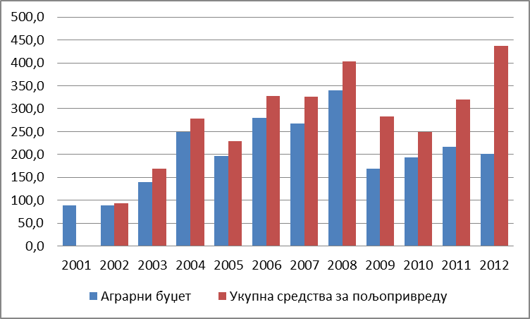

Total allocated funds for agriculture

Ag Budget

Chart 18. Ag Budget and total allocated funds for agriculture (millions euro)

Source: Ministry of Finance, Republic of Serbia, the Law on Budget for the relevant years

The amount of the agricultural budget and the total funds allocated for agriculture and rural development are expressed in absolute terms annually, had a tendency to increase until the 2008. However, growth was not stable and steady even in this period, because in 2007 and especially in 2005, there was a decrease from the previous year. In 2009, a radical reduction in the nominal value of the agricultural budget by 50% happened.

In 2009, 2011, and particularly in 2012, the total assets invested in agriculture were significantly higher than the agricultural budget. These were the funds from MoAg own income (Directorate for Agricultural Land, Veterinary Directorate and Budget Fund for Water), the amount has been growing since 2009, when state land leasing started, generating significant funding in the budget.

Despite the general tendency to increase the agricultural budget until 2008, its share in the total Serbian budget significantly increased in the period 2003-2004. For most of the evaluated period, the agricultural budget accounted for around 4% of the total budget, until last years when it dropped to only about 2.6%. Total funds invested in agriculture in the 2012 reached a record 5.7% of the total budget (increased by one third compared to the previous year, in which the absolute and relative term was the lowest during the whole observation period).

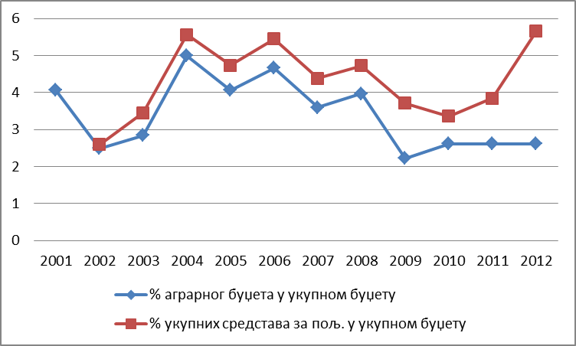

of the agricultural budget in the total budget

of the total allocated funds for agriculture in the total budget

Chart 19. The share of the agricultural budget in the total budget of Serbia

Source: Ministry of Finance, Republic of Serbia, the Law on Budget for the relevant years

2.7.4 The structure of the agricultural budget by pillars of support

Analysis of the structure of the agricultural budget by pillars of support was made based on data on the realized budgetary funds of MoAg. Data on the budget implementation measures are collected through different methodologies and systematization, which obstructs the creation of a consistent series for monitoring of the effects and results of individual measures. For this reason, the current agricultural policy of Serbia is only partially comparable to the international standards and theoretical concepts. Description of measures deviates from these standards, or they contain different elements that cannot be classified into conceptual established groups. It is particularly important to note that the resources of the agricultural budget in this analysis do not include the funds invested from the budget of the Autonomous Province of Vojvodina, as well as municipal budgets.

The systematization of support on measures groups within the individual pillars of support, was performed using the *APM* database (*Agricultural Policy Measures database*) for Serbia, which allows qualitative and quantitative analysis applied measures of agricultural policy, through uniform measure classification by the EU and the OECD approach. *APM* classification of all agricultural policy measures are grouped into three main pillars:

measures of market-price support and direct support to producers,

structural and rural development measures, and

general measures to support agriculture.

*APM* model also includes the distribution on other transfers to agriculture, which contained all the payments with missing information on the basis on which they can be separated into appropriate categories.

The structure of the agricultural budget by pillars of support over the last decade has varied considerably. The main reasons were the lack of funds in the budget in some years why some of the individual measures were extinguished, and the frequent changes in management structures which are usually been accompanied by radical changes in the programs and support systems.

The dominant share of the budget structure has measures of market-price support and direct payments. If we have in mind that unallocated funds mainly consist of outstanding liabilities in respect of reimbursement of inputs and milk premiums, it can be concluded that, with the exception of the 2006, support to the first pillar consists of more than 80 % of the total funds invested in agriculture of Serbia. The share of funds to support the second pillar since 2006 has been declining, while the share of funds for general support measures for agriculture and non-appropriated funds has been increasing. The permanently low amount of funds to support general services in agriculture is indicative, and for this purpose relatively more resources were spent at the beginning of the period when donor support for these purposes was higher.

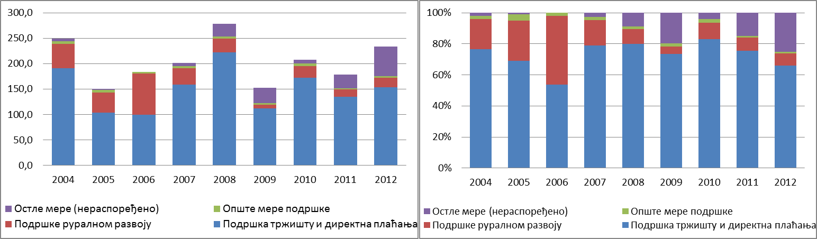

Market support&direct payment

Market support&direct payment

Rural dev. support

Rural dev. support

General measures

General measures

Other measures

Other measures

|  |  |
| --- | --- |
| EUR m | (%) |

Chart 20. Support to agriculture in Serbia, in measures by pillars

Source: internal data of the MAFWM

Significant changes in the structure of the budget have been in the 2006, when more funds are spent on funding non-commercial ("elderly") farms. This support was abolished in the following year, and the amount of funds to the second pillar since then has been continuously decreasing. In fact, in the years when the production was affected by weather conditions and/or strong market fluctuations, an increasing portion of the funds was diverted to producers in the form of support for inputs or in the form of direct payments, in order to support the financing of current production.

2.7.5. The structure of agricultural budget by groups of measures of agricultural policy

During the monitored period there were frequent changes in the support program, in some years, even several times, changing the descriptions of measures and methods of their operationalization. Therefore, grouping of measures in appropriate groups, and then the presentation of funds used to finance them, is not always sufficiently accurate or detailed. In fact, measures with the way of financing changed so much during the same year, that they became completely different, were switched to another group of measures, and that was presented in this analysis using very generic descriptions and disclosed are as "other transfers to agriculture". In addition, funds that were disbursed for payments from previous years, were stated as undistributed funds, since relying on the available database is not possible to reconstruct how much of the funds were spent for any of the measures of the previous year.

***2.7.5.1Market-price support***

From the group of measures of market-price policy in Serbia during the period 2004-2012, various measures were implemented, such as: export refunds, intervention buying, operating costs of keeping public reserves and co-storage costs. Among these measures in the period only export incentives were continuously applied, while the incentives for support for private storages and for emergency purchase, were financed only occasionally (in terms of, when the bad weather caused market distortions).

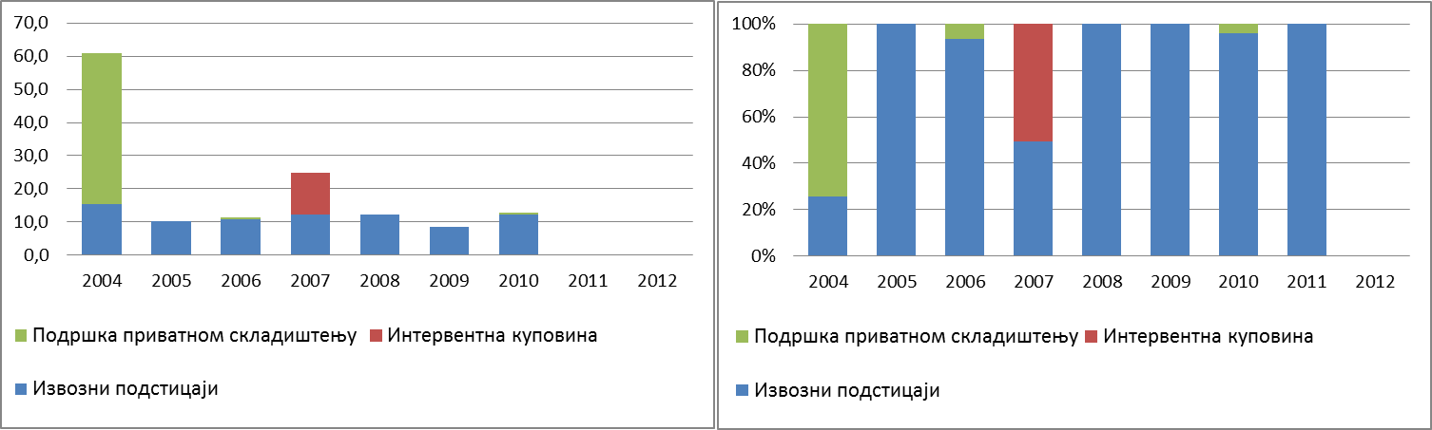

Emergency purchase support

Emergency purchase support

Export support

Export support

Private storage support

Private storage support

|  |  |
| --- | --- |
| EUR m | (%) |

Chart 21. Market-price support measures for Serbian agriculture

Source: internal data of the MAFWM

The share of market-pricing measures in the total agricultural budget is continuously declining, from 32% in 2004 to only 0.2% in 2011. After 2011, financing of these measures was discontinued and replaced by direct incentives.

***Measures of direct support to production***

Measures of direct support to production in Serbia during the period 2004-2012 included direct payments to producers based on the output (price support), payments per hectare and livestock, as well as subsidizing inputs (including regress, subsidized interest rates, insurance premiums, etc..). As measures of the longest tradition and immediate, direct effect on farm production and income, these types of incentives for producers are most comfortable and most important, so, they are the most sensitive to their changes.

For the financing of direct payments, on average, 64% of the agricultural budget was allocated within the specified period (from 42% in the 2006, to 75% in 2011).

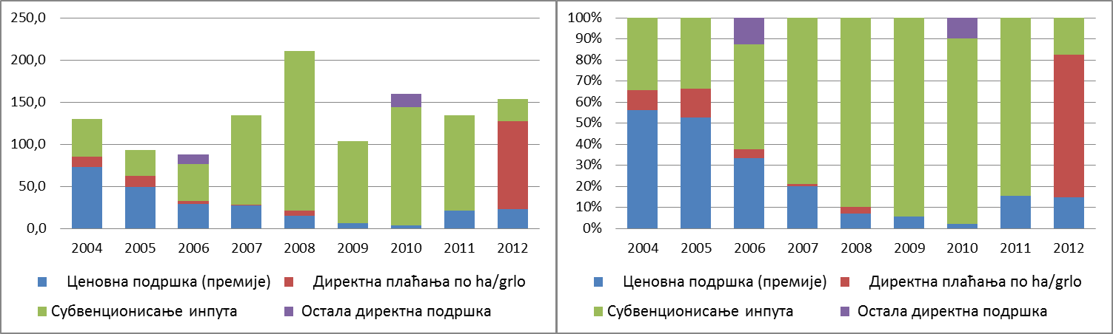

Other direct payments

Other direct payments

Input subsidies

Input subsidies

Price support (premiums)

Direct payments per ha/animal

Direct payments per ha/animal

Price support (premiums)

Price support (premiums)

|  |  |
| --- | --- |
| EUR m | (%) |

Chart 22. Measures of direct support to Serbian agriculture, based on groups

Source: internal data of the MAFWM

Measures of direct support significantly varied in volume of funds, and in the share of certain groups of measures. In addition to milk premiums, other measures were changing dynamically, introduced and abolished without giving clear signals to business. The most common reason for these changes were market failures resulting from adverse weather and resultant price fluctuations, as well as the lack of adequate strategic guidance and a clear policy framework. In this sense, it can be evaluated that the market support was driven by pragmatic reasons and attempts to stabilize the income of farmers in emergency circumstances.

The general intention is reducing of the pricing incentives, both in terms of volume of placed funds, and in terms of their share in the overall structure of support as direct incentives. In addition, the amount of product in price support model was gradually reduced. The premium for milk, as the most important measure of price support, was ​​at the beginning of the evaluating period about 20% of the total agricultural budget. Its share in recent years has fallen to about 10%, while the other forms of price support were abolished.

Table 16. Measures of price support in Serbian agriculture (euro/t, euro/l)

|  |  |  |  |  |  |  |  |  |  |
| --- | --- | --- | --- | --- | --- | --- | --- | --- | --- |
|  | **2004** | **2005** | **2006** | **2007** | **2008** | **2009** | **2010** | **2011** | **2012** |
| Premium for wheat handed over to processors | 6,89 |  |  |  |  |  |  |  |  |
| Premium for the handed over and storage wheat | 13,78 | 9,05 | 8,91 |  | 9,05 |  |  |  |  |
| Premium for commercial wheat | 89,57-96,46 |  |  |  |  |  |  |  |  |
| Premium for soya beans | 27,56 | 24,12 |  |  |  |  |  |  |  |
| Premium for sunflower | 27,56 | 18,09 |  |  |  |  |  |  |  |
| Premium for sugar beets |  |  |  |  |  |  |  |  |  |
| Premium for oilseeds |  |  |  |  |  |  |  |  |  |
| Premium for tobacco | 206,7-1309,08 | 120,61-1085,51 |  | 312,15-1373,45 | 305,21-1342,94 | 266,13-1170,96 | |  |  |
| Premium for oil pumpkin | 110,24 | 72,37 |  |  |  |  |  |  |  |
| Premium for hops |  | 603,06 | 0,00 |  |  |  |  |  |  |
| Premium for milk |  |  | 0,00 |  |  |  |  |  |  |
| *Hilly/mountain areas* | 0,06 | 0,05 | 0,05 | 0,04 | 0,03 | 0,02 | 0,01 | 0,05 | 0,06 |
| *Other areas* | 0,06 | 0,05 | 0,04 | 0,02 | 0,02 | 0,02 | 0,01 | 0,05 | 0,06 |

Source: internal data of the MAFWM

The share of direct payments for subsidizing inputs continuously grew during the evaluated period. Since 2007, the subsidization of inputs has been the dominant form of support to agriculture, with a share that exceeds 50% of the total agricultural budget. However, the structure of funds for subsidizing inputs is dynamically changing, with the tendency of concentration on support for diesel fuel and the use of mineral fertilizers. Incentives for the purchase of breeding animals until 2011 were relatively modest (with 2-3% of the total budget), while in 2011 funds for this purpose reached the amount of 9% of total agricultural budget. Among the measures of direct payments, measure for subsidizing short-term loans should be mentioned, for which in the beginning of a period about 10% of the total budget was set aside. After 2008, these incentives are reduced to a minimum and in 2010 left the support system. Although the volume of measures, users and the conditions for exercising the right to direct incentives were often changing, essentially since 2007 the support has been reduced to the incentives for subsidizing fuel and mineral fertilizers.

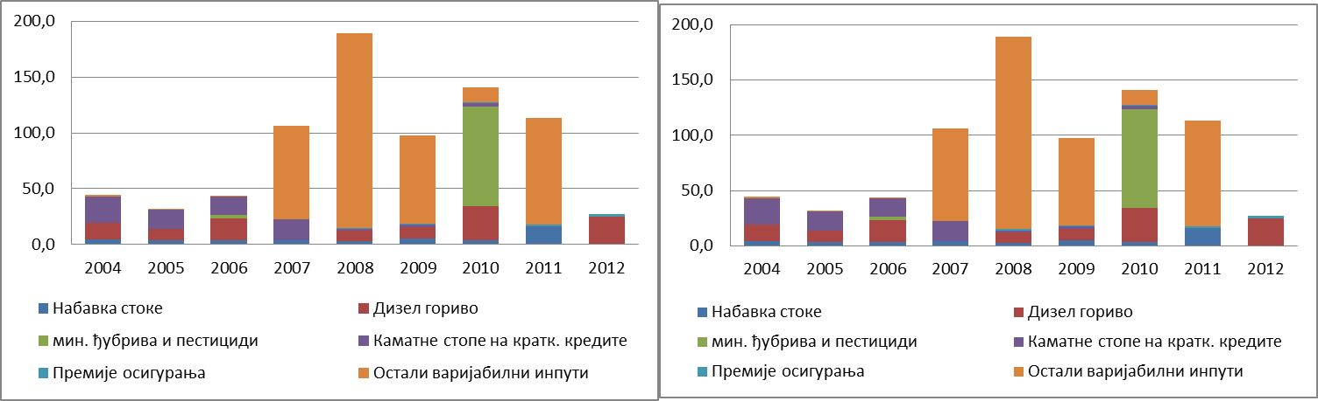

Other inputs

Interest rates on short term loans

Diesel fuel

Insurance support

Fertilizers and pesticides

Breeding animals

Other inputs

Interest rates on short term loans

Diesel fuel

Insurance support

Fertilizers and pesticides

Breeding animals

|  |  |
| --- | --- |
| EUR m | (%) |

Chart 22. Direct support for used inputs

Source: internal data of the MAFWM

Direct payments per acreage/animal are type of incentives that reflect the willingness of national policies to accept CAP solutions. The first forms of these payments were applied at the beginning of the period 2004-2012, with a constant tendency to decrease, until the total abolishment of this measure in 2008. In the 2012, these measures were again significantly present as a mode of support to agriculture, especially when agricultural crop production was promoted (except vegetables and fodder crops), as well as milk cattle.

***2.7.5.2 Policies for rural development***

Rural development policy at the beginning of the period was significantly present in the total budgetary expenditure for agricultural support, and by number of measures and programs through which was operationalized was much more diverse. Gradually, its importance is declining and measures for rural development are operationalized through a variety of programs of other organizational units within the MoAg.

The largest share of support for rural development has assets named for investment incentives at the households. Investments on the farm are encouraged by grants for the renovation and construction of buildings, purchase of equipment and machinery, renovation and expansion of perennial plantings. The criteria for allocation of funds were often changed. The general idea was that the farms in mountainous areas, as well as those who are registered to persons under the age of 40, have more favorable conditions. In addition, in some years the criteria had a prominent social component, in the sense that the evaluation of projects gave priority to the households registered on the female members, or were designed specific measures for socially vulnerable rural groups (support Roma and refugees).

Support in increasing in the average farm size and for consolidation of households possession was done through various forms, including different models of incentives for land lease and support of land consolidation.

Marketing and promotional activities, as well as business networking in the food chain, are not part of the regular supporting practice, and only sporadically appear in the budget structure with negligible amounts. These activities were generally more encouraged by donor project activities, local governments’ budget funds and through *SIPA* activities.

Support measures for environment protection are poorly represented in the budget structure, except for supports for the preservation of genetic resources (which was permanently funded until 2010) and the development of organic production.

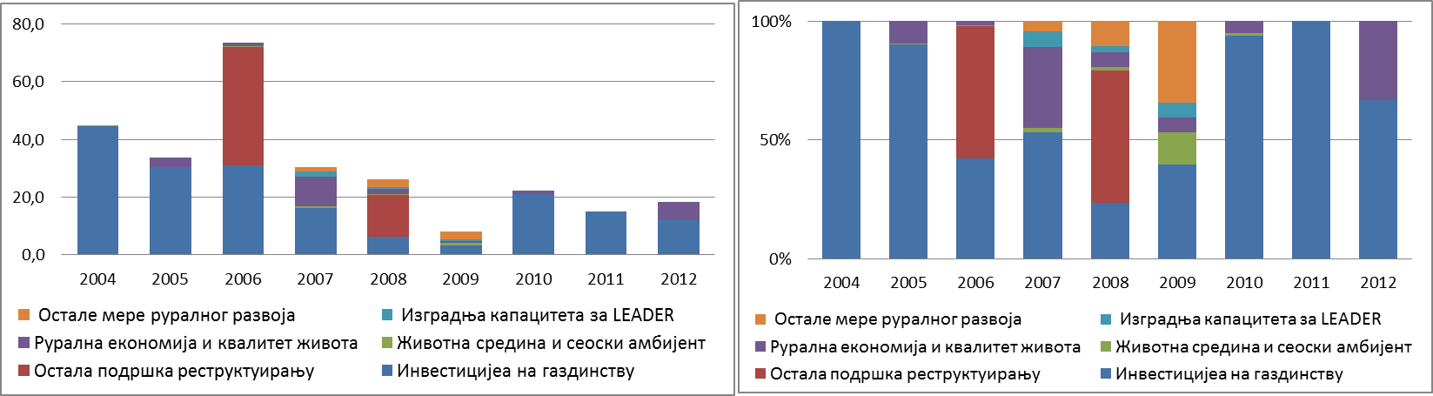

LEADER Capacity Building

Environment&rural ambient

Investments in households

LEADER Capacity Building

Environment&rural ambient

Investments in households

Other measures of rural development

Rural economy&quality of life

Other support measures

Other measures of rural development

Rural economy&quality of life

Other support measures

|  |  |
| --- | --- |
| EUR Euro m | (%) (%) |

Chart 23. Size and structure of support to Serbia’s rural development, by measures

Source: internal data of the MAFWM

The development of the rural economy through support for income diversification of households and improvement of infrastructure is modestly represented in the support structure. Major funding for this purpose was spent only in 2007 (from the funds of the National Investment Plan), after that these activities were financed from small funds. Support was operationalized through incentives for crafts, facilities reconstruction for development of rural tourism, etc.. Here it should be emphasized that some of the activities in the development of rural tourism and infrastructure were financed from other funds (funds of the Ministry of Economy, donor projects and local governments).

***2.7.5.3 Support to general measures and services in agriculture***

The users of this group of measures are not directly farmers, but they aim at establishment of better business environment in agriculture. As a rule, these measures are related to the financial support of the various activities in areas such as: inspection/surveillance, research and development activities, promotional activities, etc. This type of incentive does not affect the income or consumption, and the effects on trade and production are negligible. Therefore, this group of measures is an entirely acceptable way of supporting the development of agriculture in terms of international standards, or organizations responsible for monitoring of agricultural policies.

Within the policy of support to general services in agriculture, regular programs of the Ministry are implemented, such as the work of the services for livestock selection and breeding, agricultural extension, control of soil fertility, control of plant diseases and pests, the reporting and forecast service, etc. Most of the funds were used for the work of the Extension Service, for the research projects and expert services. There was no significant variation in funding of this support, since the funds and activities were defined through multi-year plans, which are changed only in exceptional circumstances.

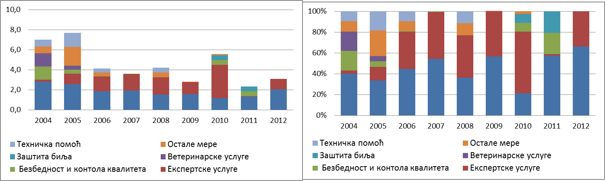

|  |  |
| --- | --- |
| EUR m | (%) |

Chart 24. Structure of support to general services in agriculture, by measures (%)

Source: MAFWM internal data

2.7.6. Access to agricultural budget funds

In addition to the dynamic changes in the volume and structure of the budget subsidies for agriculture, equally problematic from the users’ perspective were the changes in the operationalization of specific measures, and pre-conditions for user to access fiscal incentives. Availability of support was limited by introducing criteria for determining potential users, which were not always in line with the set objectives of individual measures. While for some measures it was possible to recognize favoring certain groups of users or type of production, also there were measures whose operationalization was through disadvantaging access to support for certain types of households.

A system of registration of households was introduced in 2004, as a prerequisite for the use of budget support to agriculture. Conditions for registration, and thus for the exercising these rights have been changed several times. Although these changes were not consistently in line with efforts to find and keep in the system support a good households with the potential for market production, these directions was evident. In a sense, it can be said that the significant differences in the regional distribution of funds, as well as distribution to households of different sizes, were caused in good part precisely due to these reasons.

Furthermore, a limitation was introduced in 2009, which was predicted that registered households ought to have covered liabilities to the Farmers Pension Fund for the previous calendar year. In this way, the support systems virtually excluded farms owned by people that have retirement insurance through other schemes (mostly younger employee owners of small and medium farms, which in some parts of Serbia are vital contingent workforce in agriculture). In the same year, a solution was applied that anticipated that the amount of subsidy will be reduced to only 30% for those households whose owners have crossed the age limit of 65 years. Bearing in mind the unresolved property relations, unregulated land register and many of other administrative barriers, it is clear that this solution has not achieved anything else but exclusion of large number of farms from the incentive system.

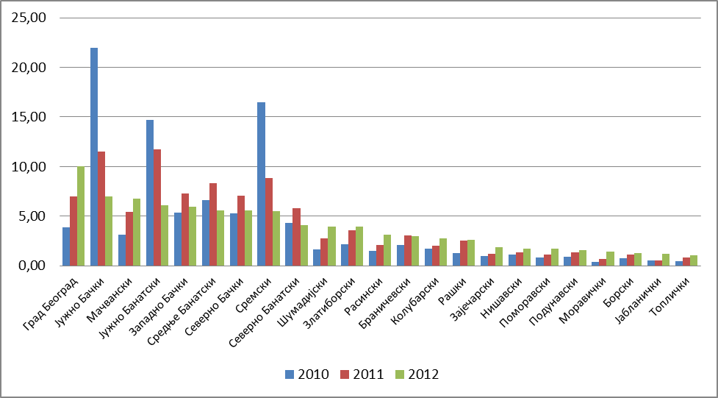

Graph 25. Distribution of agri-budget funds by districts[30]

Source: MAFWM internal data

The general view is that the budgetary support to Serbian agriculture is insufficient, and expressed through both standard criteria (per capita and per hectare) it lags significantly behind other countries. Such comparisons are usually not supported by sufficient reliable data, for several reasons: on one side due to use of unequal statistical definitions related to agricultural land (and population), and the other side due to lack of consistent data on fiscal incentives. Also, we should have in mind that there is a certain amount of subjectivity in terms of measures classification, especially in the case of countries whose budgetary incentives are not subject to external audit (not members of the EU, OECD, WTO, as is the case with the Balkan countries).

2.7.7 International donations

International assistance to Serbia in the field of agriculture has been intensified since 2001, mainly reflected in the form of providing technical assistance (equipment, laboratories, vehicles, computers, etc.) and the training and education of employees (mostly in preparation for the adoption of EU procedures and rules). Projects were covered the key elements of agriculture, according to the priorities set out in the Agricultural Development Strategy of the Republic of Serbia and the National Strategy for Serbia's EU accession.

According to the *ISDACON* a total of about 91 million euro of realized development aid during the period 2007-2012, agriculture and rural development occupy 8 place among all recipients of support from international donors. There are three main sources of international support: the EU through IPA funds, bilateral support - from the EU through their development agencies (Germany, the Netherlands, Denmark, Sweden, Austria, Italy, etc.), and other countries (USA, Japan, Norway, Switzerland); and the support of international organizations and IFIs through credit lines, loans and grants (UNDP, FAO, EBRD, WB, USAID, USDA, Germany, etc.). The largest and most important donor in the sector was the EU with a total of 58 million euros realized in the period from 2007 to 2013 within the framework of the IPA Component I. Financial support from IPAI funds for agriculture and rural development in the period 2007-2012 was used for activities such as: establishing a system of agricultural accounting data (FADN), the support to the Directorate for National Reference Laboratories, support for food safety, improving of animal welfare and control/eradication of classical swine fever and rabies, institutional capacity building for the implementation of *IPARD*, etc.

Although all donors have expressed their willingness to support Serbia in preparation for European integration and harmonization, their programs and projects are often focused on very specific topics, usually market reforms and increase of competitiveness (e.g. large USAID Agribusiness project, or work on improving the system of extension services by the World Bank STAR project) or to improve the position of specific sectors.

However, different forms of donor assistance have contributed to undertaking and accelerating significant reforms in agriculture. This especially applies to the establishment and modernization of laboratories, organizing farmers, introduction of new technological and organizational solutions in some sub-sectors of agriculture and food industry. In addition, a large number of local experts and parts of administration had the opportunity to go through various forms of education and they were trained to use new technological, organizational and other solutions in the field of agriculture.

***3. SWOT* ANALYSIS AND DEVELOPMENT CHALLENGES**

**3.1 SWOT Analysis Results**

Sectorial analyses provided data and other inputs that enabled SWOT analysis. The SWOT table systematically presents the findings about strengths and opportunities for improvements in agriculture and rural development, but it is also warning about the weaknesses and threats that the agriculture and rural areas will be facing in the future. This information represents the basis for systematization of the goals, measures and activities of the Strategy and accompanying documents, and thus will provide the guidelines for political decision makers.

Table 2. *SWОТ* analysis of agriculture and rural areas

|  |  |
| --- | --- |
| **STRENGTHS** | **WEAKNESSES** |
| **Resources** | |
| Rich land resources, favorable ratio of available land per capita and per an employee in agriculture;  Richness in biodiversity;  Good quality and structure of the agricultural land;  Favorable climate conditions for agricultural production;  Sufficient amounts of quality food for animals (both concentrated and solid);  Low wage costs; | Lack of agricultural infrastructure (rural roads, irrigation, drainage, wind protection);  Soil degradation, lack of management of rivers and canals;  Small areas of land owned by farmers;  Small percentage of irrigated land;  Crops appreciation;  Lack of improvement in the cattle breeding quality;  Insufficient number of cattle;  Unfavorable condition of equipment and machinery;  Unfavorable age and education structure of the agricultural labor force;  Unresolved social status of the employees in agriculture; |
| **Food production** | |
| High competitiveness of crops and vegetable production on regional markets;  Competitiveness of some types of fruit on wider international markets;  Existence of domestic sorts of crops, industrial crops and some types of vegetables;  Recovery of some parts of cattle breeding;  Growing organic production sector;  Accessibility of foreign markets and possibility for exports growth; | Low level of technology usage;  Low quality of inputs (seeds, fertilizers, etc.);  Low level of fruit and vegetables production in protected spaces;  Incomplete growing programs and inefficient system of genetic improvement;  Insufficient application of modern knowledge and technology,  Low level of products finalization;  Inefficient quality control system;  Inadequate insurance system; |
| **Production chain** | |
| Well supplied input market;  Significant capacities of storage facilities (ex state-owned companies);  Significant processing capacities;  Significantly improved technology in some sub-sectors (mill industry, oil production companies, meat and milk processing facilities, freezing and processing facilities for fruit, grapes and vegetables);  Accessibility of the raw materials produced in the country;  Privatization process mostly finished;  Existence of horizontal structures of association (cooperatives association, numerous associations, chambers, etc.); | Obsolete technology used for drying and storage of crops, in packing facilities and for cooling of vegetables;  Low level of processing facilities usage;  Low level of horizontal and vertical organization;  Existence of monopolies;  Insufficiently developed market institutions and infrastructure;  Lack of information systems and insufficient logistic support (weather forecast service, registers, cadastre, LPIS);  Low level of professionalization and lack of managers;  Low influence and negotiation power of producers’ associations; |
| **Technological development and environment** | |
| Large number of educational and scientific institutions that could become the part of the knowledge creation and transfer system;  Existence of interest in accepting new technologies (big households);  Relatively low level of agricultural pollution in the most areas in the country;  Rich biodiversity and existence of genetic resources;  Significant areas of High natural value fields;  Significant biomass production, possibility of production of energy crops and usage of renewable energy sources; | Low quality of equipment and technical conditions for research;  Lack of development institutions and demonstration facilities;  Relatively small number of beneficiaries of the organized knowledge transfer;  Degradation of biodiversity, especially in the areas with limited conditions for agricultural production;  Inadequate waste management system;  Inadequate water management system; |
| **Rural development** | |
| Diverse and attractive rural ambient;  Rich cultural heritage;  Preserved traditional knowledge and technology;  Existence of good practice in rural tourism and accompanying activities;  Launched activities for establishing local social networks;  Solid situation with infrastructure in some rural areas; | Unfavorable demographic trends;  Inactive labor market;  Unfavorable social structure;  Unused possibilities for income diversification in households;  Insufficient usage of cultural heritage;  Low level equipment of the infrastructure;  Impaired accessibility of social services;  Low level of social capital; |

|  |  |
| --- | --- |
| **OPPORTUNITIES** | **THREATS** |
| **Resources** | |
| Improvement of agricultural land and other resources management;  Possibility to increase the areas of land for organic production;  Possibility to increase the number of cattle and to revitalize beef and cattle production and breeding;  Investors are interested in new areas of land with intensive production technology;  Inclusion of wider areas in the support program; | The restitution process is not finished;  Inadequate response to climate change effects- lack of systemic solutions;  Inefficient land, forest and water management systems;  Lack of financial resources and lack of investments in improved equipment, facilities and machinery;  Agricultural policy neglects areas with hard conditions for agricultural production; |
| **Food production** | |
| Investors increasingly interested in investing in the sector and accompanying areas;  Production of organic and integral products has potential to grow;  The production of products with geographic origin, medicinal herbs, aromatic herbs and spices has possibilities for growth;  Possibilities for export growth;  Harmonization of the domestic law and regulations with EU requirements and standards (*Acquis Communitaire*);  Adoption of the quality system; | Lack of financial resources;  The interest of producers and processors for business cooperation hasn’t been recognized;  Increasing competition coming from the countries with highly subsidized production;  Lack of adequate response to climate changes;  Political and economic instability in the country, region and worldwide;  Further drop in buying power of the consumers in the country and region;  The agro-industrial sector is not prepared for the trade liberalization process; |
| **Production chain** | |
| Existence and usage of domestic sorts and breeds;  Possibility of investing in distribution systems;  High export potential on the basis of free trade agreements;  Possibility to establish connections with retail chains; | Non-functional inspection system;  Non-promoted public warehousing system;  Insufficient recognition/branding of the products, insufficiently innovated assortment;  Monopoly and grey economy in processing and trade;  Lack of specific banking products and offer packages; |
| **Technological development and environment** | |
| Capacities for knowledge creation and transfer exist;  There are underused possibilities for public-private partnerships in knowledge and technology creation and transfer;  Increasing needs for various types of consultancy services;  Possibility of production of bio-energy crops;  Improved usage of thermal water in greenhouses;  Improved usage of solar and wind energy; | High costs of knowledge transfer;  Lack of coordination among the relevant ministries and low participation of the applicable projects in food production field;  Lack of interest and motivation of producers to accept new knowledge and technologies;  Inadequate and insufficiently diversified offer of educational modules and practical trainings;  Lack of systemic response to climate change; |
| **Rural development** | |
| Possibility for creation of new products and services;  Possibility for public-private partnerships;  Revitalization of the resources and social services in the areas with limited conditions for agricultural production;  Possibility to intensify regional cross-border cooperation;  Usage of the pre-accession period to increase competitiveness, apply standards using the EU funds (IPARD);  Possibility to develop all kinds of tourism related to rural areas including the areas of high natural value | Rural specific characteristics haven’t been adequately recognized in local and national policies;  Investors insufficiently interested;  Growing rural poverty and regional differences in poverty;  The specific characteristics of small households haven’t been recognized in national policies, including the agricultural policy;  Pause in the EU integration process;  Lack of capacities in the areas with limited conditions for agricultural production to use budget support; |

**3.2 Internal challenges for agricultural and rural areas development in Serbia**

On the basis of the results and findings of the SWOT and PESTLE analyses, some strengths showed to have potential to be transformed into opportunities and to contribute to more dynamic development of the sector and of the rural areas. Also, the analyses identified weaknesses which, in the case the threats were realized, could jeopardize development in the long term. Both dimensions were viewed through challenges the agricultural sector and rural development are facing, since both options require the intervention by the political decision makers.

The general conclusion would be that agricultural sector and rural development in Serbia have significant resources, both in terms of their scope and diversification, which provides significant potential for production growth, products and services diversification and creation of the new and innovative products and practices. On the other hand, it is necessary to invest significant efforts in structural reforms in the sector and rural areas, in terms of strengthening their economic efficiency and competitiveness. As especially important challenges that this Strategy should provide solutions for the following have been identified:

***Resources***

Small areas of land, low level of technical equipment, neglected infrastructure, small number of cattle per agricultural land unit and appreciated crops, are only some of the examples of several decades long neglect of agriculture in terms of investments. Having in mind the climate change effects on significant volatility of production, threats the agricultural pollution to the natural resources, low level of productivity and reached standards, it is clear that there must be a long-term and sustainable solution for improvement of the natural, physical and human resources (as preconditions for development).

***Competitiveness***

Lack of organized market, low level of product finalization and inefficient knowledge and technological solutions transfer system have been identified as main limiting factors of production and competitiveness growth. Establishing the efficient market chain, introducing the missing parts of the logistic support system in the form of innovative solutions, modern management systems and strengthening of horizontal and vertical connections, would help the Serbian agriculture transform from raw-based into a modern sector that can offer goods recognizable by quality. The development of the most important sub-sectors of agriculture is going in the following direction:

In the crops production, there is room for significant competitiveness growth in the area of improvement of domestic seed production through introduction of quality schemes, development of organic and integral production and products with geographic origin; there are significant unused potentials in vegetable production in protected spaces and medicinal herbs production.

The basic guideline of fruit and grapes production in Serbia is adjustment of production technology to the climate change, introduction of the new sorts, increase in areas with intensive production and reaching the quality adequate for international and domestic markets. The basic preconditions for development of fruit and grapes production in Serbia are establishing the fruit growing areas, establishing the weather forecast and advisory service, education of producers, introduction of organic and integral type of production, establishing the production of certified seeds, full implementation of the registries in wine and grapes production and meeting other EU standards.

The directions of cattle breeding development should be based on entering new markets, application of standards for facilities the animals are kept in, application of products quality standards and meeting the procedures in production and placing the products. The production concentration is the main precondition for ensuring the scope, continuity and quality of the products. The change in orientation in beef production and introduction of the “cow-calf” system is of extreme importance for the areas with non-arable land and with not so dense population. The basic preconditions for improved competitiveness, productivity and quality are improved genetics in cattle breeding and improved nutrition.

***Market chain and logistic support to the sector***

The basic characteristics of the market chain are: lack of horizontal and vertical connections in the food production and trade systems, insufficient usage of the available resources and capacities, low level of equipment in all segments, lack or low level of efficiency among institutions and systems for logistic support to the sector. This situation is a result of unattractive area for investments due to the fact that the export EU standards have not been met for the large group of products, due to unpredictability of support policy and unestablished institutions.

The most important challenges in market chain development in the future are: involvement of the small producers into modern retail chains, competitiveness improvement on the levels of production and processing, creation of the environment for investing and EU standards application. Construction of the storage facilities and distribution centers, IT support to the sector and development of the innovative managing mechanisms that would lead to products with higher levels of processing, creating the brands and associations of different kinds would enable increased safety of placement and market competitiveness, especially in fruit, grapes and wine production.

***Rural areas***

Serbian rural areas are characterized by biodiversity, rich cultural heritage and natural resources. On the other hand, they suffer the consequences of the demographic drainage. It is the reason for their lagging behind in development, for all types of deprivation and increasing poverty. Their economy boils down to exploitation and further degradation of the natural resources, based on agriculture and accompanying activities, with poor offer of quality jobs and with modest possibility for generating external income.

The increased attraction of the rural areas to the young families as their potential place for living is closely connected with improved infrastructure, improved accessibility of social services, improved social structure and improved entrepreneurial support. The serious threat for further growing of the development gap between rural and urban areas comes from the lack of recognition of the specific needs of villages and their population and the lack of systemic and coordinated activities of various actors. Accessibility of the IPARD funds, strengthening of the social capital and market connections would lead to strengthening of the rural areas and contribute to their sustainable development in the future. The significant development opportunities for agriculture and rural areas lie in establishing the efficient knowledge, technology and information transfer system as well as in the innovative ways of using the potentials of cultural heritage and biodiversity.

**3.3 External challenges**

3.3.1 Climate change

For a long time, the agricultural production has been facing numerous challenges caused by climate change, since agriculture is at the same time the sector that causes the climate change and that suffers the consequences of the climate change. It is estimated that in the future we can expect further temperature increase, changes in the quantities and timing of the precipitation, increase in volatility of the climate parameters and appearance of extreme incidents such as draughts, floods and stormy winds. Although the climate change was noticed globally decades ago, and although its effect on crops, cattle, hydrological balance, production costs, production resources and other components are very well known, the awareness of issues and climate change effects on agriculture is still undeveloped, the investments in addressing the issues are insufficient, and systemic multi-disciplinary research can be found only in the most developed countries[31].

Having in mind the climate change trends and different hydrological and meteorological phenomena, it is obvious that the climate change has led to significant changes in climate characteristics in Serbia. The average temperature levels have grown over the last 50 years in almost all parts of the country, except for the south-eastern part where the temperature level has dropped. The temperature increase has been more significant in northern than in southern parts. Besides, the most significant increase has happened in springs and the least in falls. In the same period, in almost whole territory, except for eastern and southern part, a small increase in precipitation has been recorded. The most positive change has been recorded in the western areas, and the most negative in the south-western parts. The increased levels of precipitation have been recorded during summers and winters and more so in the northern parts than in southern, while lower levels of precipitation have been recorded during springs and winters in northern and eastern parts of the country. Although at first glance these changes may be minor, they may have an adverse effect on Serbian agriculture.

Numerous climate models foresee that both Serbia and the whole region of the South-Eastern Europe will face significant climate change in the near future. According to the regional climate models, the average annual air temperature until the end of this century is expected to grow from 2.4°C to 2.8°C according to the optimistic scenario (А1B), or from 3.4°C to 3.8°C according to the pessimistic scenario (А2). The temperature increase will have different trends in different seasons, and more significant increase may be expected during summer months (3.2°C–3.6°C). The situation is more complex when it comes to the expected levels of precipitation. According to the A1B scenario, the whole territory of Serbia will have lower levels of precipitation, with less significant changes in Vojvodina and some parts of eastern Serbia. According to A2 scenario, Vojvodina may experience increase in precipitation levels, and other parts of the country may face the same or lower levels of precipitation. Some newer climate projections show similar general trends but show more of local differences[32].

Climate change has a strong influence on water resources. The results of numerous models show that only due to the changes in the annual sum of precipitation the average flow of the streams may be lower (until 2020 by 12.5%, and until 2100 by 19%). This could deteriorate the situation even further and decrease the irrigation potentials.

Apart from its effect on crops, the climate change may further make the agricultural production harder through expansion of the existing causes of contagious diseases and appearance of the new species. Also, the bad insects may change their geographical places of living, they can change their reproductive abilities, abilities to survive winters, ways of spreading, number of generations, etc. Finally, weed may spread to new areas which may cause additional problems in plant growing. All these suggest the very complex influence of the climate change on agriculture, and thus the necessity to develop measures for adjusting in order to avoid or alleviate its adverse effects.

The participation of the sector which depends on weather conditions in the gross domestic product of Serbia is very high and in 2005 it was 47.18%[33]. The Serbian economy significantly relies on activities that depend on weather conditions and their influence on the Serbian economy has not been adequately analyzed, the national strategy of adjusting to the climate change has not been designed yet, and majority of the existing sector strategies and plans has not addressed this issue properly.

3.3.2 Economic globalization

The globalization process has exposed the agricultural sector to fundamental changes. Those changes are opportunities for some countries and threats for some other. The 21st century, when it comes to agriculture, will be characterized with global competition, industrialized agriculture expansion, differentiated products production, changes in scope and and structure of the food demand, establishing the new food supply chains and growing production risk.

No country will be spared or in position to regulate its agricultural sector independently from others. In that regard, the global economic crisis has led to global contraction of the aggregate demand, and thus narrowed the market for agricultural sector. Serbian agriculture, according to the reached level of liberalization and scope of the international food trade, is already integrated into international market and exposed to effects of change in the global market. The growth of prices of energy, inputs, resources (land), and food demand, as well as instability of prices of food globally, are creating a completely new business environment for Serbian agricultural sector. On one hand, the increased food demand, especially in Asian countries with increasing income, opens the space for export growth, while on the other hand the increase in production costs further jeopardizes already low level of efficiency and productivity of Serbian agriculture. Also, there are more and more frequent scandals worldwide with food quality. Such incidents and trends require the review of the attitude towards agriculture and affirm the focus on local markets and shorter supply chains.

As a consequence of domestic market liberalization, appearance of major retail chains on the domestic market and accelerated integration into international market, in Serbia we witness establishing the long, highly demanding supply chains in production and distribution of food. Their negotiating position is very strong and is getting stronger, and they become the major actors in shaping the business terms and conditions and appearance on the market. Such situation limits the access to the market for major number of producers, who are not capable of meeting the requirements for quality, quantity, and continuity of supply standards, or who are not capable of lowering their prices in order to be competitive. In such circumstances, the alternative strategy should be orientation towards shorter chains, direct sale and system related to very special products, with clear identity and recognizable characteristics. In other words, the sector should try to find its solutions in innovative approach, knowledge and technological improvement. The solutions expected from the domestic science should go towards “localization” of the production and market, and adjustment of the “imported” technological solutions and market systems, or promotion of the solutions that would make the domestic products more attractive and competitive for the external markets.

3.3.3 Membership in the World Trade Organization

The World Trade Organization (WТО) is the only multilateral framework that sets the rules for international trade. In this moment, WTO includes 159 member countries out of 193 counties members of the UN. The WTO members have over 97% of the world trade share, 97% share of the GDP worldwide, 90% of the financial transactions, 92% of the telecommunications and IT and 97% of the intellectual property rights.

The basic goal of the WTO is to ensure the international trade is performed in a fee and predictable way by establishing an operational and efficient multilateral trade system. WTO offers a solid legal basis based on mutual consent of its members which introduced the rules in their own legal systems. Thus the members have directed their efforts towards liberalization and alleviation of the international trade in order to ensure the sustainable economic growth. They agreed that the primary goal should be improvement of the living standard and reaching the full employment.

The WTO membership for a country means that it has harmonized the domestic laws with the WTO rules, and thus enabled its foreign trade system to be recognized by others as a system that observes the rules of the international trade. The membership ensures the stable conditions for business in a country, which creates more favorable conditions for potential investors. By becoming a WTO member, a country becomes protected from the possibility to be faced with breaching the rules in trading with other countries, and obtains a possibility to influence the decision making process when it comes to accepting new members, which means it can implement its political and economic goals.

In this moment, Serbia is out of this system and has no protection from, for example, economic sanctions or illegal measures any country could impose on Serbia. Bearing in mind Serbia is a small country with poor negotiating position in bilateral disputes, the WTO protection system is far more efficient since the disputes are resolved in a systemic way on a multilateral level (the WTO system has proved to be very efficient, and the proof for that is the fact that smaller countries are suing bigger and more developed ones more often).

Serbia formally started procedure for WTO membership after its application for negotiation launch was accepted by WTO General Council in February 2005. During the WTO accession process, Serbia has adopted numerous laws and legal acts, such as the Law on Foreign Trade, Law on Foreign Currency Business, Law on Excise Taxes, Law on Customs, Law on Companies, a set of laws related to intellectual property rights protection (Law on Copyright and related rights, Law on Patents, Law on Marks, etc.). By adopting the Law on Food Safety, Law on Herbs Health, Law on Veterinary, etc. and many other by-laws, Serbia has harmonized provisions that regulate application of sanitary, veterinary and phyto-sanitary measures with the Agreement on Sanitary and Phyto-sanitary Measures of the WTO (SPS Agreement). A review done among the laws and regulations related to technical rules and standardization was very important, and the following laws were adopted: The Law on Technical Requirements for Products, Standardization Law (2009), Law on Accreditation, Law on Meteorology (2010), and related decrees. By adopting the mentioned laws and regulations, Serbia has done a complete harmonization with the principles from the Agreement on Technical Barriers to Trade (TBT), and thus with the relevant EU rules.

Generally, the multilateral negotiations are in the final phase, and the time of their completion will depend on internal factors, primarily on the pace of the remaining laws and regulations adoption (Law on GMO, Law on Excise Taxes, Law on Copyright, ensuring a non-discriminatory estimation of excise taxes for alcoholic beverages).

Having in mind the universal character of WTO membership, it is clear that Serbia should become members as soon as possible, since the lapse of time also leads to more strict condition for joining. Since the WTO membership is a precondition for U membership as well, it is clear that fast joining to international economic relations through WTO and EU is far more favorable for Serbian economy in terms of adjusting to international competition and faster access to benefits the WTO and EU members have.

The accession documents will, among other things, contain the list of consolidated customs fees for agriculture on the highest level that will not be changed later by the national laws. It is expected that the total level of customs fees will be below the level currently applied, i.e. below the MFN customs fees. At the same time, the total level of subsidies for agriculture that is allowed according to the WTO rules will be agreed on, and by the negations that have been done so far it looks favorable for Serbia.

3.3.4. Common agricultural policy – Integration process requirements and review of the CAP measures after 2013

Common Agricultural Policy is a complex system of legal regulations, budget support and other public interventions, related to the situation in agriculture and in rural areas of the EU members. During previous 55 years, CAP has undergone different phases and reform, but the original goals have remained relatively stable: ensuring the stable income for the rural population, stabilization of the market and improving the competitiveness and productivity in food production. Over a few last decades, CAP has devoted a lot of attention to relationship between agriculture and environment, as well as to ensuring the food safety. In that way, agriculture has become more socially important and its non-economic functions have become emphasized.

CAP reforms in the previous two decades were directed towards further market deregulation, introducing the principle that direct payments to producers should not be related to specific types of production and strengthening the rural development policy. In the mid 2013 the process of negotiating the principles of the new reform was completed, and the foundations for the CAP until 2020 were placed. The novelty in the CAP is that the direct payments are conditioned with the new requirements related to the environment protection, that the direct payments per countries and households become equal, but it does not mean introduction of the uniform amount for all member countries. Besides, the measures of market interventions have been further relaxed, while the focus on rural development policy has been widened. Also, new, specialized support schemes have been introduced, placing the small households and small farmers in the focus.

Constant conceptual changes to CAP on one hand, and complex transitional problems the candidate countries are facing on the other, are reasons for the process of adjusting the agricultural policies for membership to be very demanding. From the moment a country starts applying the CAP, its agricultural policy has become fully harmonized with EU members’ policies. This position means that the national agricultural policy should be regulated through common bodies, according to unique principles, and that there is a common budget for it. Due to complex policies, procedures and mechanisms CAP is based on, it is necessary for the EU candidate countries to start taking over CAP gradually from the very beginning of the EU accession process.

***CAP integration process requirements***

CAP integration process consists of harmonization of laws, building and strengthening of institutions and policy reforms.

а) *Harmonization of laws*. A candidate country must be ready to implement the complete legal regulations in a specific field after accession. The Common Agricultural policy is based on regulations, that do not need to be directly incorporated in the legal system of a candidate country, but they need to be fully implemented. CAP measures are very demanding in terms of institutional building and implementation (financial procedures, IT support, control, monitoring), and in the sense of understanding and programming of measures, both for administration and beneficiaries. That is why it is recommended to adjust the legal system to the EU measures implementation long time before accession, which demands both significant reforms and essential adjustments.

б) *Institutional building*. The high modern public policy standards are built in the CAP implementation system. The payment agencies, IT and administrative control systems and other institutions must be fully built, which requires significant administrative, financial and HR changes.

в) *Policy reform and restructure support*. The successful adjustment involves the decrease of negative and strengthening of positive effects of EU integrations. As a rule, significant number of measures is not compatible with CAP, so retaining them until the very accession would send wrong signals to beneficiaries. It is necessary to emphasize that taking over the EU measures may serve as a support to sector restructuring and adjustment, that is why it rational and useful to adjust the policy to CAP requirements gradually. It is not possible without policy reform and budget strengthening of the agricultural support.

***Review of CAP measures after 2013***

The basic CAP structure consists of two main pillars: direct payments and market interventions in the first pillar and rural development support in the other. Besides, other measures, such as general services, social transfers, etc. are not a subject matter of CAP. They and some other measures can be implemented in the form of a state aid, which means that they are completely financed by the member country, but it requires a permit from the European Commission, so that they do not result in endangered competitiveness on the common market.

*The first pillar* consists of various measures that support the producers’ income, and which have more or less significant influence on the market and prices. Basically, the policy in this field is divided into two major groups: direct payments and market regulation measures.

The direct payments are constantly changing. Until 2013, it was allowed to have part of payments as a form of single payments for farming households on the basis of historical rights, and part is remains of production-coupled payments per area unit and per herdmate. The countries joining EU have a simplified payments system for all the areas the subsidies are demanded for.

The current single payment scheme for farming households (*SPS - Single Payment Scheme*) on the basis of the historic rights have two basic forms. The first one involves that the households which in a relevant period were receiving support for certain products (such as milk, grain) can continue to receive the same amount of funds but they can produce other things as well (that is why it is called production decoupling). It is estimated that such support system leads to extensive and restructured production, since the producers are not being stimulated to increase the scope of a certain type of production. Besides, the significant differences in average payments per ha among the member countries remain (from 100 euros in Baltic countries up to 500 euros in Belgium and Greece), and even more so among different households types within one country.

The second form, the so called regional model, is adjusted to the member countries which joined the EU after the 2003 reform. According to that model, that represents the Single Area Payment Scheme (*SAPS*), the total amount for direct payments is defined in a special way, and the amount is then divided into agricultural areas that are expected to be included the support system (that the households which will apply for support will use them).

In the Cap reform process for the period 2014-2020, the direct payments have been significantly reformed. Everybody who is entitled to subsidies, may receive basic payments, defined as a fixed amount per ha of the land area. That amount must be equal for all ha in the scheme. The change is also that 30% of the direct payments will be subject to various forms of environment protection (the so called greening policy). The producers will have to keep parts of their land under pastures and meadows, while on arable land they will have to have at least two production lines, and part of the area will have to be separately environmentally treated (special regimes). Due to complex implementation, certain deviations are allowed. For example, small households, or regions with lot of forests, do not have to fully observe the mentioned requirements. Only active farmers can receive subsidies, and the terms will be defined by the member countries. Young farmers, who manage the households, will receive additional payments. Part of the payments may remain production coupled, and the total amount of funds for a country will be possible to share to areas with higher natural value. Small households (depending on the number of ha or subsidies) may receive fixed amounts per household instead of this complicated system, as an alternative and far simpler form of support.

The existing system provides that the farmers must meet certain conditions related to environment, food safety and animal welfare protection in order to be eligible for direct payments. Those conditions are called cross compliance and are less demanding during the SAPS system implementation, i.e. during the first period after the accession of the new members, but are valid for direct payments measures and for some measures within the rural development policy. The direct payments system is a very complex one that requires very strict control of the areas, cattle, applications and financial flows. It is one of harder institutional requirements during the integration process, it demands huge funds and institutional strengthening.

*Single Common Market Organizations (CMO*) represent the set of rules that regulate agricultural production and trade in all EU member countries. *CMO* cover around 90% of the final agricultural production of the EU. The market interventions are constantly being deregulated, but this process does not end even with the 2013 reform. The range of measures is very wide: from foreign trade policy, intervention purchase and other forms of withdrawal of goods from the market, through support to consumption of certain goods, to production quotas for milk and sugar being abolished and support to producers’ organizations. The main instrument and measures in the common market regulation reform from 2013 involve the following:

Interventions on the internal market in the case of significant prices drop: public intervention purchase (basic grain, rice, sugar, beef, butter and skimmed powder milk, pork), private storage (butter and skimmed powder milk, some sorts of cheese, sugar, olive oil, wine, beef, pork, mutton) and special intervention measures (in the cases of crises due to animal illnesses, more significant disturbances on the grain and rice markets, special measures for sugar, withdrawal of fruit and vegetables from the market),

Specific measures of support to processing and production (dairy products, wine, sugar, dry fodder, flax and hemp) and to specific sectors (beekeeping, silk beetle),

Market standards and production conditions: classification of carcasses on the slaughter line (grown up cattle, pigs, sheep, goats), market standards ( olives and olive oil, fruit and vegetables, wine, bananas, plants, eggs, chicken meat, milk and dairy, fat),

Producers’ organizations (olives, fruit and vegetables, tobacco, wine, hop, silk beetle, etc),

Duty of monitoring and reporting on prices,

The trade with third countries: general rules (nomenclature and general customs tariffs), import rules (import permits, import fees, managing import quotas, protective measures) and export rules (export permits, export subsidies, managing export quotas).

In the area of market interventions, as well as with direct payments, the policy is completely defined on the Eu level, so a member country cannot have its own measures; From the aspect of a country that aspires to join EU, Serbia will have to abolish all the measures that do not comply with those requirements before the moment of accession; The adjustments will be also needed in the area of foreign trade; The export subsidies in the EU will be abolished soon, but the complex system of foreign trade protection will remain; The reforms in the segment of foreign trade policy, Serbia will be adjusting with rules and regulations of the WTO in the following period (which was already done by abolishing export subsidies in 2011), with additional adjustments to specific requirements of EU policy.

*Rural development policy* The 2013 reform provides that the rural development policy should involve six priorities:

Encouraging the knowledge and innovations transfer;

Competitiveness improvement;

Promotion of the food chain organization and risk management;

Renewal, improvement and preservation of the ecosystems;

Promotion of the efficient resource usage and support to transfer to economy with low carbon-dioxide emission, resistant to climate effects in agriculture, food and forestry sectors;

Promotion of social inclusion, poverty reduction and economic development in the rural areas.

These priorities may be realized through various measures. EU adopts the measures lists, more thoroughly defined in the rural development program. The various types of support to capital investments in production and processing agricultural products and in forestry are a key measure; land operations, investment in human resources, in food quality and safety improvement. Within the environment support, there are various direct payments for subsidizing the production costs, which ensure improved maintenance of the environment (agro-ecological measures) or for production in the areas with limited possibilities for agriculture, as well as for sustainable forestry systems, support to improved animals welfare, etc. Besides, the rural development measures will include the measures for improvement of the quality of life and spreading the economic activities in villages. Those are the measures that exceed the framework of agriculture and forestry. It is possible to support different projects dealing with rural infrastructure construction, micro-enterprises establishing, cultural heritage maintenance, etc. There is also LEADER approach that is important, that does not represent a group of measures but the way to develop specific programs. It supports the local action groups organizing, local communities, that unite aiming at implementing specific projects coming from other measures.

The 2013 reform introduced, as a novelty, the measures that support the knowledge transfer (support to knowledge development networks from science to producers), as well as the measures for risk management support (for example, support to insurance due to production and income related instabilities). Besides, more attention and support was devoted to measures that support connecting the producers and processors in value chains, in shorter food supply chains, etc.

When programming the measures, it is necessary to observe certain basic principles. One of them is coherency of measures, which means that the measures of different policies should not be separated, should not have contradictory effects, etc. The program needs to be designed to have the internal consistency among measures and the maximum effects with limited public funds. In principle, all smaller countries, (such as Slovenia, Austria and Bulgaria), have one rural development program, while in bigger countries the program is implemented according to regions. The selection and financial framework of the individual measures are at the discretion of each country.

The allocation of finds for rural development in some countries is very different. Generally, the least amount is allocated for improvement of life quality in rural areas and for LEADER approach, which means that the agricultural support remains to be dominant in the programs. In the countries with lower GDP and poorer agricultural structure (except for Slovenia, Cyprus and Malta, those are all other new EU member countries), much more funds are allocated for the measures that improve the food production competitiveness. The countries with developed agriculture (the Netherlands, Denmark, Ireland), or countries with hills and mountains covering most of their territories, more than 50% of the funds allocate for agro-ecological measures and measures intended for agriculture in the areas with limited possibilities.

# 4. VISION OF DEVELOPMENT AND STRATEGIC GOALS

## 4.1 Vision of agriculture and rural areas of Serbia

The current situation analysis in the agricultural sector and rural areas, along with identified external and internal development goals for the following decade, have directed the development vision, goals and priority areas of the Strategy.

***The vision of development of agriculture and rural areas of Serbia reflects the projected situation in the sector we want to achieve in the following decade, and as such it involves:***

***in 2024, the agriculture in Serbia should be a sector whose development is based on knowledge, modern technologies and standards, that offers innovative products to domestic and demanding foreign markets, and that enables the producers to have a stable and sustainable income;***

***the natural resources, environment and cultural heritage of the rural areas are being managed in accordance with sustainable development principles, in order to make the rural areas attractive places for living and work for young people and other rural population.***

Realization of the vision defined in this way involves taking into account several key principles:

*Sustainable agriculture* is the main orientation of the agricultural policy strategic implementation, which perceives the multi-functional agriculture as one of the most important economic branches in rural areas. In this context, observing the sustainable development principles involves:

*Economic efficiency growth in the sector*, based on technical and technological improvements and innovative products and solutions;

*Responsible resources management* and their preserving for the next generations, with improved preserving of biodiversity in the long run;

*Reaching the wellbeing level of the rural population* that would stop further deterioration in the demographic trends; full understanding of the vulnerable position of the youth and women on rural labor market, as well as of the other vulnerable social groups.

*The polycentric development, based on recognition of differences in types of production and households,* that result from heterogeneous geographic, natural, socio-economic and other characteristics of the rural areas in Serbia.The equal attention will be devoted to all the producers and other actors involved in the production chain, who see their future in agriculture and related activities. The special attention will be devoted to meeting the specific needs of the agricultural producers in the areas with limited possibilities for agriculture, to households with potential for further growth of the production and young farmers.

*Institutional modernization*The implementation of the strategic goals is closely connected to the necessity of modernization of institutions and strengthening them in order to manage public policies efficiently. The necessity to modernize the institutional framework is the result of the need to harmonize various levels of legal and organizational structure of the Ministry of Agriculture, aiming at development of the systemic framework ready to efficiently and transparently implement the set development goals and manage public funds. The importance of the institutional framework reforms is even more significant in the light of the fact that the accessibility of the pre-accession funds is subject to harmonization of the national agricultural policy management system with EU standards.

*Stability and consistency of the agricultural budget*Realization of the set goals requires necessary adjustments in budget financing of agriculture. Instability of the support to agriculture in terms of the funds scope, their purpose and potential beneficiaries, represent a serious barrier for the sector competitiveness, decrease of the income risks of the producers and more dynamic reform of the agriculture structure. The budget adjustment involves the growth of budget allocations for agriculture, changes in the structure of the total support per pillars and measures and in the area of implementation mechanisms. The target matrix should be is the agriculture and rural areas support model as it is in the CAP, since Serbia is aspiring to become the member of the EU.

Realization of the vision requires the full implementation of the Strategy, which depends on various external factors, such as political stability and rule of law, institutional reform and administrative capacity strengthening and creation of the environment for market economy rules functioning.

## 4.2 Strategic goals

In accordance with the vision and mentioned principles of the Strategy, the following strategic development goals are defined:

*Production growth and producers’ income stability;*

*Competitiveness improvement with adjustments to requirements of the domestic and international markets and with technological and technical improvement of the sector;*

*Sustainable resources management and environment protection;*

*Improvement of the quality of life in rural areas and poverty reduction;*

*Efficient public policy management and institutional framework improvement for agricultural and rural areas development.*

*The production growth and stability of the producers’ income* is one of the primary goals of Serbian agriculture. Reaching this goal means that agricultural production has to be competitive, economically efficient, based on implementation of modern technologies, meet the phyto-sanitary and veterinary standards as well as standards of environment protection and animal welfare.

In order for the agricultural producers and other actors in the production chain respond to this challenge successfully, the agricultural policy has to take over the duty to apply a set of adequate measures which in the long term will ensure income stability and stable employment in agriculture. The essence of the sustainable development and efficient restructuring of the agricultural sector consists of adequate, competitive and stable income of farming households. That is why the goal of the policy is to ensure efficient and rational decision making with minimum risk and a possibility to earn income that would be competitive with other branches of economy.

*Growth of agricultural and food production competitiveness* is a permanent goal of Serbian agricultural policy, which is based on rich resources, importance of the sector for national economy and rural development, and on improving possibilities for food export. The agricultural and food sector of Serbia made a significant improvement in the last decade when it comes to positioning on the world market. The regional competitiveness of the sector in the region within CEFTA market is on a very high level. On the other hand, in trade with EU and other markets, despite the surplus, the exports structure is not favorable. Besides, the further globalization and liberalization of the agricultural products market demand more efficient measure for competitiveness support within Serbian agriculture and increased ability of producers to respond to modern consumers’ needs, especially of those with higher income.

Active role of the state as well as the strong initiative from the private sector are necessary preconditions for more dynamic restructuring of Serbian agriculture and food industry into sectors that offer innovative and highly valued products, which are market flexible and integrated into economic environment, whose development is based on knowledge and sustainable and efficient use of natural and human resources.

*Sustainable usage of available natural resources* is a basis of the long-term food production stability, and it contributes to the quality of the domestic food production in the context of increased risks on the global food market. The specific character of the agricultural production, reflected in its reliance on the scope and quality of the natural resources, which are limited and given as such, suggests that the government should create the environment and conditions that will contribute to preserving of the vitality of the resources for the next generations. Responding to the climate change, protection of the agricultural land, lowering of the greenhouse gas emissions levels, biodiversity and rural areas protection, rational usage of water and forests demand defining the new policy that recognizes the multi-functionality of agriculture.

*Improvement of the rural population life quality*, more equal share in income distribution and economic possibilities, and more favorable social position, are key aspects of the sustainable development in rural areas Serbia is aspiring to. The structural reforms of the sector and changes in the socio-economic structure inevitably lead to vanishing of some households. This process must be economically sustainable and cannot be done at the account of further degradation of the rural areas and deterioration of the social structure in the country. The balanced and socially sustainable development of the rural areas requires synergy and good coordination among all the policies related to rural areas and their resources. The alleviation of the problems for those who are abandoning agriculture and promotion of the equality principle may give a significant contribution to sustainable development. The agriculture policy has a special responsibility to ensure the stability of the agricultural production, food production and forestry, as leading rural economy sectors, through structural changes, and thus contribute to rural economic development and decreasing of the gap between rural and urban areas. Abandoning villages and agriculture, as a result of economic development, results in deep demographic misbalances and loss of some productive resources. These changes inevitably lead to irreversible processes, reflected in the adverse effects supply of the products from rural areas. One of the basic goals of agricultural policy, which should ensure more equal regional development of Serbia, is creation of more favorable living conditions for young people and their staying in rural areas.

Meeting the strategic goals requires the *efficient policy management* and establishing an operational institutional framework for agricultural and rural areas support. The complexity of the agriculture sector, the challenges the food production is facing and multi-dimensional aspects of influence of agriculture on social and economic structure, suggest that the government cannot avoid its leading role in socially responsible and and structurally sustainable development. In that regard, the role of the government is to create the environment which will guide the decisions and alleviate the adverse effects of individual decisions of famers and other members of rural population. The significant complexity of the system and heterogeneous participants in the production chain require the government to respond to their needs through adequate policies. On the other hand, On the other hand, the entrepreneurial initiative, innovations and motivation of all the actors in the sector are increasingly becoming the basis of their development, that has to be economically sustainable and ensure their independent survival on the market.

Meeting the set strategic goals requires different types of interventions that can be divided into several reform pillars:

Improvement of the natural resources management system;

Facilities and equipment modernization;

Strengthening of the food chain and of the institutions that logistically support the sector;

Establishing the more efficient and operational system for knowledge creation and transfer;

Improvement of the quality of life in rural areas through diversification of the rural economy and strengthening of the social structure;

Institutional modernization and agriculture policy adjustment to CAP.

## 4.3. Priority areas of the strategic changes

The concept of the sustainable agricultural development and meeting the set strategic goals will be realized through interventions in several priority areas of the agriculture policy, such as:

Stabilization of income in agriculture

Financing of agriculture and rural development and risk management;

Efficient land management and improved accessibility of the land resources;

Improved physical resources;

Improvement of the knowledge transfer system and human resources development;

Adjusting to and alleviation of the climate change effects;

Technology development and modernization of the agricultural production and processing;

Market chains development and logistic support to the sector;

Protection and improvement of environment and preserving of the natural resources;

Preserving of agriculture, human and natural resources in the areas with limited conditions for agriculture;

Diversification of the rural economy and preserving of the cultural and natural heritage;

Improvement of social structure and strengthening of the social capital;

Modernization and adjustment of institutions and legal framework;

Improvement of the products quality and safety;

The selection of the priority areas is a result of the situation analysis and perceived internal and external challenges the sector is facing. The selected priorities are to a significant extent adjusted to the budget support structure according to pillars and groups of measures, presented in the chapter The Budget plan *2014-2024*. The selected priority areas however, may be accompanied with the combination of various budget support measures. Since the legal framework in agriculture is subject to frequent changes, this document provides concept definitions which have a long-term strategic effect, and which could be applied even in the case of expected changes to the agriculture policies in the next ten years.

## 4.4. Operational goals according to priority areas

#### Priority area 1 Stabilization of the income in agriculture

The issue of the stabilization of the income of the employed in agriculture is a key issue of the agricultural policy. This issue is resolved through support to sector development, but the nature and character of agriculture require other forms of state interventions as well when it comes to farmers’ welfare. Namely, the significant instability of production and prices caused by natural conditions and global economic trends, low level of competitiveness of some products and some producers, demand a more complex system of support to income stability than the one that can be provided by random market mechanisms and by the standard set of measures intended for production growth.

Farmers in Serbia lack stability of production conditions and stability of income. Their income, apart from mentioned risks, is also exposed to other risks, resulting from insufficiently regulated business environment. Aiming at creation of more favorable, just and equal conditions for domestic producers, the government must launch the eligible mechanisms for supporting their income. Such obligation is at the same time the part of harmonization process with EU policy, which has its own ways and mechanisms of income support that Serbia must adjust to.

The planned operational goals for reaching the more stable agricultural income are the following:

Ensuring the equal competitive conditions for domestic producers in accordance with the planned solutions that can be found in foreign trade agreements of the Rpublic of Serbia;

Support for market regulation during disturbances on the market (safety net).

*Principles and mechanisms*The two basic mechanisms to be applied for realization of the planned goals are: various forms of direct and indirect income support (direct payments) and market interventions. Within the direct payments, the basic principles will be observing the WTO criteria of the eligible support and gradual harmonization with the CAP, with the clear development orientation of the support measures. The new support measures that are going to be introduced in future will observe the mentioned principles, while the measures that are not compatible with the WTO and EU rules will be gradually abolished. Comparing to the existing support system, it would mean the reallocation towards less production-coupled payments that have a development effect on agriculture and at the same time enable the efficient harmonization with the EU approach.

Market and pricing support measures will be directed towards stabilization of prices during disturbances on the market (the drop or excessive increase of prices). In such circumstances, various intervention measures will be applied to encourage additional demand or regulate the supply. General orientation will be gradual introduction of the “safety net” system for market stabilization, according to the EU principles and mechanisms.

#### Priority area 2. Establishing the efficient agriculture and rural development financing system and risk management

The systemic changes to the existing agriculture and rural development support model and creation of the efficient agriculture financing model must become the priority of the agriculture policy. To implement them successfully, it is necessary to reach the wider social consensus on necessity of increased investment in agriculture and rural areas as important segments of national economy, economic and social structure. The long-term stability of the available financial sources for support to agriculture and rural development, as well as the equal and fair access to financial market of all potential beneficiaries, are basic preconditions for investment growth in the sector. Without the special financial products and services that enable the insurance against production and markets risks and that encourage the households to invest again, the rural households and companies can only take commercial loans. The lack of competitive saving instruments and other financial services in rural areas lead to less profitable forms of saving, which further deteriorate the potentials for development. The proposed operational goals aiming at establishing the more efficient financing model are:

Increasing of the available support schemes for different purposes (grants);

Increasing the number of beneficiaries and scope of the available financial capital intended for agriculture and rural areas development;

Development of the loans market and ensuring the improved access to loans for agricultural producers, including the new forms of loans;

Improved insurance system, adjusted to the needs of agriculture.

*Principles and mechanisms* Establishing the efficient agriculture support system requires significant institutional adjustments aiming at building and reforming of the financial institutions (strengthening of the guarantee funds) and financial products (insurance, loans), adjusted to the needs of agriculture. The task of the government is to adjust the legal framework aiming at improved collateral offer, to enable the dialogue and promotion of the innovative solutions on the financial market, but primarily to ensure the efficient and stable budget support.

#### Priority area 3 Efficient land management and improved accessibility of land resources

Land the basic resource of agricultural production. The scope of this resource is limited , and its quality characteristics may be improved up to a certain level, and not without significant costs and effects on the environment. On the other hand, the development of the agricultural and food production sectors depends on the availability of the production factors, primarily of land, and on equal accessibility to this resource for all relevant actors under equal conditions.

The agricultural production in Serbia over the last two decades has been based on excessive use of land. The usage of manure has been insufficient, as well as investments in improvement of physical and chemical characteristics of land and of land infrastructure. As a result, the main threats for preserving the land potentials are: permanent loss of land, depleted organic matter, increased acidity, erosion, pollution, increased amount of salt, flooding and loss of biodiversity. Besides, the lack of favorable loans intended for improvement and regulation of households and land, inadequate tax policy, unclear policy in the area of land inheritance, unfinished restitution process and relatively long probate proceedings, further slow down the process of changing of the agricultural structure and of increasing the average area of the land in possession.

That is why the preserving and improvement of the agricultural land fertility as well as the creation of the efficient land resources management system are the priorities of the agriculture policy. The defined operational goals are:

Increased usage of agricultural land;

Increased amount of average land area owned by farmers;

Establishing of the functional land market;

Improved land infrastructure;

Increased area of meliorated land and improved land fertility;

Accelerating the restitution (including the land owned by cooperatives) and (re)privatization processes;

Decrease in loss and land degradation;

Controlled change of purpose for the agriculture land;

More efficient usage of poor quality land and/or non-arable agriculture land;

Systemic land quality monitoring;

Establishing the efficient land management system (cadastre, GIS, *LPIS*).

*Principles and mechanisms* Realization of the mentioned principles requires significant changes to the laws, tax policy and budget subsidies.

Adopting and adjustments to the set of laws will regulate the issues in the area of land inheritance, lease and trade, and introduce the obligation to maintain the land in good condition for production. The special emphasis will be placed on the protection of the agriculture land in terms of limiting the change of purpose of the best quality agriculture land. The tax policy and budget subsidies will encourage the land consolidation in the sustainable households and establishing of a more active land market.

The special attention will be devoted to improvement of land quality and its production capacities. Apart from conditioning the subsidies to farmers by the obligation to observe good agriculture practice that helps maintain the land in good production shape, the melioration and land infrastructure improvement projects will also be supported.

A separate set of activities is planned for institutional capacities strengthening aimed at efficient land management, such as establishing the functional ledger, registries and data base systems (*LPIS*, land register, pedological maps, etc.).

#### Priority area 4 Improved physical resources

The current state of the physical resources (machinery, equipment, plantations, cattle, and facilities) is not favorable. They are obsolete technology-wise and as such cannot provide the competitiveness improvement of the sector and meeting the environment protection and hygienic standards. Besides, the successful response of the sector to climate change challenges is impossible without the resources improved in terms of technology, usage of improved seed sorts, aiming at change of the production structure production technology and agricultural measures used. In that regard, it is necessary to plan rational and uniform solutions for technological improvement of machinery, equipment and facilities, adjusted to the size of households, health safety and animal welfare standards and climate change. Investments into new plantations must take into account the recommendations of zoning of fruit and wine production areas, while in cattle breeding the emphasis should be placed on improvement of cattle selection improvement.

Operational goals for this priority implementation are:

Technical and technological modernization of facilities and equipment;

Increased number of cattle, improved cattle breed and improved usage of the genetic potential from domestic herds;

Increased area of perennial plantations (including mother plantations);

Adjustment of the fruit and grapes sorts to the production conditions and improved production technology;

Improvement of the complete seed production and distribution system;

Establishing the more efficient service system in both plant and animal production areas;

Improved health protection system for both animals and plants.

*Principles and mechanisms* The support to the technical and technological improvement of the sector will be implemented through subsidies for modernization of facilities, machinery and equipment, increase of the basic herds and improvement of the cattle breed, as well as through subsidies for revitalization of old and launching new perennial plantations. The special emphasis will be placed on implementation of innovative technological solutions and production systems.

Apart from the investments in improved state of the physical capital, special attention will be devoted to improved standards, both from the aspect of adjusted legal framework and establishing the efficient control system.

The radical changes in the area of technological improvements of the sector require the mobilization of many other actors – counseling services, research institutions, input producers, and others. For establishing and encouraging cooperation among them, as well as for establishing of all kinds of administrative support, a wide range of general support measures to agriculture will be applied.

#### Priority area 5 Improvement of the knowledge transfer system and human resources development

Knowledge and technology creation and transfer in agriculture are very important for improved competitiveness of Serbian agriculture.

The government must participate in proposing and selection of the scientific projects in which the domestic scientists should create the competitive knowledge and technology in the area of agriculture, that have to be in accordance with the realistic needs of beneficiaries.

A systematic analysis should be performed in terms of the needs for certain types of knowledge and in terms of the feedback and the way of receiving the feedback by the beneficiaries.

Strengthening of the cooperation among institutions that create knowledge (institutes, faculties) with those who finance the knowledge and those who transfer the knowledge would facilitate the path towards the final beneficiaries.

Due to insufficient number of advisors involved in the knowledge transfer process, the rationalization of the advisory activities should be done (work with groups, cooperatives and association and use of media).

The government needs to ensure the free exchange and transfer of knowledge and information needed for improvement of agriculture, and the existing counseling service and its knowledge transfer model should contribute to that goal, and if needed this system can be widened and improved. Also, the private initiatives should be facilitated and supported and counseling in general should be commercialized wherever there is interest between counselor and beneficiaries.

The technological improvement of the sector, investments in new knowledge and technologies and their transfer to beneficiaries, are necessary preconditions for reducing the lagging behind of the Serbian agriculture, and for battle with two major challenges of agriculture and food production in Serbia – productivity growth and adjustment to climate change. The major investments in new technologies and knowledge (equipment and people) on one hand, and the increasing need to respond to climate change and global market changes as efficiently as possible, require the reaction of the government in terms of providing an efficient framework for creation, promotion and implementation of the modern production practices, as well as innovations in the areas that are important for agriculture.

Aiming at supporting the producers to introduce the new practices and technologies, the government must try to widen the scope of counseling services and research programs and adjust them to local needs. Improved connections and cooperation between knowledge creators (academic and research communities) and actors in agriculture and food production sector, is of key importance for ensuring the accelerated adoption of the new technology by numerous beneficiaries. The insufficient level of involvement of the domestic science in solving the current issues of the sector, bears the risk of excessive dependence of the sector on foreign technologies.

The technological improvement of the sector requires, apart from physical resources modernization, strengthening of the competencies of the employed in agriculture, i.e. their ability to apply new technologies. By excessive relying only on traditional knowledge and skills, the employed in agriculture risk further marginalization of their own economic and social status. The current system of creation and transfer of the agricultural knowledge requires new solutions in order to meet the ambitious demands this strategic document places in front of Serbian agriculture. The operational goals that should contribute to the reform of the knowledge creation and transfer system are the following:

Improved education structure of the work force in households;

Strengthening and reorganization of the institutional capacities;

Strengthening and functional connecting of all the actors in the knowledge creation and transfer system;

Technical and human resources improvement of institutions involved in the knowledge creation and transfer system in accordance with the agriculture development needs and Strategy implementation;

Improved offer of the training programs of all levels and types of education;

Strengthening of the knowledge acceptance capacities, through raising awareness and improved motivation for education.

*Principles and mechanisms* Improvement of the knowledge creation and transfer system will be supported through general agriculture support measures as well as with the funds of other ministries.

Introduction of the legal solutions and institutional framework reform will support the creation of the efficient knowledge creation and transfer system that will be able to respond to problems and needs of beneficiaries. The development of the monitoring and evaluation of the knowledge transfer system as well as the functional connections among all the actors in the system will lead to improved and more efficient resource usage. The special attention will be devoted to development of mechanisms and procedures for participation of the sector representatives in the decision making process related to the projects of special national interest, both in the area of applied research and in education programs and consultancy services for which the need arises.

In order to respond to all the requirements of agriculture development and Strategy implementation, it is necessary to widen the offer of educational and training programs in the area of agriculture and rural development.

Preparation and use of modern counseling tools, improved counseling modules and innovative approach to training and education will be supported.

The affirmation of agriculture education of farmers will have the special emphasis and their motivation to attend trainings will be encouraged and supported. The counseling services will be promoted in order to give recognition to this profession.

#### Priority area 6 Adjustment to and alleviation of the climate change effects

Agriculture development will be increasingly facing the climate change effects in the future. Higher concentration of the carbon-dioxide and other greenhouse gases, increase in temperature, change in the regime of the annual and seasonal precipitation and increased frequency of extreme temperatures will inevitably influence the scope of production and quality of food, stability of yield and environment. Besides, the consequences such as decreased accessibility of water, more frequent appearance of diseases and pests and deteriorated land quality can be also expected. All of these effects will have a significant consequences on yield, agricultural production structure and food supply safety. In such circumstances, the risks for households, quality of life and socio-economic status of rural population are increasing. The operational goals which should facilitate the food production to face these effects more efficiently are:

Climate change monitoring, creation of adaptive measures and measures directed towards greenhouse gases emission coming from agricultural production;

Improvement and adjustment of production technology;

Technical improvement of land, facilities and equipment;

Raising awareness on climate change, its consequences and needs for its addressing.

*Principles and mechanisms* It will be a major challenge for agriculture policy to identify adequate support mechanisms, in the form of technological solutions, which will prevent or alleviate the climate change effects and increase the food production levels.

Adjustment of agriculture to climate change effects will be supported through institutional solutions in the area of definition of standards and permanent monitoring of the climate change effects system, through support to scientific innovations and knowledge dissemination in this field. The support to investments in the sector will especially recognize the application of technology with minor effects on environment and global warming. The technology and practices (agricultural measures, assortment, breeding and management systems) which contribute to decreased effect of the global warming will be a priority, and innovative solutions will be specially awarded and recognized.

#### Priority area 7 Technological development and modernization of agricultural production and processing

Improvement of competitiveness of agriculture and food production sector demands the support to restructuring, development and innovations along the whole food chain. Modernization and technological development of the sector (except for capital investments in resources, physical capital and knowledge transfer) involve application of modern technology in industrial processing sector. Improved competitiveness of the processing sector has the major significance for Serbian agriculture, and it should be based on the domestic raw material and increased added value in order to increase the export competitiveness.

The operational goals leading to realization of this priority are:

Technology improvement and more efficient system of experience and innovation transfer;

Creation of new knowledge, technology, products and services adjusted to local conditions

;

Increase of production level and improved quality off all domestic inputs;

Increased productivity and efficiency in production on all levels along the whole food chain;

Strengthening the capacities of food industry to create new products with increased added value, using the domestic raw materials;

Improved system quality products and their promotion;

Improved technological performance of the food production sector and creation of the new products in the food chain.

*Principles and mechanisms* The basic support mechanisms will be focused on increased productivity and food processing efficiency. The support will be intended for increased agricultural industry capacities in order to meet the quality standards, for training the producers to participate in quality schemes and promotional activities. The producers who voluntarily participate in EU or national programs designed for improved quality of agricultural products and processes, who guarantee the quality of their products in terms of: protected geographic origin and marked origin for agricultural and food products, certificates of special characteristics of agricultural and food productsorganic products and special conditions for it, etc. Besides, the support will be provided for the activities of producer’s groups intended for informing the producers and promotion of products mentioned in the quality schemes. Also, the support will be available for the farmers who are willing to adjust to introduction of demanding EU standards not yet introduced into national legal framework, especially in the area of environment, public health, health of animals and plants, animal welfare and food safety.

#### Priority area 8 Market chains and logistic sector support development

The increase of agricultural competitiveness significantly depends on establishing an efficient food chain, which involves a wide range of new products, services, actors. Development and improvement of the market chain in all its segments should contribute to strengthening of sector efficiency and its ability to deliver quality and safe food for consumers. The goal is to establish an efficient production chain connection system which will guarantee and promote the best production practices and enable efficient products management in the phase after harvesting. The modern retail systems fundamentally change the technical infrastructure and entrepreneurial behavior of the agricultural and food production sector actors. The food chain in Serbia is currently very fragmented and insufficiently organized both on the side of production and processing, with the obvious deficit of institutions for providing the adequate and sophisticated logistic support. As such, it certainly represents the threat to further growth of competitiveness in the agriculture and food production sector.

The duties of the producers to adjust to consumers’ demands in the sense of food quality and traceability will be increasing, especially with appearance of new wholesale systems, whose demands usually exceed the existing standards on the domestic markets. By creation of the conditions for meeting the demands of the big wholesale systems the risk for the producers to be excluded from this growing market segment will be diminished. Regardless of the selected adjustment model (decreasing the production costs or increasing of the added value of the products) it is necessary to have an improved vertical coordination and improved logistic support in the food production chain. By developing and improvement of the market chain and existing logistic support, the conditions for more equal access to (goods, capital, information) market are created for all producers, regardless of type or size of their households; introduction and implementation of quality schemes is facilitated, as well as the creation of innovative solutions and products, their branding and promotion. The operational goals are:

Development of the new services in the food chain and strengthening of the logistic infrastructure in food production;

Increased ability of the sector to get involved in the global value chains (supply to the retail chains);

Strengthening the capacities and motivation of the producers for various forms of associations;

Strengthening the visibility of the domestic products on the market ;

Strengthening of the export performance of the sector;

Strengthening of the horizontal and vertical connections in the production chain, based on market principles;

Decrease of grey economy;

Strengthening and development of the market institutions.

*Principles and mechanisms* The task of the agriculture policy is to define and implement the measures and solutions which will contribute to improved efficiency of the market chain. To that end, the government will realize numerous activities aiming at improvement of the institutional framework and support to all forms of business association. The government support to strengthening of the production chain will be implemented through support to capacity and efficiency strengtheningof the market institutions and their infrastructure, development of the market information system, and support to producers in the area of association, marketing and post-harvest process management. The government support to improved integration of the production chain will be directed to supporting the co-financing the initial administrative costs in marketing activities. The special attention will be devoted to supporting the producers’ associations and enabling them to participate in the quality schemes. The government will be permanently working on decrease of grey economy by adopting the laws and control mechanisms.

#### Priority area 9 Protection and improvement of environment and preserving of the natural resources

The clear strategy and natural resources management policy are key factors for sustainable environment management and long-term and stable economic growth. The adequate political framework and subsidizing programs contribute to increased accountability and more rational usage of natural resources, as well as to more active participation in implementing the environment related activities. The transitional societies, such as Serbian, usually lack the clear political framework through which the environment issues would be adequately incorporated in economic activities, primarily agriculture. It is the responsibility of the government to ensure establishment of the relevant legal framework, implementing mechanisms and subsidizing measures, and make them coherent with the duties according to the signed international agreements. In that regard, this Strategy pays special attention to reforms that need to be implemented in order to encourage the sustainable agriculture practice (agri-ecological measures, agri-forestry, integrated natural resources management, integrated plants protection, land fertility, sustainable water management, organic agriculture), implementation of laws and regulations for pollution prevention, preserving the land and water, control of the non-selective conversion of the agricultural land into land for other purposes, protecting the forests and the areas with highly-valued natural resources. The planned operational goals for realization of this priority area are:

Protection of water from adverse effects of agriculture;

Increased application of environment favorable agricultural practices;

Establishing and promotion the integral production system;

Improved organic production, control system, certification and monitoring in organic production;

Raising awareness on usage of renewable energy sources and growing of energy rich crops;

Controlled management of waste coming from primary agricultural production;

Development and improvement of the food industry side products management;

Preserving and sustainable management of plant and animal genetic resources;

Preserving of the agricultural areas of high natural value and their resources.

*Principles and mechanisms*  Solving the issue of environment and its improvement belongs to universal, general principles which are introduced into all measures and all intervention areas of the new agricultural policy. The agri-ecologial policy will also use financial subsidies and other activities aimed at raising awareness of the producers to protect and improve the natural resources at their disposal. It involves the protection and preserving the land, air quality, water, places of living of animals and plants, traditional rural areas and agricultural areas of high natural value. Agri-ecological requirements and payments will be adjusted to characteristics of some agricultural systems and environment conditions, and agri-ecological policies will be created according to specific national, regional and local needs. This issue will be solved through synergy of measures such as: setting the special criteria for investments support, special subsidized program in the energy supply area, technological improvement of production processes and special subsidies for introduction of environment friendly technology.

The special group of measures (organic production, biodiversity protection, water protection, etc.) will involve compensation payments for missed income due to environment care, especially for the households and areas which have capacities to offer these products and services. The support policy is going to gradually obtain the shape of the policy harmonized with EU standards, which requires the administration strengthening in the area of agri-ecological schemes monitoring and implementation.

#### Priority area 10 Preserving agriculture, natural and human resources in the areas with limited conditions for agricultural production

The significant part of the rural areas is facing the low productivity and socio-economic marginalization, the result of geographical and/or natural limitations. At the same time, these areas often fall into the category of High natural value areas (HNV), and they are characterized with increased application of the traditional agricultural practices which are more environment friendly. The farmers in these areas need help to stay in the sector, to continue to use the land and keep it in good condition, to preserve the rural surrounding, to apply and promote the traditional production systems. The operational goals for realization of this area are:

Preserving and strengthening of the vital social structure in the areas with limited conditions for agriculture;

Equalizing the economic conditions in the areas with limited conditions for agriculture;

Revitalization and preserving of the pastures (both as the part of nature and element for production).

*Principles and mechanisms* The support to agriculture in the areas with limited conditions for agriculture should result in the equal economic position of the producers in these areas comparing to the rest of the country. The support will be based on the reimbursement for major production costs and/or lost income due to unfavorable production conditions, aiming at reaching the competitiveness of agriculture in those areas as well.

Except for the support in equalizing the income for all the producers, the support measures for areas with limited conditions for agriculture will be created in such a way as to meet the specific needs of the rural areas, both those related to environment and those related to preserving the social structure. Realization of such complex goals requires the types of support to be adjusted to types of households and production, their location and activities structure in the household. The implementation of such support requires the establishment the necessary IT systems (especially in the areas with limited conditions for agriculture, according to systems of EU, LPIS, cattle registers, etc.).

#### Priority area 11 Diversification of rural economy and preserving the cultural and natural heritage

The economic activities and income diversification transforms the rural economy by moving it away from primary sector activities towards industry and tertiary activities. The increased number of jobs and possibilities for employment outside agriculture open the room for structural changes and agricultural competitiveness growth. At the same time, the rural economy diversification and decreased dependence on agricultural income ensure the conditions for survival of those households whose survival would otherwise be unsustainable. In that way the rural areas would become socially and economically less vulnerable. On the other hand, by diversification of economic activities in the rural areas the range of services available to rural populations is being widened, as well as products and services based on traditional knowledge and technology, natural resources and cultural heritage, which rural areas supply the market with.

The agricultural policy itself is not efficient enough to solve the increasing social issues in the rural areas, which is partly the result of amended function of agriculture in the general context of sustainable development and multi-functional agriculture. The complex social challenges in the rural areas must be addressed in combination with other public policies. The scope of the agricultural policy in the context of rural development is related to finding solutions for small households and alleviation of effects of the structure changes on them. The agricultural policy supports the possibility of earning additional income for the rural households within agricultural sector and related sectors. The following operational goals have been identified:

More diversified offer of products and services in rural households

;

Rural tourism development;

Increased number of products and services based on the local identity of rural areas;

Preserving and safekeeping of the cultural heritage;

Strengthening of vertical and horizontal coordination of the rural development actors;

Improvement of the physical infrastructure, relevant for rural areas, which relies on the agricultural sector.

*Principles and mechanisms* The support to rural economy development and preserving of the cultural heritage will be increasingly important in the future, not only though more focus in rural development policy but through establishing mechanisms for improved coordination with other policies. The measures of the rural development policy will support the establishment of the new, non-agricultural activities of the rural households members, by investing in the physical capital (equipment, facilities, infrastructure) and human potential improvement. Creation of the additional value for the local products, including the support for the business networks, marketing of the collective products and services, local products branding, quality improvement of the local products and development of artisan processing activities will be additionally supported.

Also, the raising awareness campaigns, information dissemination and provision of counseling services to rural households interested in widening their activities outside agriculture wiil be supported as well. There will be various types of investment and counseling support to those interested in establishing micro-enterprises, developing tourism and accompanying activities, which will enable the rural areas to offer more attractive jobs, especially to young and more educated people. The improvement of the quality of life of the rural population will also be realized through support for development and renovation of the rural ambient, preserving of the cultural and natural resources, preserving and promotion of the local architecture and other cultural, natural and historic values.

#### Priority area 12 Improvement of the social structure and strengthening of the social capital

The social structure of the rural areas reflects the relationships among various subjects or groups in the rural areas, their ways of behavior and roles, and it significantly influences on many important aspects of rural development. The goal of improvement of the social structure and social circumstances in the rural areas is to strengthen the inner potential of rural communities, and their capacities for organization and joint activism. In that way, the local communities will be able to independently manage their own development, to better articulate the development issues in their communities, to advocate their interests with improved potential and offer innovative solutions for improvement of life quality of their citizens. By creation of critical number of local actors, able to take over the responsibility for their communities’ development and to actively participate in that process, the social structure of the rural communities and their inner potential are being strengthened. In that regard, the planned goals are:

Stopping the negative demographic trends in the rural areas;

Mobilizing the local human and social resources through local action groups and LEADER approach;

Strengthening of the regional cross-border cooperation for improvement of the socio-economic development;

Improved accessibility of the social services to rural population;

Decreased rural poverty and improved position of the vulnerable parts of the rural population;

Improved social status of the agricultural work force;

Inclusion of the small households in the support systems;

Affirmation of the women and youth entrepreneurship in the rural areas;

Affirmation of differences (cultural, religious, national, etc.) in the rural areas.

*Principles and mechanisms* In defining the activities and measures for meeting this goal, the special attention will be devoted to strengthening of the local action groups, in terms of improvement of their resources and expertise. The innovative ways of management through local initiatives strengthening and bottom-up approach to rural development will be introduced through these forms of support. All forms of local partnerships related to promotion and activation of local values and products, improvement of the social status of the underprivileged parts of the rural communities and addressing the social exclusion will be promoted and financially supported in cooperation with other government bodies. Besides, creation of the local development strategies and action plans addressing the development issues and improved connections between rural and urban areas will be encouraged and promoted.

#### Priority area 13 Modernization and adjustment of institutions and laws

Building of new and adjustment of the existing institutions is a part of the needed reforms which should contribute to strengthening the capacities for public policy management in agriculture and rural development. In spite of the significant improvements, especially in the area of the legal reform, the institutional capacities, their infrastructure and quality control systems, their implementation and evaluation systems are still on a low level. The reform of the institutional framework and building of an efficient system for implementation of the complex public policies in agriculture and rural areas will be of extreme importance within the preparation process for accepting and absorption of the pre-accession assistance from the EU.

Apart from building and adjustment of the institutions, the permanent efforts in human resources improvement are necessary, especially in the area of pre-accession EU funds management, in accordance with accounting and audit standards, as well as timely adoption of the relevant laws. The planned operational goals for institutional modernization involve:

Acceleration of the process of *Acquis Communitaire* adoption;

Building up of the missing and strengthening of the existing institutions;

Modernization of the administration in terms of improved professionalism, implementation of the IT solutions and new management practices;

Strengthening of the partnership between the government and non-government structures, of the participatory decision system and of decentralized decision making and funds management.

*Principles and mechanisms* Meeting the Strategy goals requires the reform of the institutions, development of the relevant information and communication systems, as well as adoption of numerous legal acts. It is necessary to have the adequate institutional capacity integrated into a functional system. In that regard, the organizational structure of the Ministry and its internal units will be organized in such a way as to ensure the efficient realization of the set goals, introduction and implementation of the new policy (primarily in the area of agricultural and technological measures, reaching higher quality standards and new rural development policy implementation). Besides, it is necessary to establish the Integrated Administration and Control System (*IACS*) whose goal is to manage and control the payment system to the producers, including the check up of the accuracy of those payments. The permanent activities of all the actors involved in implementation of the agriculture policy will be investing efforts in human capacities and administration strengthening, as well as in all the other accompanying institutions and actors with the potential to help in the taking over the EU model of agriculture support.

#### Priority area 14 Improvement of the products safety and quality

In spite of the growing awareness on food safety as a priority and preserving of the public health as an important factor in food trade, the investments in this this area are still insufficient. The reason for that is not only the lack of funds, but the lack of knowledge about the concept of the food safety and its consequences. The issue of the food quality and safety improvement has a key effect on ability of the food production sector to face the competition on local, regional and international markets. Improvement of the capacities and systems in the area of the food quality and safety involves creation of the environment in which all the relevant actors in the production chain (government institutions, food industry, academic community and consumers) will observe the standards of the *Codex* *Аlimentarius,* taking over the accountability and ensuring the food quality and safety.

Building up the capacities for implementation and adoption of the needed demanding processes of quality control, managing practices and logistic and improved food quality and safety systems require huge effort on the side of government institutions and private sector. The identified operational goals for agriculture policy of Serbia in the following period are:

Permanent improvement of the food quality and safety, including the food for animals, along with the permanent improvement of the complete food safety system,

Improved implementation of the international standards in food and animal food production,

Establishment and strengthening of the systemic framework for quality scheme implementation,

Strengthening o the capacities and effectiveness of the controlling and inspections infrastructure,

Establishment of the effective system of the lab control of food and animal food,

Adjustment of the food hygiene standards for the facilities intended for the standard traditional and organic food production, as well as for the production in the areas with special geographic limitations.

*Principles and mechanisms* The efficient and sustainable capacity development in the area of food safety and quality must be encouraged through national policies and programs. The responsibility of the government in the area of food safety and quality is to establish a clear institutional framework and administrative structure with clearly defined duties.

The implementation of the set goals include the complex interventions in the existing food quality and safety system, which means the adjustment of the legal framework and strengthening the capacities of the authorized institutions (in the human resources, technological and organizational sense) for improved food control system and response in emergency situations.

One of the permanent activities in support to public services in agriculture must be information, encouragement and motivation of the private sector to improve the food quality and safety standards, through trainings and support to this kind of investment, especially for small processing capacities.

# 5. MEASURES AND ACTIVITIES FOR REALIZATION OF THE STRATEGIC GOALS

## 5.1 Budget plan 2014-2023

On the basis of the mentioned goals, this chapter will provide projected amount of subsidies to agriculture and rural development of Serbia according to the basic forms of support (pillars) and major measures within pillars.

The budget projection depends on many factors whose influence could be simulated in the situation when there are adequate sophisticated models for that purpose. Since such solution is lacking, the relevant presumptions will be the ability of the national budget for financing the agriculture and rural development, as well as the estimation of the accession and pre-accession EU funds.

The projected budget framework was made aiming at defining the following:

Realistic basis for reforming the agricultural policy;

Realistic framework of the financial resources necessary for support to Strategy goals realization;

Structure of the measures and tools which enable increased absorption of the pre-accession EU funds;

Reform of the support system necessary to gradual adjustment of the budget to what the country is going to face by entering the EU.

Aiming at setting the more clear and precise guidelines for budget resources planning, the strategic period 2014–2024 has been presented according to sub-periods instead of years. The reason for that is the fact that in this moment the precise time of starting the use of pre-accession funds is not clear yet, and the deep economic crisis the country is facing. The period 2014–2024 is divided into two pre-accession sub-periods, and the third, last one, which is expected to come right before joining the EU (or in the first period after joining). This structure enables the support programs for agriculture to be defined on the level of three-year intervals, while the program for the last sub-period would be in accordance with the EU policy for the period that will come after 2020.

The planned sub-periods are:

*Sub-period of the economic crisis* (probably 2014–2016) – This is the period when the significant support to agriculture and rural development cannot be expected. During this period, it is important to preserve the support system stability, without radical changes to the measures’ structure and scope of the funds allocated for individual measures and programs. The period of the economic crisis for a country whose economy strongly relies on agriculture is, as a rule, a period during which the agricultural sector is expected to be a kind of a buffer for social and economic misbalances. In such circumstances, agriculture contributes more to the social welfare and national economy than it is being given through budget allocations, which has been recognized in the presumption that the budget allocations for the sector will remain the same during the crisis period.

*Sub-period of the renewed economic growth and access to IPARD funds (*probably 2017–2020) – the more significant GDP growth is expected in this period, which would make the room for increase in allocations for agriculture. This is the period in which the underestimated allocations for agriculture from the previous period should be compensated, and that is why it is necessary for the agricultural budget to grow at a rate higher than GDP growth rate (realistic growth of the budget value).

The other, equally important characteristic of this period is characterized with the fact that in this period the dynamics of Serbia moving in international integration processes will be far clearer. It is expected that from the beginning of this sub-period the time of Serbia joining the EU will be more visible, and thus the complete integration of the agricultural policy into CAP. In order for the agricultural sector to be ready for that time and for the sector to be able to attract the most funds from the pre-accession assistance, it is necessary to make an effort in this sub-period to increase the support to agriculture. The goal is to reach the biggest possible support for the domestic producers, but it cannot exceed the support they would have after joining the EU. Only in that way would the sustainable system be created and would the competitive level of income be preserved after the integration.

*Sub-period of the new program period of EU* (after 2020) – the period of strong focus on accession and qualifying for absorption of the most EU funds after joining; sub-period of the expansive growth of the budget support to agriculture. In this period, the EU will have a new agriculture support program, with the new and different system of measures and budget rules for agriculture, according to which Serbia will probably join the EU. It is not possible to make realistic projections of the national budget framework for this period at this moment. That is why the budget projection for this period includes the existing conditions applicable in the EU, and calculated proportion for Serbia on that basis. It is suggested that for this period a separate support program should be designed, that would focus on EU solutions and at the same time take into consideration the position of Serbia in the international integration processes.

The planning of the budget funds for sub-periods included several factors:

The basis for budget planning for the first sub-period is the situation with the budget transfers of the Ministry in 2012, calculated on the basis of the support analysis according to support pillars and measure groups. The budget structure from 2012 is indicative enough to suggest the possible and realistic budget framework for agriculture in the following several years, which will not change significantly in the conditions of the uncertain financing (as in the period of crisis).

The other factor, i.e. the targeted situation in terms of scope and structure of the budget after the last sub-period, is the estimation of the possible budget in the first year after Serbia joined the EU. This estimated value includes the domestic budget funds and potential EU pre-accession funds.

The amount of the EU funds was estimated on the basis of comparison of scope and structure of the agriculture support in the countries which joined the EU the most recently. The structure and scope of support in Serbia in the last several years significantly deviate from the agriculture support in the mentioned countries in the period before and after their accession. Besides, in Serbia the level of support per ha and per a citizen is much lower (by around 50%)[34], the share of the rural development policy in the whole Serbian budget comparing to these countries is insignificant, while in the Serbian support structure the measures incompatible with the CAP are still dominant. The proposed budget framework and its adjustment in the area of support structure according to pillars and measures, is trying to alleviate these differences.

The budget projection took into account the financial framework of the agriculture support as planned in the Multi-annual budget plan of the Republic of Serbia for agriculture 2014–2016 (the internal document of the Ministry of Agriculture and Ministry of Finance).

## 5.2 Elements and principles of the budget projection

The projected budget scope is related to the support measures for agriculture and rural development, general support measures for agriculture, veterinary support and plants protection. The administrative costs, general expenses of the Ministry, expenses of the water management, forestry and soil administrations have not been taken into consideration. The budget projection includes only the funds of the Ministry of Agriculture, since the funds of other providers cannot be divided into pillars and measure groups. It is estimated that the total amount of these funds amount to 30 million euros and that their structure is more focused on rural development support than it is the case with the Ministry of Agriculture budget. The planning has been done on the basis of the three support pillars, according to CAP, and they involve:

Direct payments and measures of the market and price support

Rural development support,

Support to general services, including veterinary and plants protection.

The pillars have been differentiated inside into several measure groups, for which the funds have been projected in the total budget amount. The additional explanations have been provided for major measure groups, while the detailed measures, the planned funds and types of beneficiaries, will be presented in the national programs of agriculture and rural development.

*The budget scope principles* The targeted budget in the last sub-period is double than the current one. The reason for this approach is the low level of the current budget in comparison with other countries, the need that the budget (as well as the whole Strategy) should have the development character, the need that the budget should be programmed so as to increase the absorption ability of the EU funds and to improve the preparation stage for negotiations. This level of support would increase the subsidies to agriculture in Serbia to the level other countries in the region had at the moment of their accession to the EU, while on the other hand, such budget would ensure the preconditions for realization of the strategic goals.

The calculation of the budget funds after the accession was based on several elements:

The important elements of the planning are the areas that would enter into CAP support system through IACS. The calculation started with the optimistic estimation that it could be around 3 million ha, which means that almost all the used area would become the part of the support system.

The calculation of the potential funds for the first support pillar has been estimated in the following way: I is estimated that the funds Serbia can expect amount to EUR 250 per ha (the level between Poland, as a country with relatively low level of the received funds per ha and Slovenia/Croatia, the countries with high levels of funds). This amount is determined as a result of the resources situation and production in Serbia. With estimated 3 million ha, Serbia might expected EUR 750 million, while the realistic span of support might me between EUR 600 and EUR 900 million. In the first year after joining, Serbia might use 25% out of estimated EUR 750 million from EU funds, along with the domestic funds in the amount of around EUR 200 million. This amount of the support from domestic funds would guarantee the producers the equal position with other EU producers, since the total amount of funds for the support to the first pillar would thus decrease to EUR 350-400 million.

The calculation of the potential funds for support to the second pillar is based on the estimated amount of support to rural development of EUR 200 per ha, which is total EUR 600 million, while the estimated span of support is EUR 400-800 million. This amount is a result of the analysis of the second pillar support according to CAP in the countries that joined the EU the most recently and the amounts they were receiving from the EU funds for these purposes. As a rule, the funds for these purposes depend on resources (land, work force, situation with total GDP and GDV of agriculture). As in the case of estimation of the first pillar support, in this case as well the detailed estimations are necessary for which the reliable parameters are lacking at the moment (they will be part of the analysis for the purposes of preparations for negotiations). With additional EUR 150 million of support to rural development from the domestic funds, the total amount for second pillar support would amount to EUR 750 million. The estimation involves the expcted EUR 60 million that can be realistically withdrawn from the IPARD funds (expected in the middle of the second sub-period).

The third pillar support is estimated around EUR 100 million. This amount reflects real needs of this policy area, including the necessity of introduction and permanent increase of the funds intended for technological transfer and improvement. The important preconditions for sector policy efficiency are development and stability of the system in all its segments, which need to be financially supported in order for the planned goals to be implemented.

## 5.3 Budget structure according to pillars

The existing budget structure according to pillars is unequal, with increasing domination of the first pillar over the last several years. The orientation of the Strategy is reaching the increased level of compatibility with the EU model, which means more just allocation of funds among beneficiaries and regions. That is why the budget projection according to pillars plans the following: а) significant strengthening of the second pillar (рrural development) in order to observe the principle of sustainable development; b) strengthening of the third pillar (general services) in order to spur the institutional development, technological improvement and acceptance of the EU standards (which is very expensive).

The targeted budget structure according to support pillars until the end of the third sub-period is 55:30:15%. This support proportions in different pillars will facilitate the process of accepting the CAP at the end of the period, in which the realistic ratio between the two pillars of support is 50:50. With this policy and with turning to second pillar measures, the development is emphasized more strongly, and that is the basic orientation of the Strategy.

Table 17. Projected agricultural budget of Serbia 2014–2024, the total budget scope, and according to pillars (million EUR)

|  |  |  |  |  |  |
| --- | --- | --- | --- | --- | --- |
|  | **2012** | **Economic crisis sub-period** | **Sub-period of the renewed economic growth and access to *IPARD*** | **Sub-period of the new EU program period** | **Accession** |
| First pillar | 204 | 220 | 245 | 290 | 400 |
| Second pillar | 22.7 | 26 | 60 | 150 | 750 |
| Third pillar+rest | 27.6 | 35 | 55 | 75 | 110 |
| TOTAL | 254.3 | 281 | 360 | 515 | 1,260 |

### 

### 5.3.1 Guidelines for the first pillar of support

The principles applied in the formulation of the first pillar support were the following:

Gradual decrease of measures incompatible with WTO and EU. This principle will be applied more in the second and third sub-period.

New measures which would make the domestic policy incompatible with the EU model should not be introduced. The policy stability must be an imperative.

Gradually ensure the equal competitive conditions as in the member countries, especially those in the region.

Modulation - the decrease of the support for big households and introduction of the special support to small households. The reduced payments for big households are expected to be the major challenge of the policy, since the existing beneficiaries’ structure (according to types of the households and areas) suggest the significant unequal distribution of funds according to these two criteria.

Widening the scope of beneficiaries and systematic gradual introduction of the new systems. Gradual taking over the CAP implementation rules for the measures to be financed from the domestic funds.

Table 18. Projection of the first pillar of the agricultural budget of Serbia 2014–2024, the total budget scope, and according to pillars (million EUR)

|  |  |  |  |  |
| --- | --- | --- | --- | --- |
|  | **2012** | **Economic crisis sub-period** | **Sub-period of the renewed economic growth and access to *IPARD*** | **Sub-period of the new EU program period** |
| **Direct payments – support to input consumption** | 167 | 150 | 80 | 50 |
| **Direct payments – production support (per output)** | 23 | 20 | 15 | 0 |
| **Direct payments per ha/cattle** | 14 | 65 | 155 | 215 |
| **Direct payments on the basis of historic rights** | 0 | 0 | 0 | 10 |
| **Market and price support measures** | 0 | 5 | 10 | 15 |
| **TOTAL** | 204 | 220 | 245 | 290 |

*Subsidizing the input* – This type of support is dominant at the moment, and it has undoubtedly positive consequences on the costs and production growth. However, the benefits from these subsidies are partly taken over by input producers. Besides, this kind of support to agriculture is not compatible with WTO rules, due to its direct effect on production and thus on the market.

In the projected budget there was a conclusion that the amount for this kind of support must be decreased gradually, especially in the second and third sub-periods, in order to adjust the model gradually to the CAP. The exemption from this decrease could be subsidy for fuel (blue diesel), which is an accepted form of subsidy to agriculture in other countries as well. As a compensation for decrease in input subsidies it is planned to increase the direct payments per cattle and per ha, with the clear emphasis on conditioning the assistance by meeting the rules of the cross conformity.

*Payments per output/production* – Out of production-coupled payments in Serbia in the last several years, only the milk premium was subsidized as a form of support, while the subsidies to tobacco producers was abolished in 2010. Such forms of subsidies are unacceptable according to CAP model, and they need to be timely reformed. Due to significant sensitivity and importance of the milk sector, the estimation is that the current premium payments will be transformed into direct payments per cattle and historical payments.

The general intention is that, over time, the major support measures from the first pillar should become the direct payments per ha and cattle. Those are partly production-non-coupled measures, which are intended to involve all the used land in the support (according to the EU definition). It would involve unique payments per ha for the complete crops production, while the support for cattle breeding would involve those branches supported by the EU (cow, sheep and goat breeding).

*Market and price support measures*– This type of support involves the possibility of financing the part of costs of stock maintenance, strengthening of the producers’ associations (especially in fruit and vegetable production), marketing, etc. The projected budget planned the funds for these purposes in order to ensure the highest level of market stability in the years of crisis. It is planned to introduce the safety net system, i.e. the possibility to intervene on the market during some distortions, special food aid programs for underprivileged parts of society, etc. In order for the measures to be implemented in accordance with international standards, it is necessary to change the role and way of work of the Republic administration for buffer stock and gradual taking over the control over that administration by the Ministry of Agriculture which needs to end before joining the EU.

### 5.3.2 Guidelines for the second pillar of support

The projection for the second pillar of support takes into consideration the necessity to address some of the priority issues related to sustainable development of the rural areas. That is why it is planned to strengthen the focus of support on the measures from the second pillar, and the funds for these purposes have to increase its relative share in the total budget.

The principles on the basis of which the measures and funds structure in the second pillar was projected, are:

All forms of rural development support must grow comparing to the current level. This approach is necessary as the Strategy has the development character that is impossible to reach without significant investments in all kinds of territorial capital of the rural areas (physical resources of the households and rural areas, social network, physical infrastructure, public services, environment, etc.).

It is planned that the absolute increase of funds should be the most significant in the part of the support intended for the environment, which includes the funds intended for areas defined according to LFA criteria of the EU regulations. It is planned that this type of support should become one of the key elements of the policy in the last sub-period. The motivation for this approach lies in the fact that that the large part of the Serbian territory is covered with the land that is not suitable for intensive agricultural production, and thus they are exposed to natural degradation, depopulation and high poverty risk.

The major share of the funds intended for the second pillar will be intended for competitiveness growth, since the current situation of the technical equipment of the agricultural and food production sectors is such that it requires significant investments in technology, equipment and production chain strengthening.

The projected budget foresees the significant support increase for rural infrastructure development. This type of support for agriculture is equally important from the aspect of the environment and natural resources improvement as from the aspect of production costs decrease. In this moment, there is no record on the funds that are spent in Serbia for these purposes (they are mostly financed from the municipal budgets), but it is evident that the investments are insufficient.

Table 19. Projection of the second pillar of the agricultural budget of Serbia 2014–2024, the total budget scope, and according to pillars (million EUR)

|  |  |  |  |  |
| --- | --- | --- | --- | --- |
|  | **2012** | **Economic crisis sub-period** | **Sub-period of the renewed economic growth and access to *IPARD*** | **Sub-period of the new EU program period** |
| **Competitiveness growth** | 16.6 | 16 | 45 | 69 |
| **Environment improvement** | 0 | 3 | 10 | 56 |
| **Income diversification and improvement of life quality\*** | 6,1 | 10 | 18 | 32 |
| **Technical support** | 0 | 1 | 2 | 3 |
| **TOTAL** | 22.7 | 30 | 75 | 160 |
| **\* 3 оса и *LEADER*** |  |  |  |  |

*Support to competitiveness growth* The projected budget foresees significant increase of the funds intended for competitiveness growth, which during the whole period remains the most significant type of support to rural development, although the relative share of these funds will gradually go down. These funds will be used for financing the following:

Increased investments in resources – land infrastructure (irrigation, land grouping, re-parceling);

Investments in households’ physical capital (modernization of the equipment, machinery and facilities, according to the needs for adjusting to the climate change, meeting the quality standards, animals’ welfare, etc.);

Investments in processing and marketing of the agricultural products, with focus on processing of the domestic raw materials and domestic products branding; increased support for the products with more added value;

Strengthening of the market chain and establishment of the market distribution centers; strengthening of the logistic support to the sector (warehouses, post-harvest management, IT, etc.);

Increased support to strengthened knowledge transfer system – concrete projects for introduction of the new technological systems (climate change).

*Increased support for environment protection* – Support fore these purposes will involve the support to producers living in the areas with difficult conditions (as defined in EU criteria), subsidies for organic production, and preserving the genetic resources. It is planned that through this policy segment the following should be supported:

Improvement of the agricultural production practice for sustainable land use and improved quality of land, water and air;

Protection and improvement of environment in rural areas aiming at preserving certain habitats, biodiversity of animals and plants, genetic resources, authentic species;

Preserving of the rural ambient, varieties in scenery and other types of environment support;

Development of organic and integral production;

Support for equalizing the income and competitiveness of the producers in the areas with hard production conditions, especially of the small households.

*Diversification of the economic activities and improved life quality in rural areas* It is planned that the funds for these purposes should grow, especially in the third sub-period, when the increased absorption from IPARD program is expected. The funds for support to diversification and improved life quality will finance the following:

Creation of the new activities in the households, related to providing the new products and services in them;

Rural tourism development by investing in facilities with quality accommodation and recreation services;

Improved situation of the rural infrastructure related to agriculture (village roads, water supply, etc.).

*Support to improved social structures in rural areas –* Development and strengthening of the social networks and structures will be supported through subsidies for establishing the local action groups and their activities. The separate segment will be related to activation of the civil society organizations and cross-border cooperation of the rural areas.

### 5.3.3 Guidelines for the third pillar of support

The institutional reform and institutional capacities strengthening are permanent and expensive processes. The needs for funds for these purposes are going to increase simultaneously with the process of accession to the international organizations and the necessity of establishment of the functional system for implementation of all the agricultural policy segments.

Table 20. Projection of the third pillar of the agricultural budget of Serbia 2014–2024, the total budget scope, and according to pillars (million EUR)

|  |  |  |  |  |
| --- | --- | --- | --- | --- |
|  | **2012** | **Economic crisis sub-period** | **Sub-period of the renewed economic growth and access to *IPARD*** | **Sub-period of the new EU program period** |
| Knowledge transfer and tech.improve. | 3.1 | 4 | 15 | 22 |
| Food safety- veterinary | 17 | 21 | 25 | 34 |
| Food safety-  plant protection | 7.5 | 9 | 12 | 14 |
| Other | 0 | 1 | 3 | 5 |
| Total | 27.6 | 35 | 55 | 75 |

The projected budget foresees the increase of funds intended for general support measures in agriculture, especially in terms of supporting the knowledge transfer and technological improvement. These funds will finance the activities of the agricultural expert and counseling administration, creation of the new training modules, establishment of the partnerships and networks for knowledge transfer, selection programs as well as other forms of expert services.

The funds are planned to increase, especially in the last sub-period, for the purpose of food safety control system improvement through co-financing the veterinary services and plants protection, which have significant influence on the sector development.

Besides, the support to general services in agriculture will be intended for financing the costs of establishing the registries, data bases and other part of the operational system necessary for efficient public policy management according to the highest standards of beneficiary services.

## 5.4 Activities related to realization of the strategic goals

Realization of the mentioned development goals and the new agricultural policy are imposing the need to take different measures intended for improved sector efficiency which are primarily related to institutional regulation. The efficiency of any policy, especially of the one related to numerous beneficiaries of different profiles, involves a well-structured and efficient institutional framework. That framework is very complex in the area of agriculture and rural development, which, apart from numerous beneficiaries, have other complex and multi-dimensional aspects.

A special dimension to the institutional improvement is provided by a fact that, in preparation for the EU membership, Serbia is obliged to adjust its policy and laws to the very complex European model of agriculture and rural development. The institutional framework is expected to fully implement all the relevant policies, provided the planned activities are implemented, and it is also expected to ensure functioning of the whole system in such a way as to enable the domestic producers to keep the maximum benefits.

The preparations for these processes have so far been focused on adoption of legal solutions and adjustment to legal framework of the EU. Besides, the first steps have been made in establishing the new and improvement of the existing institutions. Many laws and regulations have been adopted, but their efficient implementation in most areas is still in early stage. The basis for further adjustments will be Acquis communautaire*,* along with continued education and training of the administration, farmers, entrepreneurs and all the other actors relevant for implementation of this very demanding legislation.

### 5.4.1 Legislative activities

Over the last few years, Serbia was very active in improving its legal framework relevant for agriculture. On the other hand, the whole *Аcquis communautaire* in the area of agriculture, veterinary and phyto-sanitary protection and issues related to food safety policy, involve several thousands of legal acts with different levels of obligation for adjustment (decrees, directives, decisions, recommendations and opinions). The harmonization dynamics of the legal framework with EU regulations in the period 2013–2016 is presented in the document “National Program for Adoption of the EU regulations”[35]. The National program was prepared in such a way to connect the EU regulations and domestic laws to provide insight into the dynamics, scope and quality of the adjustment. The jurisdiction of the Ministry of Agriculture lies in the following areas: Agriculture and rural development, Food safety, phyto-sanitary and veterinary policy and Fishing.

The more detailed activities plan for development of laws and relevant by-laws will be presented in the document that should be derived from this Strategy.

### 5.4.2 The institutional reform

The agricultural policy reform and EU accession process impose the need to reorganize the institutions. This primarily means the Ministry of Agriculture which needs to improve the internal communication, coordination and level of efficiency of some of its parts. These reforms are necessary since the way of agricultural policy implementation needs to radically change in the near future. It means that some of administrations should be relieved from some of their duties that should not (or do not need to) be in their jurisdiction. In that way we would create an ambient for improved professionalism and competencies of the employed, strengthening of the human capital in the administration which is at the top of agriculture policy management.

Since some institutions do not need to be established until the very moment of joining the EU, it is important to map the institutional capacity and define priorities in institutional adjustment, so as to make the whole process conformed to the requirements that will be coming from the EU. Also, the internal system and organization fot he Ministry of Agriculture must be adjusted to better respond to the requirements related to IPARD implementation, and eventually the CAP.

The complex institutional structure in the sector of agriculture and rural development, with numerous actors and complex horizontal and vertical ties among them, demands not only the reform of the Ministry but the reform of the other actors in the sector, such as:

Reform of the expert and counseling service system and strengthening of other actors in the system of knowledge transfer and creation; adjustment of laws, strengthening of the material base and improvement of the communication system;

Strengthening of institutions involved in the food safety control system, in material and human resources sense; improving the operation of the whole system by adoption of the by-laws, work and reporting protocols, etc.

Strengthening of the institutional capacities related to testing the species for establishing the differences, uniformity and stability (the DUS test), used for the purposes of species recognition, protection of the rights of plant breeders and post-control tests.

Development of all sorts of analytical and IT systems for assistance in agriculture, including the missing parts of the statistics, public reporting and weather forecast systems, market information, registries, etc.; material and human resource strengthening, providing the missing elements, improvement of the communication system.

Reforming the cooperatives and other forms of organizing in agriculture and agri-industry; legal regulation, material and human resource strengthening, vibrant environment for public-private partnerships along the whole value chain.

Creation of the new and strengthening of the existing social networks; creation of the preconditions for their improved involvement in political decision making; human resources strengthening, improved communication and coordination systems; decentralization of the decision making and financing systems.

The establishment of the new institutions requires the several important principles to be observed:

Gradual process – although the work on establishing the new institutions is very demanding, human resource and material-wise, the experience we have had so far showed that just formal meeting the obligation is not a solution. Without previously clearly defined vision, regulated obligations of the stakeholders and adequate preparation of the future human resources, this activity often has adverse effect. The evidence for this are numerous pilot and donor projects which did not bring sustainable solutions. The institutional changes must be derived from the reform of the complete political system in charge for agricultural policy, not the other way round.

The new institutions must be sustainable for the long-term, must be adequate for the size of the agriculture sector and economic power of the country. Having in mind the limited material and human resources capacities, it is of extreme importance to prevent the overlapping of institutional jurisdictions. The stability of jobs of administrative staff is also important, since it is an important precondition for strengthening of their competency.

The common denominator of institutional reform in all segments and levels is improvement of the human resources capacities. This is equally the case with the human resources in scientific and educational institutions and in administration on the lower levels of decision making. It is necessary to put a lot of effort in strengthening the competencies in the area of political practice and legal framework of the EU, in analytical potentials especially.

The detailed plan for institutional reform will be the subject of the document that will be derived from the Strategy, and which should be the internal document of the Ministry.

### 5.4.3. Indicators for monitoring of the strategic goals realization (evaluation)

The precondition for the efficient implementation of the Strategy is the regular control of the strategic goals realization. This process will ensure the timely adjustments due to new developments. The evaluation process will help the implementation of the Strategy, and it will rely on the selected indicators to measure the results and impact the Strategy has in key areas[36]. There are several functions of the evaluation:

The estimation of the realization of individual activities;

The estimation of relevancy, effectiveness and efficiency (evaluation);

Providing input for adjustments in the segments where it is needed, in order to ensure the goals are met;

Differences analysis between the expected and the final results;

Dissemination of the final results to wider public.

As a rule, the evaluation is done after the monitoring, reporting and review of the program goals and solutions. The evaluation indicators for the Strategy should be estimating its following characteristics:

Relevancy – if the Strategy is adequate for priority needs of beneficiaries. It is necessary to estimate to what extent the goals and solutions are adequate for addressing the key issues of the sector in the current circumstances (that might change during the implementation), as well as whether the goals are in accordance with the national development priorities.

Efficiency – the reached output value related to invested inputs, the performance of the engaged inputs. This dimension of the evaluation is essentially the cost-benefit analysis, which may point out the need for seeking alternative solutions and approaches, in order to estimate whether the adopted approach is the best possible.

Effect and impact – the reached benefit level for targeted groups and beneficiaries after Strategy implementation. That process must estimate the effect and impact of all the measures and activities on social, economic environment and other development goals.

Sustainability – estimation of the results of the Strategy in terms of their long-term impact; measuring the sustainability of the set goals, solutions and activities in the long-term perspective, including the potential risks.

The evaluation process should be monitored by a team which would be in charge for operational management of the Strategy implementation, from its adoption, through adoption of the results from the interim reports on evaluation to making decisions on necessary corrective measures. The reached results in Strategy implementation will be presented in the annual report. The operational aspect o the evaluation and reporting will be presented in more details in the plan for institutional reform, that should be derived from this Strategy.

All these facts lead to a conclusion that without good indicators it would be impossible to implement a good evaluation. The lack of indicators would mean the loss of an important tool in the decision making process. One of the most delicate tasks in public policy management is selection of the adequate indicators for measuring success according to the selected criteria. There are extensive lists of standardized indicators for monitoring of the different types of interventions in the area of agriculture and rural development, and in many cases they are not practical and they are difficult to identify and measure. Besides, often there is no possibility to ensure precise reporting, which makes these indicators useless. This is especially characteristic for agriculture, where many phenomena cannot be timely or reliably identified.

The proposed indicators set is defined on the basis of the strategic goals, and they provide the possibility of continuous or periodical monitoring in separate segments.

Table 7 Indicators

|  |  |  |  |  |  |  |  |  |  |  |  |  |
| --- | --- | --- | --- | --- | --- | --- | --- | --- | --- | --- | --- | --- |
| **Indicator** | **Unit** | **2013** | **The set goal** | | | | | | | | | |
| ***2014*** | ***2015*** | ***2016*** | ***2017*** | ***2018*** | ***2019*** | ***2020*** | ***2021*** | ***2022*** | ***2023*** |
| **Priority area 1: Stabilization of income in agriculture** | | | | | | | | | | | | |
| **Number of the employed in agriculture[37]**  *Source: RSA (Dissemination data base, “Employed persons, age of 15 and above, by sectors KD 2010“)* | number | 461.819 | The number of the employed in agriculture does not show the dropping trend, it is stagnationg around 460,000. | | | | | | | | | |
| **Реални индекс нето зарада у пољопривреди (исти месец претходне године = 100)[38]**  *Source: RSA (Dissemination data base, „Income index per sectors and fields KD2010“)* | index | 100,8 | The real index of net income in agriculture in the period 2014-2023 is in the interval of 105-110. | | | | | | | | | |
| **Priority area 2: Agriculture and rural development financing and risk mamangement** | | | | | | | | | | | | |
| Број корисника регреса за премије осигурања  *Извор: МПШВ - УАП* |  |  |  |  |  |  |  |  |  |  |  |  |
| **Учешће кредита пласираних у пољопривреду у укупним кредитима пласираним у привреду**  *Извор: Народна банка Србије (Кључни макропруденцијални индикатори – квалитет активе)* | % | 2,8[39] | Учешће кредита пласираних у пољопривреду у укупним кредитима пласираним у привреду повећава се током периода 2014-2023, уз постепен пораст учешћа, до нивоа од 10% крајем периода. | | | | | | | | | |
| **Приоритетно подручје 3.:Ефикасно управљање земљиштем и повећање доступности земљишних ресурса** | | | | | | | | | | | | |
| Успостављени систем евиденције LPIS  *Извор: МПШВ - Управа за пољопривредно земљиште* | Да/Не | Не | Не | Не | Не | Да | Да | Да | Да | Да | Да | Да |
| Успостављени систем евиденције ГИС  *Извор: МПШВ - Управа за пољопривредно земљиште* | Да/Не | Не | Не | Не | Не | Да | Да | Да | Да | Да | Да | Да |
| Површина коришћења пољопривредног земљишта  *Извор: МПШВ - Управа за пољопривредно земљиште* | Мил. ha | 3,8 | 3,8 | 3,8 | 3,8 | 3,8 | 3,85 | 3,85 | 3,9 | 3,9 | 3,95 | 4,0 |
| Површина земљишта обухваћеног комасацијом  *Извор: МПШВ - Управа за пољопривредно земљиште* | 000 ha | 93 | 93 | 93 | 110 | 110 | 130 | 130 | 150 | 150 | 175 | 175 |
| **Приоритетно подручје 4.: Унапређење стања физичких ресурса (механизација, опрема, засади, стока)** | | | | | | | | | | | | |
| Број грла под контролом продуктивности  *Извор: МПШВ - Група за сточарску производњу и прераду* | % |  |  |  |  |  |  |  |  |  |  |  |
| Површина под засадима (вишегодишњи засади- воћњаци, виногради и остало) | 000 ha | 4,0 | 4,0 | 5,00 | 5,5 | 6,0 | 7,5 | 8,0 | 8,5 | 9,0 | 9,5 | 10,0 |
| **Индекс раста укупних инвестиција у основне фондове у пољопривреди (претходна година = 100)[40]**  *Извор: РЗС (Дисеминациона база података, „Укупне инвестиције у основне фондове, по техничкој структури и делатностима", израчунат ланчани индекс)* | индекс | 140,4  (2012) | Индекс раста укупних инвестиција у основне фондове у пољопривреди (као ланчани индекс) неће показивати приближне вредности током година, али тежи се уравностежењу раста укупних инвестиција у основне фондове у пољопривреди са индексом око 110-115. | | | | | | | | | |
| **Приоритетно подручје 5.: Унапређење система трансфера знања и развој људских потенцијала** | | | | | | | | | | | | |
| Успостављен систем сертификације саветодаваца  *Извор: МПШВ - Група за савтодавне послове* | Да/Не | Не | Да | Да | Да | Да | Да | Да | Да | Да | Да | Да |
| Број сертификованих саветодаваца у ПССС  *Извор: МПШВ - Група за савтодавне послове* | број | 0 | 250 | 250 | 250 | 250 | 250 | 350 | 350 | 350 | 350 | 350 |
| **Приоритетно подручје 6. : Прилагођавање и ублажавање утицаја климатских промена** | | | | | | | | | | | | |
| Површине наводњаваног пољопривредног земљишта  *Извор: МПШВ - Управа за пољопривредно земљиште* | 000 ha | 40 | 45 | 55 | 70 | 100 | 125 | 150 | 180 | 210 | 230 | 250 |
| Површине под противнградним мрежама и мрежама за засењивање  *Извор:* | ha | 1500 | 2500 | 2750 | 3000 | 3500 | 4000 | 4250 | 4500 | 4750 | 5000 |  |
| Површине под анти фрост системом  *Извор:* | ha | 200 | 250 | 275 | 300 | 350 | 400 | 425 | 450 | 475 | 500 |  |
| **Приоритетно подручје 7.: Технолошки развој и модернизација пољопривредне производње и прераде** | | | | | | | | | | | | |
| ~~Промене индеxа пољопривредне производње~~ |  |  |  |  |  |  |  |  |  |  |  |  |
| **Учешће БДВ у пољопривреди у БДП**  *Извор: РЗС (Дисеминациона база података, „Бруто додата вредност по делатностима“)* | % | 8,3  (2012) | Учешће БДВ у пољопривреди у БДП би требало да се повећава током посматраног периода са унапређењем степена прераде пољопривредних производа током периода 2014-2023, уз достизање процента од 15-20% до краја периода. | | | | | | | | | |
| Удео прерађених пољопривредно прехрамбених производа у укупној вредности извоза пољопривредно-прехрамбених производа  *Извор: РЗС* ***ТАМАРА (попунити)*** | % |  |  |  |  |  |  |  |  |  |  |  |
| **Приоритетно подручје 8.: Развој тржишних ланаца и логистичке подршке сектору** | | | | | | | | | | | | |
| Обим промета на берзама  *Извор: Продуктна берза* | т | 95.000 | 100.000 | 110.000 | 120.000 | 150.000 | 160.000 | 200.000 | 200.000 | 220.000 | 250.000 |  |
| Број берзанских трансакција  *Извор: Продуктна берза* | број | 900 | 1.000 | 1.100 | 1.200 | 1.500 | 1.600 | 2.000 | 2.000 | 2.200 | 2.500 |  |
| Вредност извоза пољопривредно-прехрамбених производа по ha  *Извоз*:*РЗС* | USD/ha | 532 | 550 | 600 | 650 | 700 | 730 | 750 | 800 | 850 | 900 |  |
| **Коефицијент покривености увоза извозом**  *Извор: РЗС* | коефицијент | 1,72[41] | Коефицијент покривености увоза извозом би требао да се повећава са пласманом производа више додате вредности, уз достизање очекиваног нивоа од 2,0-2,3 крајем периода. | | | | | | | | | |
| **Приоритетно подручје 9.: Заштита и унапређење животне средине и очување природних ресурса** | | | | | | | | | | | | |
| Пољопривредна површина под органском производњом  *Извор: МПШВ – Одсек за органску производњу* | ha | 6340 | 6400 | 6500 | 6600 | 6800 | 7000 | 7200 | 7500 | 7800 | 8100 | 8400 | |
| Донет закон о интегралној производњи  *Извор: МПШВ – Група за унапређење квалитета пољопривредно-прехрамбених производа* | Да/Не | Не | Не | Да | Да | Да | Да | Да | Да | Да | Да | Да | |
| Израда мапа *HNV* површина  *Извор: МПШВ – Одељење за рурални развој* | Да/Не | Не | Не | Не | Не | Да | Да | Да | Да | Да | Да | Да | |
| Нитратна директива  *Извор: МПШВ – Одељење за рурални развој* | Да/Не | Не | Не | Не | Не | Не | Не | Не | Не | Не | Не | Да | |
| Донет Програм развоја шумарства Републике Србије за период 2015-2024 (и примењује се)  *Извор: МПШВ – Управа за шуме* | Да/Не | Не | Да | Да | Да | Да | Да | Да | Да | Да | Да | Да | |
|  |  |  |  |  |  |  |  |  |  |  |  |  | |
|  |  |  |  |  |  |  |  |  |  |  |  |  | |
|  |  |  |  |  |  |  |  |  |  |  |  |  | |
|  |  |  |  |  |  |  |  |  |  |  |  |  | |
| **Донет пропис којим се регулише добра пољопривредна пракса**  *Извор: МПШВ* | Да/Не | Не | Не | Не | Да | Да | Да | Да | Да | Да | Да | Да | |
| Број грла у систему очувања аутохтоних раса животиња  *Извор:* *МПШВ – Одељење за рурални развој* | број |  |  |  |  |  |  |  |  |  |  |  | |
| Број биљних гентетичких ресурса у националној колекцији  *Извор:* *МПШВ – Дирекција за националне референтне лабораторије* | Број узорака | 4.200 | 4.300 | 4.400 | 4.500 | 4.600 | 4.700 | 4.800 | 4.900 | 5.000 | 5.100 | 5.200 | |
| **Инвестиције за заштиту животне средине**  *Извор: РЗС* *(Дисеминациона база података, „Инвестиције за заштиту животне средине, од 2012. године“)* | Мил. RSD | 12.501  (2012) | Инвестиције за заштиту животне средине би требало да расту током периода 2014-2023, према стопи од бар 10% годишње. | | | | | | | | | | |
| **Приоритетно подручје 10.: Очување пољопривреде, природних и људских ресурса на подручјима са ограниченим условима привређивања у пољопривреди (ПОУРП)** | | | | | | | | | | | | |
| Успостављен систем за *LFA* подршку  *Извор:* *МПШВ – Одељење за рурални развој* | Да/Не | Не | Не | Не | Не | Да | Да | Да | Да | Да | Да | Да |
| **Приоритетно подручје 11.: Диверзификација руралне економије и очување културне и природне баштине** | | | | | | | | | | | | |
| **Учешће жена** **носилаца пољопривредних газдинстава у укупном броју носилаца пољопривредних газдинстава**  *Извор: РЗС, Попис пољопривреде 2012. (није редовно истраживање!)* | **%** | 17,3  (2012) | Учешће жена носилаца пољопривредних газдинстава у укупном броју носилаца пољопривредних газдинстава би требало да се повећава, уз достизање учешћа од 25% крајем периода. | | | | | | | | | |
| **Учешће прихода од пољопривреде, лова и риболова у укупно расположивим средствима домаћинства (у осталим подручјима – неградска насеља, месечни просек)**  *Извор: РЗС* *(Дисеминациона база података, „Расположива средства домаћинстава, месечни просек “)* | % | 7,6  (2012) | Учешће прихода од пољопривреде, лова и риболова у укупно расположивим средствима домаћинства (у осталим подручјима – неградска насеља, месечни просек) би требало благо да се повећава, уз очекивано достизање нивоа од 10-12% током периода 2014-2023. | | | | | | | | | |
| **Приоритетно подручје 12.: Унапређење социјалне структуре и јачање социјалног капитала** | | | | | | | | | | | | |
| Успостављен систем за акредитацију локалних акционих група  *Извор:* *МПШВ – Одељење за рурални развој* | Да/Не | Не | Не | Не | Не | Да | Да | Да | Да | Да | Да | Да |
| ~~Број газдинстава чији су носиоци млади пољопривредници~~  **Учешће носилаца пољопривредних газдинстава до 35 година старости у укупном броју носилаца пољопривредних газдинстава**  *Извор: РЗС, Попис пољопривреде 2012. (није редовно истраживање!)* | **%** | 4,6  (2012) | Учешће носилаца пољопривредних газдинстава до 35 година старости у укупном броју носилаца пољопривредних газдинстава би требало значајно да се повећа отварањем могућности коришћења IPARD фондова, уз достизање очекиваног нивоа око 20% крајем периода. | | | | | | | | | |
| **Приоритетно подручје 13.: Модернизација и прилагођавање институција и законодавства** | | | | | | | | | | | | |
| Одобравање *IPARD* програма  **Одобрен *IPARD* програм**  *Извор:* *МПШВ – Одељење за рурални развој* | Да/Не | Не | Не | Да | Да | Да | Да | Да | Да | Да | Да | Да |
| Акредитоване одабране *IPARD* мере  *Извор:* *МПШВ – Одељење за рурални развој* | Да/Не | Не | Не | Не | Да | Да | Да | Да | Да | Да | Да | Да |
| **Приоритетно подручје 14.: Унапређење квалитета и безбедности хране** | | | | | | | | | | | | |
| Број објеката са извозном дозволом за ЕУ, Царинску унију и друге трговинске партнере  *Извор: МПШВ – Управа за ветерину* | број | 9+8-17 |  |  |  |  |  |  |  |  |  |  |
| Проценат објеката /фарми које испињавају услове у погледу добробити  *Извор: МПШВ – Управа за ветерину* | % | 0%  (непозанто) | 5 | 15 | 20 | 30 | 40 | 50 | 60 | 70 | 80 | 100 |
| Проценат кланица које испињавају услове у погледу добробити  *Извор: МПШВ – Управа за ветерину* | % | 0%  (непозанто) | 5 | 10 | 15 | 20 | 40 | 60 | 70 | 80 | 90 | 100 |
| Проценат објеката за клање животиња и прераду меса и млека које испуњавају структурне и хигијенске услове  *Извор: МПШВ – Управа за ветерину* | % | - | 5 | 10 | 20 | 30 | 40 | 60 | 70 | 80 | 90 | 100 |
| Статус земље у односу на болести кромпира ПРОВЕРИТИ СА СНЕЖОМ | Да/Не |  |  |  |  |  |  |  |  |  |  |  |
| Увођење класификације у преради меса  *Извор:* *МПШВ - Група за сточарску производњу и прераду* | Да/Не | Не | Да | Да | Да | Да | Да | Да | Да | Да | Да | Да |
| Увођење класификације у преради млека  *Извор:* *МПШВ - Група за сточарску производњу и прераду* | Да/Не | Не | Да | Да | Да | Да | Да | Да | Да | Да | Да | Да |
| Број производа укључених у систем заштите географског порекла  *Извор: МПШВ – Група за унапређење квалитета пољопривредно-прехрамбених производа* | број |  |  |  |  |  |  |  |  |  |  |  |

# ANNEXES

**Annex 1 Working groups reporting form**

1. Значај прехрамбене индустрије и индустрије пољопривредних инпута за привреду Србије
2. Постојеће стање у сектору
   1. Капацитети сектора – обим и структура
   2. Техничко-технолошка опремљеност и стандарди
   3. Кадровска оспособљеност, трансфер знања и технологија
   4. Приступ тржишту сировина
   5. Приступ тржишту финалних производа
   6. Приступ тржишту финансијског капитала
3. Пратеће институције од значаја за прехрамбени ланац
4. СWОТ анализа
5. Државна подршка сектору
   1. Оцена мера и ефеката досадашње пољопривредне политике
   2. Визија развојног концепта – препоруке за пољопривредну политику
6. Библиографија
7. Прилози Радне групе 5 – Агроиндустрија

Annex 2 Participants in the Strategy development process

1. **ГЛАВНИ ТИМ МПШВ ЗА ИЗРАДУ СТРАТЕГИЈЕ**
2. Данило Голубовић, државни секретар
3. Миланка Давидовић, помоћник министра
4. Ненад Катанић, помоћник министра
5. Милица Јевтић, виши саветник
6. Бојан Живадиновић, помоћник директора, Управа за аграрна плаћања
7. Ружица Трипић, начелник
8. Данијела Стојановић, начелник
9. Представник службе за односе са јавношћу МПШВ
10. Александар Богуновић, шеф Одсека
11. **ЕКСПЕРТСКИ ТИМ ЗА ИЗРАДУ СТРАТЕГИЈЕ**
12. проф. др Наталија Богданов, Пољопривредни факултет у Београду
13. проф. др Миладин Шеварлић, Пољопривредни факултет у Београду
14. мр Драган Маковић, Задружни савез Србије

**СТРУЧНА ПОМОЋ ЕКСПЕРТСКОМ ТИМУ**

1. Саша Тодоровић, Пољопривредни факултет у Београду
2. Ружица Папић, Пољопривредни факултет у Београду
3. Михајло Мунћан, Пољопривредни факултет у Београду
4. **ЕКСТЕРНИ ЕКСПЕРТИ**
   1. проф. др Емил Ерјавец, Словенија
   2. проф. др Тина Волк, Словенија
5. **ПРЕДСЕДНИЦИ СРГ**

* Област – Ратарство и порвртартство – проф. др Горан Бекавац, Институт за ратарство и повртарство у Новом Саду
* Област – Сточарство – проф. др Драган Гламочић, Директор Департмана за сточарство и проф. др Снежана Тривуновић, Пољопривредни факултет, Нови Сад
* Област – Воће и винова лоза – проф. др Зоран Кесеровић, Универзитет у Новом Саду, Пољопривредни факултет, Нови Сад
* Област – Агроиндустрија – Жарко Галетин, директор Продуктне берзе, Нови Сад
* Област – Животна средина и природни ресурси и Област- Креирање и трансфер знања - проф. др Славен Продановић, Пољопривредни факултет у Београду
* Област – Диверзификација економских активности и развој села и Област - Мала газдинства и борба против сиромаштва – проф. др Наталија Богданов, Пољопривредни факултет у Београду

1. **СТРУЧНИ ТИМ МПШВ**
2. Александар Андрић
3. Бранислав Вељковић
4. Бранислав Ракетић
5. Бранкица Трифуновић
6. Вељко Ђорђевић
7. Дарко Јакшић
8. Драган Мирковић
9. Драган Сретеновић
10. Драгана Инђић
11. Драгана Миловановић
12. Душан Добричић
13. Зоран Кнежевић
14. Јелена Пантић
15. Колинда Хрехоровић,
16. Лидија Аћимовић
17. Љиљана Дудуковић
18. Милан Иванковић
19. Милан Ћупрић
20. Милица Јевтић,
21. Мирко Новаковић
22. Небојша Ристић
23. Предраг Јовић
24. Сања Продановић
25. Сенад Махмутовић
26. Слободан Шибалић
27. Снежана Кумбарић
28. Срђан Стојановић
29. Станислава Нол
30. Татјана Мирановић Дробњак
31. Терзић Ненад
32. Тијана Маринковић
33. Божидар Теодоровић
34. **ЧЛАНОВИ СЕКТОРСКИХ РАДНИХ ГРУПА**
35. Адам Такач
36. Александар Јовановић
37. Александар Маринковић
38. Александра Шарковић
39. Алесандар Поповић
40. Анђелко Мишковић
41. Биљана Каличанин
42. Биљана Младеновић
43. Бобан Марковић
44. Богдан Комленац
45. Божидар Александровић
46. Божидар Коцић
47. Бранислав Милић
48. Бранко Маринковић
49. Бранко Хорват
50. Будимовић Ненад
51. Вера Тошић
52. Верко Качаревић
53. Весна Вандић
54. Весна Крстић
55. Весна Нишавић - Вељковић
56. Виолета Јовановић
57. Вјекослав Савић
58. Влада Јеремић
59. Влада Пантелић
60. Владан Угреновић
61. Владимир Вечић
62. Владица Гавриловић
63. Војислав Малешев
64. Вукосав Саковић
65. Горан Забркић
66. Горан Миленковић
67. Горан Павловић
68. Горан Пуача
69. Дејан Дедијер
70. доц.др Дејан Јанковић
71. др Бранко Дуњић
72. др Виктор Недовић
73. др Вујић Радосав
74. др Драгица Јанковић
75. др Миливоје Миливановић
76. др Новица Младенов
77. др Оливера Николић
78. др Светлана Пауновић
79. др Слободан Дражић
80. др Снежана Живановић Катић
81. др Снежана Јанковић
82. др Ана Јеромела Марјановић
83. др Јасмина Здравковић
84. др Млађан Гарић
85. др Невенка Ђуровић
86. др Светлана Антић - Младеновић
87. др Сузана Ђорђевић Милошевић
88. Драган Радојковић
89. Драган Рогановић
90. Драган Рогановић
91. Драган Шагановић
92. Драгана Видојевић
93. Драгица Болић
94. Драгослав Милисављевић
95. Ђорђе Лазић
96. Ђорђе Мишковић
97. Ђорђе Моравчевић
98. Ђорђо Радојчић
99. Ђула Мадараш
100. Ђуро Карагић
101. Ева Мајор Варга
102. Евица Михаљевић
103. Жељко Граовац
104. Живота Јовановић
105. Звонко Миленковић
106. Здравко Шајатовић
107. Златко Мркшић
108. Зоран Марковић
109. Зоран Михаиловић
110. Зоран Поповић
111. Зоран Радовановић
112. Зорица Синадиновић
113. Иван Томић
114. Иван Урошевић
115. Ивана Симић
116. Јарослав Ступавски
117. Јасмина Костић Симов
118. Јелена Миловановић
119. Јелена Пераћ
120. Јелена Радаковић
121. Јелена Чубрило Вранац
122. Јованка Игњатовић
123. Јулкица Симић
124. Лазар Чобановић
125. Лјубиша Јовановић
126. Маја Крунић - Лазић
127. Марија Бабовић
128. Марија Калентић
129. Милан Бјеливук
130. Милан Вељовић
131. Милан Даниловић
132. Милан Здравковић
133. Милан Маринковић
134. Милан Простран
135. Милан Стевановић
136. Мило Гошњић
137. Милован Џопалић
138. Миломир Милићевић
139. Миломир Тошовић
140. Милорад Пантић
141. Милош Лукић
142. Миодраг Максимовић
143. Миодраг Радовановић
144. Миомир Пауновић
145. Мирослав Ивковић
146. Мирослав Јовановић
147. Мирослав Милетић
148. Митар Деурић
149. Момир Недић
150. мр Александар Лепосавић
151. Нада Мишковић
152. Небојша Вуковић
153. Небојша Станојевић
154. Ненад Николић
155. Ненад Новаковић
156. Ненад Симовић
157. Никола Бајић
158. Никола Бајић
159. Никола Младеновић
160. Никола Репац
161. Олга Чуровић
162. Оливер Огњеновић
163. Оливер Станковић
164. Оливера Вуковић
165. Павле Пустајић
166. Петар Стојић
167. Предраг Ђокић
168. Предраг Марковић
169. проф. др Драган Радивојевић
170. проф. др Драгослав Иванишевић
171. проф. др Јасминка Миливојевић
172. проф. др Михајло Николић
173. проф. др Нада Кораћ
174. проф. др Ненад Магазин
175. проф. др Славица Тодић
176. проф. др Бранко Главоњић
177. проф. др Анђелка Михајлов
178. проф. др Владан Богдановић
179. проф. др Зора Дајић
180. проф. др Мила Савић
181. Раде Шкорић
182. Радислав Јованов
183. Радован Бодрожа
184. Рајко Латиновић
185. Ратко Аксентијевић
186. Ратко Вукићевић
187. Родољуб Живадиновић
188. Санда Кљештановић
189. Сања Бугарски
190. Саша Витошевић
191. Сергеј Иванов
192. Симић Зоран
193. Славиша Думић
194. Слађана Грујић
195. Слободан Теофанов
196. Снежана Јовановић
197. Снежана Тривуновић
198. Станислава Станковић
199. Стеван Бељански
200. Сузана Нешковић
201. Ћулум Раде
202. Фрида Бауман
203. Чедо Прашка
204. **СЛУЖБА ЗА ОДНОСЕ СА ЈАВНОШЋУ**
205. Сузана Ђорђевић
206. Станислава Нол
207. Зорица Ковчић
208. **КООРДИНАТОР ПРОЦЕСА ИЗРАДЕ СТРАТЕГИЈЕ**
     1. Александар Богуновић, Шеф Одсека

# BIBLIOGRAPHY

1. Арандаренко, М. (2011) Помоћне стратегије за опоравак од кризе у југоисточној Европи – студија процене Србија, Међународна организација рада, Тим за техничку подршку достојанственом раду и Канцеларија за Централну и Источну Европу. Будимпешта.
2. Бабовић, М., Вуковић, О. (2008) Жене на селу као помажући чланови пољопривредног домаћинства: положај, улоге и социјална права, УНДП, Београд.
3. Бабовић, М. (2007) Положај жене на тржишту рада у Србији, УНДП, Београд.
4. Богданов, Н. (2007) Мала рурална домаћинства у Србији и рурална непољопривредна економија, УНДП, Београд.
5. Богданов, Н. (2010): Социјална искљученост у руралним областима. Србија – Београд, 2010
6. Богданов, Н., Цвејић, С. (2011) Poverty and Social Exclusion in Rural Serbia – Position of Family Farms, Economics of Agriculture, Vol. 58, No SN-2 (3-189) 2011, Belgrade. pp 3–16
7. Богданов, Н., Петронијевић М. (2009) Структурне промене аграрног сектора – искуства након две деценије транзиције, поглавље у тематском зборнику радова: Пољопривреда и рурална подручја Србије – Осетљиве тачке транзиције и компарација са другим земљама, ДАЕС и Пољопривредни факултет Универзитета у Београду, стр. 1–23, Београд
8. Богданов, Н., Томановић, С., Цвејић, С., Бабовић, М., Вуковић, О. (2011) Приступ жена и деце услугама у руралним областима Србије и предлог мера за унапређење стања, УНИЦЕФ Србија
9. Цвејић, С., Бабовић М., Петровић, М., Богданов, Н. и Вуковић, О. (2010) Социјална искљученост у руралним областима Србије, УНДП, Београд..
10. Чикић, Ј., Ж. Петровић, Д. Јанковић (2009): Методи саветодавног рада у функцији унапређења пољопривреде на сеоским газдинствима Војводине. Економика полјопривреде, 56/ 4, 577-587
11. Чикић, Ј., Ж. Петровић, Д. Јанковић (2010): Унутрашњи чиниоци модернизације рада у пољопривреди на одабраним газдинствима у Војводини, Економика полјопривреде, 57/3, 449-461
12. Dairy sector studu Republic of Serbia (Agri Livestock Consultants) September 2010;
13. Dalgaard T., Hutchings N.J., Porter J.R. (2003), Agroecology, scaling and interdisciplinarity. Agriculture, Ecosystems & Environment,100, 39–51
14. Дирекција за националне референтне лабораторије о Банци биљних гена, интернет сајт <http://www.dnrl.minpolj.gov.rs/banka.html>
15. Економски институт (2012), Други пољопривредни форум ХРАНА ЗА ЕВРОПУ, Суботица 11–13 октобар 2012, Београд
16. Економски институт (2012), Други пољопривредни форум ХРАНА ЗА ЕВРОПУ, Суботица 11–13 октобар 2012, Београд
17. Eurostat pocketbook Agricultural statistics Main results 2007–08 (2009);
18. Јанковић, Д. Ж. Петровић, Ј. Чикић (2010): Карактеристике саветодавног процеса у раду са одабраним газдинствима у Војводини. Економика пољопривреде, 57/2, 257–274
19. Јанковић, Д., (2004): Систем(и) знања и информација у пољопривреди, Тематски зборник са научног скупа „Капитал у пољопривреди“, Економски факултет – Суботица, Институт за економику пољопривреде Београд, Пољопривредни факултет Нови Сад, Стр. 147–160
20. ЈП „Службени гласник“ Београд, ПРЕГЛЕД (2012), Прехрамбена индустрија Србије, Београд
21. Lovell, S.T., DeSantis S., Nathan C.A., Olson M.B., Méndez V. E., Kominami H.C., Erickson D.L., Morris K.S., Morris W.B. (2010): Integrating agroecology and landscape multifunctionality, in Vermont: An evolving framework to evaluate the design of agroecosystems. Agricultural Systems, Volume 103, Issue 5, 327–341
22. Макроекономија (2012) Шећеране, Свет и Србија, Београд
23. Макроекономија (2013) Извоз вина из Србије, Београд
24. Макроекономија (2013) Извоз вина из Србије, Београд
25. Матковић , Г., Мијатовић, Б., Петровић, М. (2010) Утицај кризе на тржиште радне снаге и животни стандард у Србији, ЦЛДС, Београд.
26. Meat Sector Study for the IPARD programme FWC BENEFICIARIES 2009 LOT 1: Rural Development EuropeAid/127054/C/SER/multi (HTSPE led Consortium) 2010;
27. Миладин М. Шеварлић, Данило Томић (2010) Агропривреда Србије и европске интеграције. Неприлагођеност обостраној примени прелазног трговинског споразума, Тематски зборник, Друштво аграрних новинара Србије, Београд
28. Миладин М. Шеварлић, Данило Томић (2010) Агропривреда Србије и европске интеграције. Неприлагођеност обостраној примени прелазног трговинског споразума, Тематски зборник, Друштво аграрних новинара Србије, Београд
29. Министарство полјопривреде, шумарства и водопривреде – Основни трендови у 2012. години и нова законска регулатива, Београд
30. Министарство пољопривреде, шумарства и водопривреде – Основни трендови у 2012. години и нова законска регулатива, Београд
31. Министарство пољопривреде, шумарства и водопривреде – Пољопривреда, биланси, Београд
32. Министарство пољопривреде, шумарства и водопривреде – Пољопривреда, биланси, Београд
33. Министарство пољопривреде, шумарства и водопривреде: ИПАРД програм 2013
34. Министарство животне средине и просторног планирања, Стратегија биолошке разноврсности Републике Србије за период од 2011. до 2018. године
35. Национално удружење за развој органске производње ,,Сербиа органица'',Органска пољопривреда у Србији 2013, 2013
36. Николић, Д., Кесеровић, З., Магазин Н., Светлана Пауновић, Милетић, Р., Николић, М., Јасминка Миливојевић : Стање и перспектива развоја воћарства у Србији, Зборник радова и апстраката, 14 Конгрес воћара и виноградара Србије са међународним учешћем, 3–23, Врњачка Бања, Србија, 2012.
37. Петровић Ж., Д. Јанковић (2010): Пољопривредно саветодавство Србије – стање, проблеми и могућности реформе, Пољопривредни факултет, Нови Сад, стр. 1–201. ISBN: 978-86-7520-186-1
38. Петровић Ж., Ј. Чикић (2005): Саветодавство као чинилац руралног развоја Србије, у: Цвијановић, Д., В. Поповић, Ј. Субић, М. Савић, Р. Буквић (ур.) Мултифункционална пољопривреда и рурални развој, Институт за економику пољопривреде – Београд, Департман за економику пољопривреде и социологију села Пољопривредног факултета – Нови Сад, Економски факултет – Суботица, Институт за агроекономију Пољопривредног факултета – Земун, Друштво аграрних економиста Србије, Друштво аграрних економиста СЦГ, с. 358–367
39. Петровић Ж., Самаџжија, Ј., Јанковић Д. (2004): Проблеми дифузије и увођења иновација, знања и технологија у сељачкој пољопривреди Србије, Acta Agriculturae Serbica, Чачак, 9/17, 633–644
40. Петровић, Ж., Д. Јанковић, Ј. Чикић (2010): Problems in the extension work and farmers` needs in Serbia. Eкономика пољопривреде, 57/SI-1, 91–98
41. Петровић, Ж., Јанковић, Д. (2003): Показатељи научног потенцијала пољопривредних наука Србије, Агроекономика, 32, 275–284
42. Пољопривредна саветодавна служба АП Војводине ПСС ˝Сомбор˝ доо Сомбор , Актуелни саветник – ˝Производња поврћа и кромпира на отвореном пољу˝ Година 1, број 3, Сомбор, март, 2012.
43. Привредна комора Србије – Пољопривреда, прехрамбена и дуванска индустрија и водопривреда, Београд
44. Привредна комора Србије – Пољопривреда, прехрамбена и дуванска индустрија и водопривреда, Београд
45. Проф. др Бранислав Влаховић (2010) Тржиште агроиндустријских производа, Market of Agricurtural Products, Пољопривредни факултет Нови Сад
46. Проф. др Бранислав Влаховић, мр Саша Стевановић, мр Дејан Томашевић, мр Мирослав Зелењак (2006) Аграрна производња у Републици Србији, Друштво аграрних новинара Србије, Београд.
47. Друштво аграрних новинара Србије, Београд
48. Републички завод за статистику – Бруто домаћи производ Републике Србије 1997–2012, Београд
49. Републички завод за статистику – Годишњи показатељи пословања, Београд
50. Републички завод за статистику – Индустријска производња по производима, Београд
51. Републички завод за статистику – Индустријска производња по производима, Београд
52. Републички завод за статистику – Извоз и увоз по делатностима, Београд
53. Републички завод за статистику – Спољно трговинска робна размена, Београд
54. Републички завод за статистику Србије – Анкете о потрошњи домаћинстава, за одговарајуће године, Београд.
55. Републички завод за статистику Србије – Анкете о радној снази, за одговарајуће године, Београд.
56. Републички завод за статистику – Статистички годишњак, Република Србија, Београд (2006-2012)
57. Републички завод за статистику, Попис пољопривреде 2012. године у Републици Србији – први резултати, Београд 2013
58. Републички завод за статистику, Попис становништва, домаћинстава и станова у Републици Србији 2011., први резултати. (2012). Београд.
59. Републички завод за статистику, Студија о животном стандарду, 2002–2007. (2008). Београд.
60. Самарџија, Ј., Петровић, Ж., Јанковић, Д. (2003): Знање и модернизација пољопривредне производње. Тематски зборник „Развој и структурне промене аграрне привреде и руралних подручја“, Пољопривредни факултет, Департман за економику пољопривреде и социологију села Нови Сад, Стр. 69-78
61. Scherr S., McNeely J.: Future Harvest
62. Стојанчевић Биљана (2008) О уљу, Progresive magayin, број 8, Београд
63. UNEP: Millenium Ecosystem Assessment Report – Ecosustem Services, 2005 (<http://www.unep.org/maweb/documents/document.300.aspx.pdf>)
64. УНИЦЕФ, Републички завод за статистику – Анкетно истраживање вишеструких показатеља стања и положаја деце и жена у Србији (Mutliple Indicator Cluster Survey), 2005. (MICS3)
65. Влада Републике Србије – Национални програм за пољопривреду од 2010. до 2013. године (2010)
66. Влада Републике Србије, Праћење социјалне укључености у Србији, (2012), Београд.
67. Влада Републике Србије, Први национални извештај о Социјалном укључивању и смањењу сиромаштва у Републици Србији, 2011, Београд
68. Жунић, Д., Кораћ, Н., Славица Тодић, Папрић, Ђ., Марковић, Н., Бранислава Сивчев, Кулјанчић, И., Бешлић, З., Матијашевић, С., Вујовић, Д.: Стање и услови развоја виноградарства Србије, Зборник радова и апстраката, 14 Конгрес воћара и виноградара Србије са међународним учешћем, 23-31, Врњачка Бања, Србија, 2012.

1. Off.Gazette of RS, No. 41/2009 and 10/2013
2. Off.Gazette of RS, No. 78/05
3. Off.Gazette of RS, No. 83/10
4. Off.Gazette of RS, No. 15/11
5. Off.Gazette of RS, No. 59/06
6. Off.Gazette of RS, No. 13/2011
7. Off.Gazette of RS, No. 33/2012
8. ALC (2010)
9. Ibid.
10. Ag Census preliminary data
11. Spatial plan of the Republic of Serbia 2010-2020
12. Dajić and Stevanović and associates, 2010
13. Official Gazette RS 29/13
14. Official Gazette RS 30/10
15. Official Gazette RS 48/11 и 40/12
16. Companies can be classified according to their size, taking turnover, balance sheet and employment as key performance indicators. Definition of small and medium-sized enterprises (SMEs) and large companies are similar in Serbia and the EU by the number of employees: medium-sized enterprises with more than 50 but fewer than 250 employees (small <50; big with over 250 employees).
17. Most of the companies belonging to this category will be far more than the specified threshold, as the average turnover for the kompanioe not more than 250,000.
18. Government of Republic of Serbia, 2011, Answers to the EU Questioner, Chapter 20:432
19. S. van Berkum and N. Bogdanov 2012. Serbia on the road to EU accession : consequences for agricultural policy and the agri-food chain, CABI.
20. Official Gazette RS 18/2010
21. Official Gazette RS 41/09 and 93/12
22. Official Gazette RS 41/09
23. Official Gazette RS 72/2012
24. Official Gazette RS 72/2012
25. RSO, LSMS, 2008
26. Aranderenko, M. 2011:28
27. In the Labour Force Survey in 2008, the methodology was changed in order to comply with Eurostat. Change to (among other things) concerned and the criteria for inclusion in unemployment. Consequently, there was a significant reduction of unemployment rate compared to the previous period in favor of the inactivity.
28. RSO, Household Budget Survey 2012.
29. Official Gazette RS 78/2005
30. Pčinjski, Pirot and districts in the territory of Kosovo and Metohija in all monitored years used less than 1% of budget to support agriculture and rural development.
31. Adams et al. 1998
32. Ruml et al., 2012
33. World Bank, 2005
34. *Agriculture in the Western Balkan Countries,* T. Volk (ed.), IAMO, Halle, Studies on the agricultural and food sector in Central and Eastern Europe, Vol. 57 (2010).
35. Off. Gazette RS No. 68/12 – and 72/12
36. On the other hand, the indicators of the monitoring are measuring results, and as such they are related with goals, results and measures defined on the level of programs or projects. The monitoring indicators for example provide information on the way the human, physical and financial resources are used (support efficiency, number of beneficiaries, etc.).
37. Код свих података извора „Дисеминациона база података“ РЗС, делатност пољопривреда обухвата пољопривреду, шумарство и рибарство.
38. За вредност у 2013.год. узет је месец новембар, као последњи расположиви податак.
39. За вредност у 2013.год. узет је трећи квартал, као последњи расположиви податак.
40. Обухваћене само инвестиције правних лица у области пољопривреде, шумарства и рибарства
41. За вредност у 2013.год. узет је период јануар-октобар 2013.год., као последњи расположиви податак.